
UNIVERSITY EXAMINATIONS
EXAMINATION FOR SEPTEMBER/DECEMBER 2021/2022 FOR BACHELOR OF SCIENCE IN COMPUTER SCIENCE
COURSE CODE: RCS310: COURSE TITLE: MULTIMEDIA SYSTEMS
DATE: 29TH NOVEMBER 2021 TIME: 2 HOURS
GENERAL INSTRUCTIONS:
Students are NOT permitted to write on the examination paper during examination time.
This is a closed book examination. Text book/Reference books/notes are not permitted.

SPECIAL INSTRUCTIONS:
This examination paper consists Questions in Section A followed by section B.
Answer Question 1 and any Other Two questions.
QUESTIONS in ALL Sections should be answered in answer booklet(s).

PLEASE start the answer to EACH question on a NEW PAGE.

Keep your phone(s) switched off at the front of the examination room.

Keep ALL bags and caps at the front of the examination room and DO NOT refer to ANY unauthorized material before or during the course of the examination.

ALWAYS show your working.

Marks indicated in parenthesis i.e. ( ) will be awarded for clear and logical answers.

Write your REGISTRATION No. clearly on the answer booklet(s).

For the Questions, write the number of the question on the answer booklet(s) in the order you answered them.
- DO NOT use your PHONE as a CALCULATOR.
- YOU are ONLY ALLOWED to leave the exam room 30minutes to the end of the Exam.
- DO NOT write on the QUESTION PAPER. Use the back of your BOOKLET for any calculations or rough work.

SECTION A (COMPULSORY)
QUESTION 1 (COMPULSORY, 20 MARKS).
- Study the image below and answer the following questions
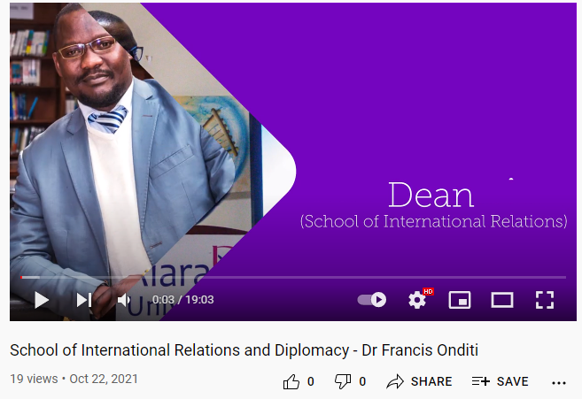
- List four multimedia components available in the page above. (4 Marks)

- Discuss three authoring tools that have been used in developing the multimedia project above giving examples of each. (6 Marks)

- Explain the following terms (6 Marks)
- Animation
- Time Stretching
- Kinematics

- Calculate the file size in bytes for an 8 second recording at 15.05 kHz, 8-bits per sample stereophonic sound. (4 Marks)

SECTION B (ANSWER ANY TWO QUESTIONS)
QUESTION 2 (20 MARKS)
- You have been contracted to prepare a Christmas TV advert that requires production of original background music that is to be played by a pianist. Explain the approach you would use in creating the music and give reasons for your selected approach (10 Marks)

- Discuss the main issues the user interface designer of a multimedia application should keep in mind while developing a multimedia project. (10 Marks)

QUESTION 3 (20 MARKS)
- Discuss the different traditional Broadcast Video Standards (8marks)
- How do the limitations of human vision help in compressing the still images and video? (2 Marks)
- Explain the difference between liner and non-liner video editing? (6 Marks)
- List four common image file formats (4 Marks)

QUESTION 4 (20 MARKS)
- Describe the various types of authoring tools, based on the style in which the multimedia presentation is created.
(6 Marks)

- Discuss the various approaches that can be used in generating images. (6 Marks)
- Compare and contrast cel and computer animation (8 Marks)

QUESTION 5 (20 MARKS)
- Explain how multimedia can be applied in the field of medical training (4 Marks)
- Discuss the role a word processing software would play in the design of multimedia content
(4 Marks)
- List four file formats that are designed specifically to contain animations (4 Marks)
- Compare and contrast linear and non-linear content giving relevant examples of each
(8 Marks)

