
UNIVERSITY EXAMINATIONS
EXAMINATION FOR SEPT/DEC 2023/2024 FOR BACHELOR OF SCIENCE IN COMPUTER SCIENCE AND BACHELOR OF BUSINESS INFORMATION TECHNOLOGY
RCS 202: WEB APPLICATION DEVELOPMENT 1
DATE: 27TH DECEMBER 2023 TIME: 2 HOURS
GENERAL INSTRUCTIONS:
Students are NOT permitted to write on the examination paper during examination time.
This is a closed book examination. Text book/Reference books/notes are not permitted.

SPECIAL INSTRUCTIONS:
This examination paper consists Questions in Section A followed by section B.
Answer Question 1 and any Other Two questions.
QUESTIONS in ALL Sections should be answered in answer booklet(s).

PLEASE start the answer to EACH question on a NEW PAGE.

Keep your phone(s) switched off at the front of the examination room.

Keep ALL bags and caps at the front of the examination room and DO NOT refer to ANY unauthorized material before or during the course of the examination.

ALWAYS show your working.

Marks indicated in parenthesis i.e. ( ) will be awarded for clear and logical answers.

Write your REGISTRATION No. clearly on the answer booklet(s).

For the Questions, write the number of the question on the answer booklet(s) in the order you answered them.
- DO NOT use your PHONE as a CALCULATOR.
- YOU are ONLY ALLOWED to leave the exam room 30minutes to the end of the Exam.
- DO NOT write on the QUESTION PAPER. Use the back of your BOOKLET for any calculations or rough work.

Section A: Compulsory (30 marks)
Question 1
- Explain the role of HTML, CSS, and JavaScript in client-side web development.
(3 marks)
- Using an example describe how you would select all <a> elements within a specific <div> with the class name "content." (4 marks)
- Describe the purpose and usage of HTML5 semantic elements. (2 marks)
- Provide examples of at least three semantic elements and explain their significance.
(4 marks)
- You are tasked with creating a basic web page for an online quiz. The web page should consist of a question, multiple-choice answers, and a button to submit the answer. The appearance of the page should be styled using CSS, and JavaScript should handle user interactions.
  - Create an HTML document with a proper <!DOCTYPE> declaration. Define the structure of your web page, including a title, heading, and a div element for displaying the quiz question. Create an ordered or unordered list to present multiple-choice options (at least four options). (5 marks)
  - Create an external CSS file and link it to your HTML document. Style the quiz question, options, and the button for submission. Use CSS to enhance the visual design, e.g., use fonts, colors, borders, or background colors. Use at least 3 different types of categories of CSS. (5 marks)
  - Write JavaScript code within a <script> tag in your HTML document. When the page loads, the JavaScript should display a quiz question and multiple-choice options. Implement functionality that allows the user to select one answer by clicking on an option. Include a submit button. When the user clicks the submit button, the JavaScript should check the selected answer and provide feedback to the user (e.g., "Correct!" or "Incorrect!"). (7 marks)

SECTION B (OPTIONAL 2 OUT OF 4)
Question 2 (20 Marks)
- Write a CSS rule that selects all images (<img>) with an alt attribute containing the word "logo." (4 marks)
- View the form below:
  - Develop the form using html (4 marks)
  - Add appropriate styling using CSS (5 marks)
  - Add validation using JavaScript (7 marks)
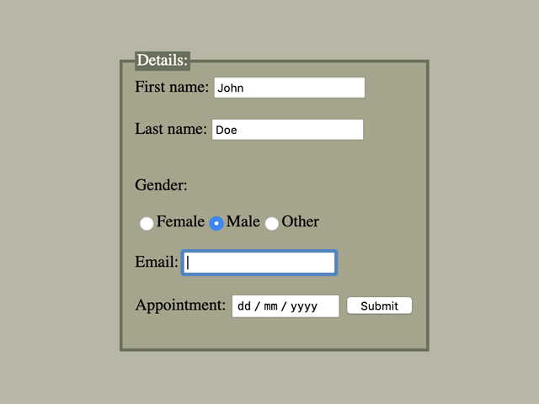

Question 3 (20 marks)
- Distinguish between let, const, and var when declaring variables in JavaScript. (6 marks)
- What does the Document Object Model (DOM) represent in web development?
(2marks)
- Show an example of how you can access and manipulate DOM elements using JavaScript. (6 marks)
- Describe the syntax for defining and invoking functions, passing arguments, and returning values in JavaScript. (6 marks)

Question 4 (20 marks)
- Create a JavaScript program that prompts the user to enter their name and age. Based on the entered age, display a message that welcomes the user and indicates whether they are a child, teenager, adult, or senior citizen. (8 marks)
- What is Tailwind CSS? (2 marks)
- How does Tailwind CSS differ from traditional CSS frameworks like Bootstrap or Foundation? (4 marks)
- Provide four examples of Tailwind CSS utility classes for text manipulation, such as changing font size, color, and alignment.) (8 marks)

Question 5 (20 marks)
  - Distinguish between grid CSS display and flex CSS display using an example.
(6 marks)
  - Create a web page that contains a button. When the button is clicked, the background color of the page should change randomly.
    - Use HTML to create a button element. (2 marks)
    - Apply CSS styles to style the button and the page background. (3 marks)
    - Use JavaScript to handle the button click event and change the background color of the page to a random color. (3 marks)
  - Using an example distinguish between function declarations and function expressions in JavaScript. (6 marks)

