
UNIVERSITY EXAMINATIONS
EXAMINATION FOR MAY/AUGUST 2022/2023 FOR BACHELOR OF SCIENCE IN COMPUTER SCIENCE
COURSE CODE: RCS 101 COURSE TITLE DIGITAL LOGICS.

DATE -- / -- / 2023 TIME: 2 HOURS
GENERAL INSTRUCTIONS:
Students are NOT permitted to write on the examination question paper during examination time.
This is a closed book examination. Text book/Reference books/notes are not permitted.

SPECIAL INSTRUCTIONS:
This examination paper consists Questions in Section A followed by section B.
Answer Question 1 and any Other Two questions.
QUESTIONS in ALL Sections should be answered in answer booklet(s).

PLEASE start the answer to EACH question on a NEW PAGE.

Keep your phone(s) switched off at the front of the examination room.

Keep ALL bags and caps at the front of the examination room and DO NOT refer to ANY unauthorized material during the course of the examination.

ALWAYS show your working.

Marks indicated in parenthesis i.e. ( ) will be awarded for clear and logical answers.

Write your REGISTRATION No. clearly on the answer booklet(s).

For the Questions, write the number of the question on the answer booklet cover page in the order you answered them.
- DO NOT use your PHONE as a CALCULATOR.
- YOU are ONLY ALLOWED to leave the exam room 1 hour to the end of the Exam.
- DO NOT write on the QUESTION PAPER. Use the back of your BOOKLET for any calculations or rough work.
- Scientific CALCULATOR will be required.

SECTION A (COMPULSORY)

Question (1) - (30Marks)
- Define the following terminologies as used in digital logics. (6 Marks)
- Bit.
- Byte.
- Digital.
- Analog.
- Decoder.
- Encoder.

- Considering the Boolean function shown below, draw an equivalent Logic circuit diagram.
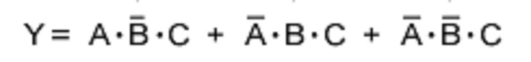. (4 Marks)

- State FOUR Number systems used in digital electronics, state their bases and showing all character ranges. (4 Marks)

- Evaluate the following Conversions for the following numbers, into the indicate format. Show all the working. (10 Marks)

- 10101011001101_{bin} into Hexadecimal number.
- 10101010_{bin} into Gray code.
- 10101010_{bin} into decimal number.
- ABC0_{hex} into octal number.
- 1010_{dec} into binary number.

- Express the logic circuit below as a Boolean function (4 Marks)

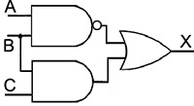

- Explain the differences between the Multiplexers and De-multiplexers. (2 Marks)

SECTION B (Answer Any Two Questions)

Question (2) - (15Marks)

- State the De-Morgan’s theorems. (2 Marks)

- Using suitable truth tables; prove the De-Morgan’s theorems. ` (4 Marks)

- Considering the logic circuit shown below, draw a truth table to show all possible inputs as well as the expected outputs. (5 Marks)
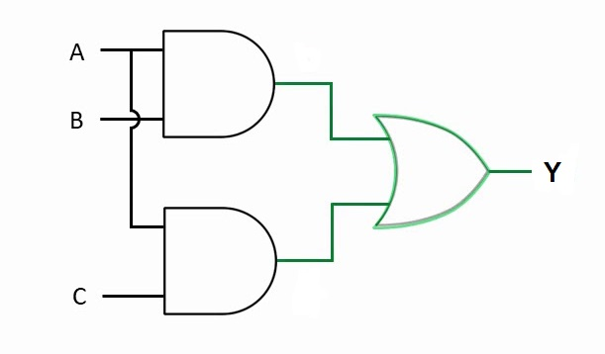

- The modern computers are able to process both digital and analog signals/data.
Discuss how this is achieved in voice processing of mobile phone devices. (4 Marks)

Question (3) - (15 Marks)
- Describe the following digital logic circuits / functions, and state how they are used in computers / Digital Systems. (8 Marks)
- Flip – Flops.
- Multiplexers.
- Shift-Register.
- De-Multiplexers.

- Considering basic logic gates used to make digital logic circuits / systems, name and draw any FIVE logic gates, and hence derive the truth tables of the gates you stated. (5 Marks)

- Considering major logic gates used in digital systems;
- Explain what the team universal logic gates means? (1 Marks)
- Give two examples of universal logic gates. (1 Marks)

Question (4) - (15 Marks)
- Describe the following digital logic circuitry / functions. (5 Marks)
- Flip-flop.
- Counters.
- Registers.
- Full adder.
- Subtractors.

- Considering the Boolean function below.

- Draw an equivalent digital logics circuit diagram. (4 Marks)
- How many gates make up the circuit? (1 Marks)

- Consider the circuit below, of a popular used function in digital systems.

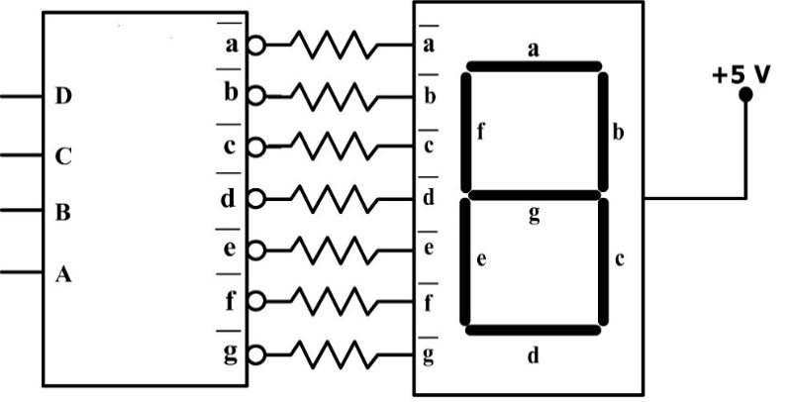

- State the purposes of the two blocks? (2 Marks)
- Explain how the circuit basically functions as well as its areas of application. (3 Marks)

Question (5) - (15 Marks)
- Considering the logic circuit diagram below.
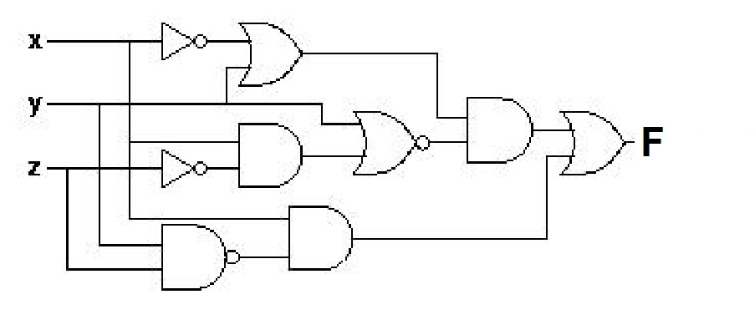
- Derive the output function (F). (3 Marks)

- Digital logic circuits require simplification after designing using any appropriate method like Boolean Simplification or Karnaugh Mapping technique. Justify by giving FOUR reasons. (2 Marks)

- Using the Karnaugh Mapping technique of Boolean simplification,
Simplify the Boolean function below to the simplest form. (5 Marks)
$$Y_{Out} = \overline{A}\overline{B}\overline{C}\overline{D}+\overline{A}\overline{B}C\overline{D}+A\overline{B}\overline{C}\overline{D}+A\overline{B}C\overline{D}+\overline{A}B\overline{C}D+\overline{A}BCD+AB\overline{C}D+ABCD$$

- Design a three bits Binary to Gray code converter, and then draw /implement the logic circuit. You can use either Boolean simplification or the K-Mapping technique. (5 Marks)

END

