

RIARA SCHOOL OF INTERNATIONAL RELATIONS & DIPLOMACY
NURTURING INNOVATORS
MAY-AUGUST 2024 TRIMESTER
EXAMINATIONS FOR DIPLOMA PROGRAM
DAY PROGRAMME
RFC 041: ENVIRONMENTAL SUSTAINABILITY

DATE: 10TH AUGUST, 2024 TIME; 2 HOURS
GENERAL INSTRUCTIONS:
- Students are NOT permitted to write on the examination paper during reading time.
- This is a closed book examination. Text book/Reference books/notes are not permitted.
SPECIAL INSTRUCTIONS
- Write your REGISTRATION NO. Clearly on the answer booklet(s).
- Answer Question One and ANY other TWO questions.
- Questions in all sections should be answered in answer booklet(s)
- PLEASE start the answer to EACH question on a NEW PAGE.
- For the questions, write the number of the question on the answer booklet(s) in the order you answered.
- Write on both sides of each leaf and indicate number of each question at the top of each page.
- Write the answers in a paragraph form unless stated otherwise.
- Marks allocated to each question are shown at the end of the question.
- All rough work must be done on the answer booklet and crossed through!
- Use supplementary pages only when you have exhausted those in this book.
- Fasten the supplementary pages to the inside back cover of this booklet
SECTION A: COMPULSORY (30 MARKS)
QUESTION ONE
a) Define the following Terms:
  - Environmental Sustainability (1 marks)
  - Pollution (1 marks)
  - Greenhouse effect (1 marks)

- Environmental conflict is one of the key causes of political instability in many regions in the world. In East African region such conflicts have manifested themselves in different border areas, a common one is shown in the diagram below.
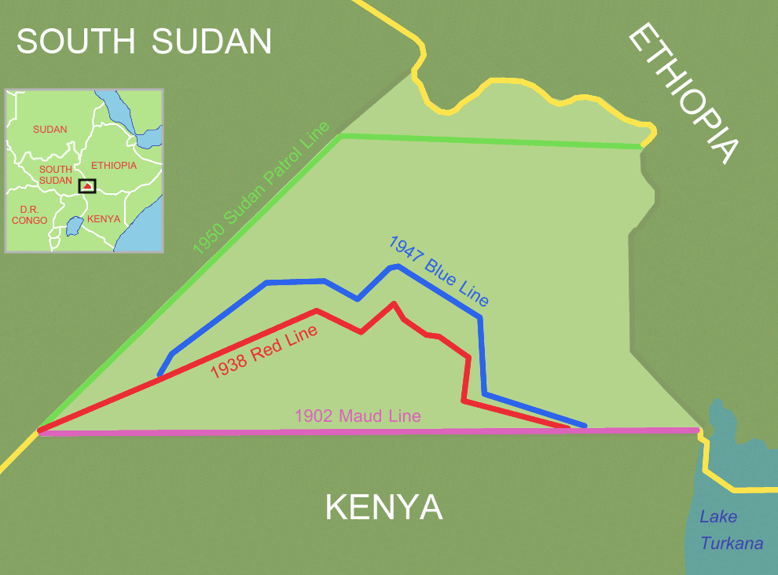
- Name the disputed area between Kenya and South Sudan shown in the diagram above (1 mark)
- You have been appointed by Kenya as one of the arbitrators in the resolution committee for the above land conflict, suggest at most three ways of resolving such conflict without affecting the good diplomatic relations that exists between the two countries ( 6 marks)

- International investors have hired expert to conduct Environmental Impact Assessment for an Integrated Resort Scheme (IRS) project consisting of 150 Villas, an 18 Hole International Level Golf Course and a Marina. The project is situated at Watamu at about 100 metres from the Watamu National Marine Park. The area is under coconut, cashew nuts and orange cultivation and there are about 20 artisanal fishermen registered for the region.

- Identify the potential key environmental impacts (positive/negative) that would require further analysis and provide a short description of each impact identified. (10 marks)
- What measures could be taken to reduce the negative impacts identified?
(5 marks)
- List FIVE Kenyan environmental regulations that the investor will adhere to and highlight the issues that will be addressed by the respective regulations.
(5 marks)
QUESTION TWO
“Development and Environment have long been considered to be contradictory”. Discuss.
(20 marks)
QUESTION THREE
- Densely populated areas are suffering major issues in the field of solid waste and waste water management.
- Relate this statement with the current situation in Kenya (8 marks)

- Suggest any three sustainable methods each for the solid waste and waste water management system (6 marks)

- Explain the significance of carbon footprint and suggest some methods for reducing the carbon footprint of your house (6 marks)

QUESTION FOUR
Discuss at least FIVE Environmental issues and suggest the possible solutions to these key issues
(20 marks)

QUESTION FIVE
a) Discuss the relationship between Law and Environment. (10 marks)

- Suggest and explain five ways in which global south countries can adopt in order to achieve environmental sustainability. (10 mark)

