

RIARA SCHOOL OF INTERNATIONAL RELATIONS & DIPLOMACY
NURTURING INNOVATORS
MAY – AUGUST 2023 TRIMESTER
EXAMINATIONS FOR BACHELOR OF ARTS IN INTERNATIONAL RELATIONS & DIPLOMACY
EVENING PROGRAMME

RIR 212: INTRODUCTION TO INTERNATIONAL ECONOMICS

DATE: AUGUST 2023 TIME: 2 HOURS
GENERAL INSTRUCTIONS:
Students are NOT permitted to write on the examination paper during reading time.
This is a closed book examination. Text book/Reference books/notes are not permitted.

SPECIAL INSTRUCTIONS:
1 Write your REGISTRATION NO. Clearly on the answer booklet(s).
2 Answer Question ONE (COMPULSORY) and ANY Two questions in section B.
3 Questions in all sections should be answered in answer booklet(s).
4 Marks allocated to each question are shown at the end of the question.
5 PLEASE start the answer to EACH question on a NEW PAGE.
6 For the questions, write the number of the question on the answer booklet(s) in the order you answered them.
7 Write your answers in paragraph form unless stated otherwise.
8 Keep your phone(s) SWITCHED OFF at the front of the examination room.

9 Keep ALL bags and caps at the front of the examination room and do not refer to any unauthorized material before or during the course of the examination.
10 You are only allowed to leave the examination room 30 minutes to the end of the Examination.

SECTION A: (30 MARKS). COMPULSORY QUESTION
QUESTION ONE
- Explain the following concepts as used in International Economics.

- Differentiated goods (3 marks)

- What is TOT, or terms of trade? (3 Marks)

- What is consumer surplus and producer surplus, respectively? Draw graphs to
illustrate and label clearly. (8 Marks)

- When home country, a large country, imposes a tariff on foreign imports, what
are the impacts on home country’s welfare? Draw a diagram and explain.
Clearly label your graph. (8 Marks)

- If home country is a small country, what are the welfare impacts? How is it
different from the case in c)? Draw a diagram and explain. Clearly label your
graph. (8 Marks)
SECTION B: CHOOSE ANY TWO QUESTIONS (40 MARKS)

QUESTION TWO
Consider Japan in the early 19th century before opening up to trade with the rest of the world. Japan uses labor to produce two goods, silk and cannons, with the following technologies: one worker can produce either 10 units of silk or 2 cannons. Use the Ricardian model to answer the following questions.
- Draw the Production Possibility Frontier (PPF) for the country. (6 Marks)

- Describe the relative price of silk in terms of cannons under autarky. (7 Marks)

- Assume now instead that Japan is such a large country that it can affect world prices. How will this affect your answer to c)? Explain your answer. (7 Marks)

QUESTION THREE
The figure below shows the market for Sugar in Home. Assume that Home is small in world market.

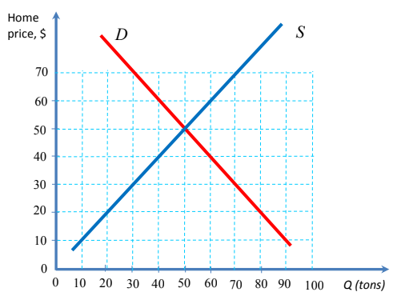
- From the Figure, what is the no-trade price of sugar in Home? (3 Marks)

- Suppose that the world market price is 20$/ton. At this world market price and
with free trade, how large are Home’s imports of Sugar? (3 Marks)

- Compare the free-trade equilibrium and the autarky equilibrium. Calculate and illustrate graphically the “production gain to trade” and the “consumption gain to trade”. (6 Marks)

- Assume now that Home applies a tariff of 20$/ton. Calculate the following
measures.

- The change in consumer surplus from the tariff (2 Marks)

- The change in producer surplus from the tariff (2 Marks)

- The change in government revenues from the tariff (2 Marks)

- The change in overall welfare from the tariff (2 Marks)

QUESTION FOUR
Free trade occurs when governments do not attempt to restrict what citizens can buy from another country or what they can sell to another country. While many nations are nominally committed to free trade, they tend to intervene in international trade to protect the interests of politically important groups:
- State THREE arguments for government intervention in free trade (6 marks)
- Explain the following policies as used in restricting free international trade
- Tariffs (2 marks)
- Subsidies (2 marks)
- Import Quotas (2 marks)
- Voluntary Export Quotas (2 marks)

- Discuss any FIVE challenges that normally arise in the implementation of trade policy between trading partners. (6 marks)

QUESTION FIVE
It is often argued that international discussions on trade liberalization follow the structure of a so-called prisoner’s dilemma. Consider the following game between Home and Foreign, where the figure below contains a matrix which describes the payoffs in terms of welfare for Home and Foreign depending on which country has import tariffs.
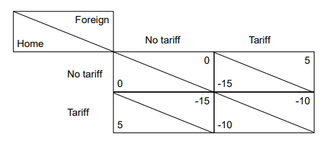
Pay off matrix
- Describe the coordination problem for two countries with this payoff structure and show possible outcomes for situations when the two countries can negotiate and when they cannot. Explain. (10 marks)

- In the provisions of the GATT/WTO-agreement, explain briefly what is meant by:
- The “Most-favored-nation-clause” (MFN), (5 marks)
- The Safeguard provision (or the escape-clause). (5 marks)

