

RIARA SCHOOL OF BUSINESS
NURTURING INNOVATORS
SEPTEMBER-DECEMBER 2022 TRIMESTER
EXAMINATION FOR BACHELOR OF LAWS PROGRAMME
RFC 105: FOUNDATIONS OF AFRICA’S CIVLIZATION

DATE: 29TH NOVEMBER 2022 TIME: 9:00AM TO 11:00AM

SPECIAL INSTRUCTIONS
- Write your REGISTRATION NO. Clearly on the answer booklet(s).
- Answer Question One and ANY other TWO questions.
- Questions in all sections should be answered in answer booklet(s)
- PLEASE start the answer to EACH question on a NEW PAGE.
- For the questions, write the number of the question on the answer booklet(s) in the order you answered.
- Write on both sides of each leaf and indicate number of each question at the top of each page.
- Write the answers in a paragraph form unless stated otherwise.
- Marks allocated to each question are shown at the end of the question.
- All rough work must be done on the answer booklet and crossed through!
- Use supplementary pages only when you have exhausted those in the book.
- Fasten the supplementary pages to the inside back cover of the booklet

“Portuguese Factories and Forts”
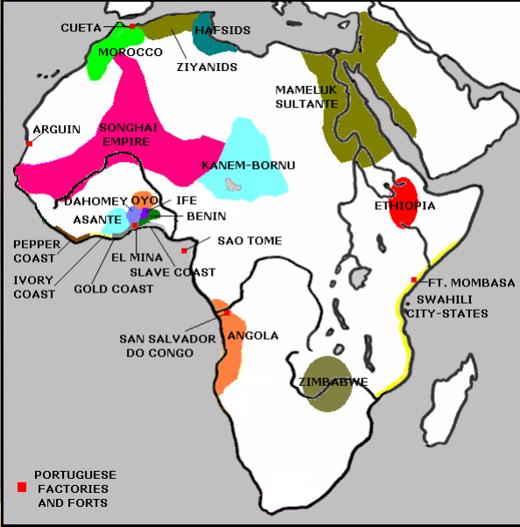
QUESTION ONE: (10 MARKS)
Based on the map above on the “Portuguese Factories and Forts” discuss the role of the Portuguese influence of Africa’s civilization with the guiding statement being “the fabric of African societies was exposed to alien forces of change of an intensity and on a scale unparalleled in the previous history”. (20 marks)

QUESTION TWO:
Africa, from Hegel’s point of view is devoid of morality, religion, and political constitution; counter this argument applying the knowledge you have learnt in this course. (10 marks)

QUESTION THREE:
Outline the FOUR African Philosophies as proposed by H. Odera Oruka (10 marks)

QUESTION FOUR:
Africa's current challenges have partly emanated from the plight of 'apemanship' or Xenocentricism, discuss this challenge and propose the solution to them. (10 marks)

QUESTION FIVE:
Briefly compare the features witnessed in Triangular Slave trade and the features that are witnessed in modern forms of slavery. (10 marks)

QUESTION SIX:
Discuss any FOUR themes identified under Nationalist Ideological Philosophy as proposed by African Philosophers: (10 marks)

----------------------------END----------------------------

