
UNIVERSITY EXAMINATIONS
EXAMINATION FOR SEPTEMBER /DECEMBER 2023/2024 FOR BACHELOR OF SCIENCE IN COMPUTER SCIENCE AND BACHELOR OF BUSINESS INFORMATION TECHNOLOGY
RCS 310: MULTIMEDIA SYSTEMS
DATE: 9TH DECEMBER 2024 TIME: 2 HOURS
GENERAL INSTRUCTIONS:
Students are NOT permitted to write on the examination question paper during examination time.
This is a closed book examination. Text book/Reference books/notes are not permitted.

SPECIAL INSTRUCTIONS:
This examination paper consists Questions in Section A followed by section B.
Answer Question 1 and any Other Two questions.
QUESTIONS in ALL Sections should be answered in answer booklet(s).

PLEASE start the answer to EACH question on a NEW PAGE.

Keep your phone(s) switched off at the front of the examination room.

Keep ALL bags and caps at the front of the examination room and DO NOT refer to ANY unauthorized material before or during the course of the examination.

ALWAYS show your working.

Marks indicated in parenthesis i.e. ( ) will be awarded for clear and logical answers.

Write your REGISTRATION No. clearly on the answer booklet(s).

For the Questions, write the number of the question on the answer booklet(s) in the order you answered them.
- DO NOT use your PHONE as a CALCULATOR.
- YOU are ONLY ALLOWED to leave the exam room 30minutes to the end of the Exam.
- DO NOT write on the QUESTION PAPER. Use the back of your BOOKLET for any calculations or rough work.

SECTION A (COMPULSORY)
QUESTION ONE (COMPULSORY, 30 MARKS).
- Describe the impact created by persistence of vision and how it helps a multimedia designer.
(3 Marks)
- In the history of multimedia, newspaper was the first medium to use text, graphics and images. Explain the developments that took place after this to reach to where we are technologically
(6 Marks)
- User-friendliness is the main property of a good user interface. Highlight the user friendliness features that should be present in a multimedia project (5 Marks)

- You have been contracted by Riara university to develop interactive computer based training content. In describe the software and hardware resources needed to accomplish this task and explain how they will be used. (10 Marks)
- Explain reasons why digital video took over and dominated over other video formats (6 Marks)

SECTION B (ANSWER ANY TWO QUESTIONS)
QUESTION TWO (15 MARKS)
- Explain the process you can undertake to create an animated scene using the images presented below (5 Marks)
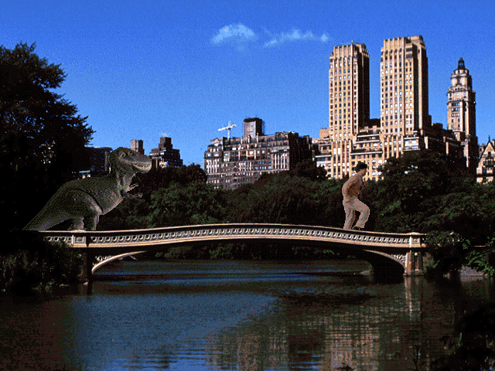
- Highlight FIVE features of an audio editing software (5 Marks)
- Describe the various industies multimedia can be applied in the world today (5 Marks)

QUESTION THREE (15 MARKS)
- YouTube, Tiktok are modern platforms for sharing multimedia content. List the advantages of such platforms compared to traditional ones such as TV. (8 Marks)
- Explain the forces driving the multimedia revolution (3 Marks)
- Highlight the general considerations which affect the selection of the sampling rate in multimedia data. (4 marks)

QUESTION FOUR (15 MARKS)
- Discuss the four components of multimedia (8 Marks)
- Describe four main perspectives in multimedia authoring tools (4 Marks)
- Highlight the Four features of Image-Editing Tools (3 Marks)

QUESTION FIVE (15 MARKS)
- Discuss the process that should be undertaken in performing sound editing when developing a multimedia project. (10 Marks)
- Describe the characteristics of the human visual system which can be exploited for the compression of colour images and video (3 Marks)
- You have been contracted to design the Riara university website. Describe the kind of media that would be ideal for this application domain. (2 Marks)

