
UNIVERSITY EXAMINATIONS
EXAMINATION FOR MAY/AUGUST 2022/2023 FOR BACHELOR OF SCIENCE IN COMPUTER SCIENCE AND BACHELOR OF BUSINESS INFORMATION TECHNOLOGY
COURSE CODE: RCS432 COURSE UNIT: DATABASE ADMINISTRATION
DATE _____________ TIME: 2 HOURS
GENERAL INSTRUCTIONS:
Students are NOT permitted to write on the examination question paper during examination time.
This is a closed book examination. Text book/Reference books/notes are not permitted.

SPECIAL INSTRUCTIONS:
This examination paper consists Questions in Section A followed by section B.
Answer Question 1 and any Other Two questions.
QUESTIONS in ALL Sections should be answered in answer booklet(s).

PLEASE start the answer to EACH question on a NEW PAGE.

Keep your phone(s) switched off at the front of the examination room.

Keep ALL bags and caps at the front of the examination room and DO NOT refer to ANY unauthorized material during the course of the examination.

ALWAYS show your working.

Marks indicated in parenthesis i.e. ( ) will be awarded for clear and logical answers.

Write your REGISTRATION No. clearly on the answer booklet(s).

For the Questions, write the number of the question on the answer booklet cover page in the order you answered them.
- DO NOT use your PHONE as a CALCULATOR.
- YOU are ONLY ALLOWED to leave the exam room 1 hour to the end of the Exam.
- DO NOT write on the QUESTION PAPER. Use the back of your BOOKLET for any calculations or rough work.

QUESTION ONE (30 MARKS)
  - Explain the meaning of the following terms in the Database Management (DBM) systems:

(i) Database Management Administrator (DBMA) (2 Marks)
(ii) Decision Support Systems (DSS) (2 Marks)
(iii) Enterprise Resource Planning System (ERPs) (2 Marks)
(b) Describe the purpose of creating a mission statement and mission objectives for the required database during the planning stage (4 Marks)

(c) Explain the process of fact-finding attempts for a database developer to achieve success (5 Marks)

(d) Case Study 1. Netflix is a movie distribution company. Movies are identified by their title and year of release. They have a length in minutes. They also have a studio that produces the movie and are classified under one or more genres (such as horror, action, drama etc.). Movies are directed by one or more directors and have one or more actors acting in them. The movie also has a plot outline. Each movie also has zero or more quotable quotes which are spoken by a particular actor acting in the movie. Actors are identified by their names and date of birth and act in one or more movies. Each actor has a role in the movie. Directors are also identified by their names and date of birth and direct one or more movies. It is possible for a director to act in a movie (not necessarily in a movie they direct).

- Identify the main entity types for the company (2 Marks)

- Identify the main relationship types and specify the multiplicity for each relationship
(4 Marks)
- State any assumptions you make about data (2 Marks)

- Using your answers for (i) and (ii), draw a single ER diagram to represent the data requirements for the company (7 Marks)

QUESTION TWO (15 Marks)

- Discuss why database normalization is important in a DBM System design (2 Marks)

- CASE STUDY 2: Starting with the unnormalized form (UNF) in the Table 2.1. below, show how the Riara University students’ course registration data can be transformed into:
- First normalized form (1NF) (4 Marks)
- Second normalized form (2NF) (4 Marks)
- Third normalized form (3NF) (5 Marks)

Table 2.1 Unnormalized Student Data Form (UNF)
UNF | 1NF | 2NF | 3NF
Application No.
Student Reg. No.
Student Address
Course Unit Code
Course Unit Description
Charges Per Course Unit
Number of Units Applied for
Total Fees for the Semester

QUESTION THREE (15 Marks
(a) In a largely wireless network environment, such as Kenya, where tele-density ratio is now more than 1:1 nearly everyone who has a personal mobile device is connected to Internet. Ultimately, existing legislatures could be enacted to let include online voting from any part of the country, even from the diaspora. The positive aspects of such a direct democracy may be obvious. Discuss FOUR negative aspects of such online data collection policy (7 Marks)
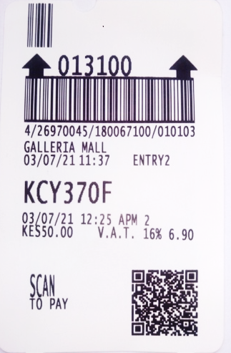
(b) CASE STUDY 3: Figure 3.1 is a car-park ticket recently obtained from a mall in Nairobi. Describe FOUR ways in which the car-park management applies Database Management technologies (8 Marks)

Figure 3.1 Park N-Go Car-Part Ticket
QUESTION FOUR (15 Marks)

- Discuss THREE ways in which the convergence of communication technologies does pose threats in Database Management for the modern work environment (6 Marks)

- Describe TWO main concerns for students who have received higher education loan board (HELB) services in the recent years. In each case describe mitigation actions (4 Marks)

(c) CASE STUDY 4: The Government of Kenya (GoK) recently launched a new electronic Universal Health Coverage (UHC) under the National Hospital Insurance Fund (e-Health) that is aimed at bridging the inequalities in poverty and medical services for all citizens. The monthly insurance remittances ranges between 500/- and 1,700/- payable by either cash, smart cards, mobile money transfers or standing orders through payroll deductions from employee’s salary. Explain FIVE ethical concerns in Database Management that the GoK would have to deal with in e-Health before gaining full trust of the society (5 Marks)

QUESTION FIVE (20 Marks)

- Business Process Management (BPM) is an approach to business that aims at continuously improving business value chain. With the merger that has taken place between Mobile Payment Systems and Banks, describe any FOUR business processes that Riara University DBM system to enhance its competitive advantages (Give examples) (8 Marks)

- Case Study 5: Figure 5.1 is a BPM concept for a physical book shop distributor in Nairobi. Describe how you may reduce these 16 in DBA stages to six or less (use a new sketch to illustrate your new concept). What shall be the implications of your actions in the company? (7 Marks)
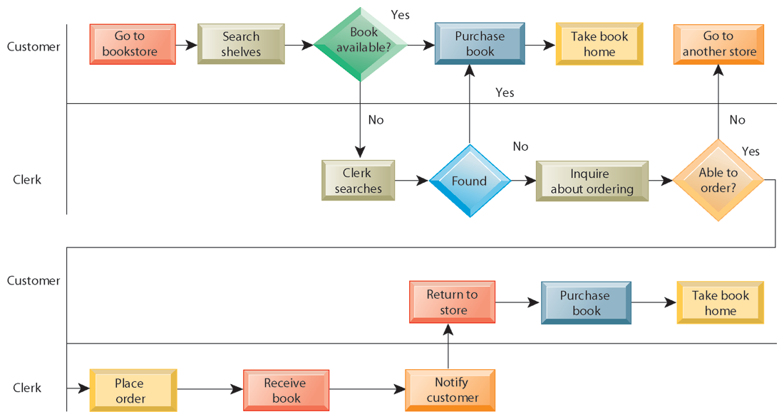
Figure 5.1 BPM Book-Store Concept for Physical Book Buyer

