

Riara School of Business
Nurturing Business Innovators

MAY-AUGUST 2024 TRIMESTER
EXAMINATION FOR BACHELOR OF BUSINESS ADMINISTRATION AND BACHELOR OF BUSINESS INFORMATION TECHNOLOGY DEGREES
DAY PROGRAMME

RFN 202: BUSINESS STATISTICS FOR DECISION MAKING AND ANALYSIS

DATE: 9TH AUGUST 2024 TIME: 2 HOURS

GENERAL INSTRUCTIONS:
Students are NOT permitted to write on the examination paper during reading time.
This is a closed book examination. Text book/Reference books/notes are not permitted.

SPECIAL INSTRUCTIONS:
- Write your REGISTRATION NO. Clearly on the answer booklet(s).
- Answer Question One and ANY other TWO questions.
- Questions in all sections should be answered in answer booklet(s).
- Marks allocated to each question are shown at the end of the question.
- PLEASE start the answer to EACH question on a NEW PAGE.
- For the questions, write the number of the question on the answer booklet(s) in the order you answered them.
- Write your answers in paragraph form unless stated otherwise.
- Keep your phone(s) SWITCHED OFF at the front of the examination room.
- Keep ALL bags and caps at the front of the examination room and do not refer to any unauthorized material before or during the course of the examination.
- You are only allowed to leave the examination room 30minutes to the end of the Examination.
QUESTION ONE (Compulsory)
- A commercial bank provides you with 10 months data for interest incomes of two of its branches (X and Y). The bank would consider merging the two branches if the correlation between their interest incomes is strong and positive: this would reduce operating costs! The casual guess is that the interest incomes are strongly related!
All figures below are in millions of Kenya shillings
n Branch X Branch Y
1. 62 50
2. 72 65
3. 78 63
4. 58 50
5. 65 54
6. 70 60
7. 66 61
8. 63 55
9. 60 54
10. 72 65
Required: compute the Pearson’s Correlation (r) coefficient using the formula provided below and advise the bank accordingly (8 marks)
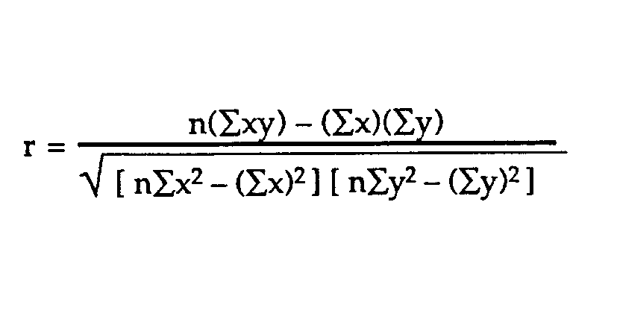
- Develop a null and alternative hypotheses in view of part a) above (6 marks)
- Explain how a Company could use Chi-square test to evaluate performance across two of its branches in Nairobi County, Kenya (6 marks)
- Distinguish between cross-sectional data and longitudinal data by citing relevant examples (6 marks)
- Describe causality by giving an appropriate example in business (4 marks)

QUESTION TWO
- Using appropriate examples, differentiate between interval and ratio scales of measurement (6 marks)
- Explain THREE circumstances under which a manufacturing company would consider multiple regression analysis to determine its financial performance changes in a particular financial year (6 marks)
- Data from a Commercial bank indicates a relationship between marketing expenses and interest income. Subsequently, a Coefficient of Determination (R-square) of 0.75 is computed out of this relationship- explain this statistical outcome (4 marks)
- Differentiate between qualitative and quantitative data citing some examples (4 marks)

QUESTION THREE
- A leading company pays heavily for aptitude tests as well as sitting allowances for oral interviews in its recruitment of sales staff. Describe how Spearman’s rank correlation could help this firm cut down on recruitment costs (4 marks)
- Differentiate between stratified random sampling and systematic sampling by citing some examples (4 marks)
- City Millers Limited considers that machine hours contribute immensely to manufacturing costs due to the machine intensive nature of the production system.
Machine hours | Manufacturing cost (‘000)
90 | 1,500
150 | 2,100
60 | 1,200
30 | 900
180 | 2,400
150 | 2,100
120 | 1,800
180 | 2,400
90 | 1,500
30 | 900
120 | 1,800
160 | 1,200

Required:
Assuming simple linear regression (machine hours having a direct effect on manufacturing cost), develop a cost function (Y= a + bX) and make an interpretation of the regression function using the Least-Square method (by Elimination or Substitution)
∑y = na + b∑x
∑xy = ∑xa + b∑x²
(12 marks)
QUESTION FOUR
- Distinguish between simple regression and multiple regression analysis (4 marks)
- Discuss TWO main characteristics/features of a good sample (4 marks)
- Citing relevant examples, differentiate between time series data and panel data (6 marks)
- A Supermarket has been experiencing loss of stock through theft. The management wishes to collect data from its employees to assess the causes and magnitude of this problem. Describe any TWO data collection methods/techniques that the management could consider in collecting data from the employees (6 marks)

