
UNIVERSITY EXAMINATIONS
EXAMINATION FOR SEPTEMBER / DECEMBER 2024/2025 FOR BACHELOR OF SCIENCE IN COMPUTER SCIENCE
RCS 101: DIGITAL LOGICS.

DATE 2ND / 12 / 2024 TIME: 2 HOURS
GENERAL INSTRUCTIONS:
Students are NOT permitted to write on the examination question paper during examination time.
This is a closed book examination. Text book/Reference books/notes are not permitted.

SPECIAL INSTRUCTIONS:
This examination paper consists Questions in Section A followed by section B.
Answer Question 1 and any Other Two questions.
QUESTIONS in ALL Sections should be answered in answer booklet(s).

PLEASE start the answer to EACH question on a NEW PAGE.

Keep your phone(s) switched off at the front of the examination room.

Keep ALL bags and caps at the front of the examination room and DO NOT refer to ANY unauthorized material during the course of the examination.

ALWAYS show your working.

Marks indicated in parenthesis i.e. ( ) will be awarded for clear and logical answers.

Write your REGISTRATION No. clearly on the answer booklet(s).

For the Questions, write the number of the question on the answer booklet cover page in the order you answered them.
- DO NOT use your PHONE as a CALCULATOR.
- YOU are ONLY ALLOWED to leave the exam room 1 hour to the end of the Exam.
- DO NOT write on the QUESTION PAPER. Use the back of your BOOKLET for any calculations or rough work.
- Scientific CALCULATOR will be required.

SECTION A (COMPULSORY)

Question (1) - (30Marks)
- Describe the following terms as used in digital logics. (6 Marks)
- Encoders.
- Decoders.
- Multiplexers.
- Digital Signals.
- Analog Signals.
- De-multiplexers.

- Express the circuit below as a Boolean function. (6 Marks)

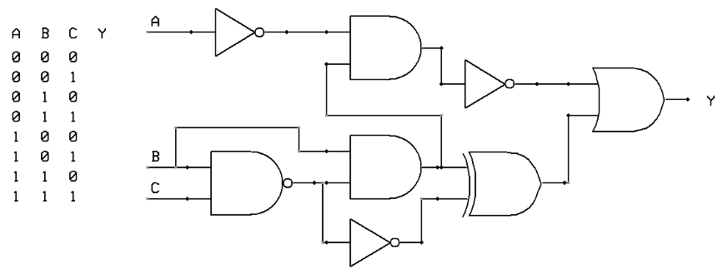

- Considering the Boolean function shown below, draw an equivalent Logic circuit diagram.
$Y_{Out} = ABC+\overline{A}BC+A\overline{B}C+AB\overline{C}$ (6 Marks)

- Convert the following binary numbers, into Decimal Number. (3 Marks)
10101010.110011₂ Show all the working.
- Convert the following Decimal numbers, into Binary Number. (3 Marks)
135.531₁₀ Show all the working.

- Design a Full adder from the first principle of digital circuit designing. (6 Marks)

SECTION B (Answer Any Two Questions)

Question (2) - (15Marks)

- The modern computers are able to process both digital and analog signals/data.
Discuss how this is achieved in voice processing of mobile phone devices. (2 Marks)

- Evaluate the following numbers Conversions, into the indicate formats.
NB: Show all the working, marks awarded on only working, not answers. (10 Marks)

- 10101010110110101_{bin} into hexa-decimal number.
- 1100110011_{bin} into decimal number.
- 10101010_{bin} into gray code.
- A0B8C9F_{hex} into octal number.
- 1010_{dec} into binary number.

- Compare the binary numbers system and gray code. (3 Marks)

Question (3) - (15 Marks)
- Design a three bits Binary to Gray code converter, and then draw /implement the logic circuit. You can use either Boolean simplification or the K-Mapping technique. (6 Marks)

- Simplify the logic circuit below to its simplest form. (3 Marks)
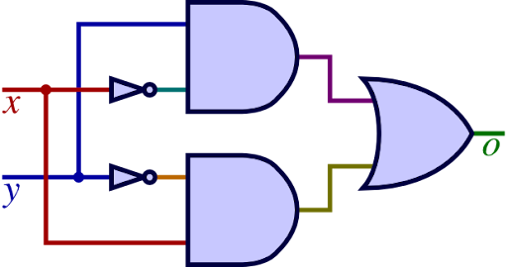
- Considering the logic circuit shown below, derive the Boolean function and hence a truth table, indicating all possible inputs (A, B and C) and specific output (Q). (6 Marks)
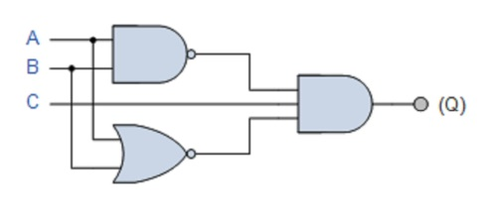

Question (4) - (15 Marks)

- Considering the following units of measurement used to measure electrical quantities, state the electrical quantities corresponding to each. (7 Marks)
- Ohms.
- Volts.
- Watts.
- Hertz.
- Weber.
- Amperes.
- Coulombs.

- Derive the Boolean function for the logic circuit below, and then simplify and implement the circuit by drawing the simplified version. (4 Marks)

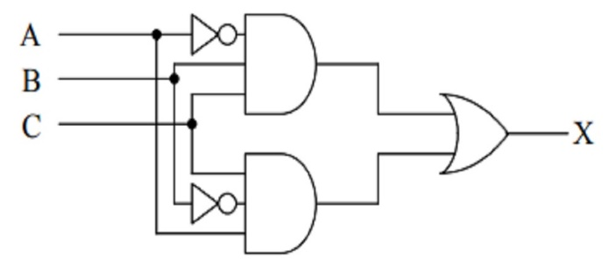

- Using suitable truth tables or Boolean derivation; prove the De-Morgan’s theorems. (4 Marks)

Question (5) - (15 Marks)

- Using the Karnaugh Mapping technique of Boolean simplification,
Simplify the Boolean function below to the simplest form. (6 Marks)
$$Y_{Out} = \overline{A}\overline{B}\overline{C}\overline{D}+\overline{A}\overline{B}C\overline{D}+A\overline{B}\overline{C}\overline{D}+A\overline{B}C\overline{D}+\overline{A}B\overline{C}D+\overline{A}BCD+AB\overline{C}D+ABCD$$

- Considering the logic circuit diagram below, Derive the outputs’ function (X, Y and Z). (6 Marks)
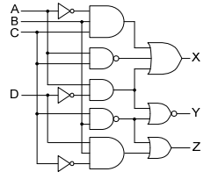

- Describe the following digital logic circuits / functions, and state how they are used in computers / Digital Systems. (3 Marks)
- Counters.
- Registers.
- Flip – Flops.

END

