
UNIVERSITY EXAMINATIONS
EXAMINATION FOR MAY / AUGUST 2023/2024 DIPLOMA IN COMPUTER SCIENCE/DIPLOMA IN INFORMATION TECHNOLOGY/DIPLOMA IN BUSINESS INFORMATION TECHNOLOGY/DIPLOMA IN CYBER SECURITY
RCS 016 / RCT 003: INTRODUCTION TO DIGITAL ELECTRONICS.

DATE 13 / 08 / 2024 TIME: 2 HOURS
GENERAL INSTRUCTIONS:
Students are NOT permitted to write on the examination question paper during examination time.
This is a closed book examination. Text book/Reference books/notes are not permitted.

SPECIAL INSTRUCTIONS:
This examination paper consists Questions in Section A followed by section B.
Answer Question 1 and any Other Two questions.
QUESTIONS in ALL Sections should be answered in answer booklet(s).

PLEASE start the answer to EACH question on a NEW PAGE.

Keep your phone(s) switched off at the front of the examination room.

Keep ALL bags and caps at the front of the examination room and DO NOT refer to ANY unauthorized material during the course of the examination.

ALWAYS show your working.

Marks indicated in parenthesis i.e. ( ) will be awarded for clear and logical answers.

Write your REGISTRATION No. clearly on the answer booklet(s).

For the Questions, write the number of the question on the answer booklet cover page in the order you answered them.
- DO NOT use your PHONE as a CALCULATOR.
- YOU are ONLY ALLOWED to leave the exam room 1 hour to the end of the Exam.
- DO NOT write on the QUESTION PAPER. Use the back of your BOOKLET for any calculations or rough work.
- Scientific CALCULATOR will be required.

SECTION A (COMPULSORY)

Question (1) - (30Marks)
- Describe the following terms as used in digital logics. (8 Marks)
- A.D.C.
- D.A.C.
- Digital Signals.
- Analog Signals.

- Considering the following electrical quantities, state the units of measurement used for each. (5 Marks)
- Potential Difference.
- Frequency.
- Current.
- Charge.
- Power.

- Derive the Boolean function for the circuit shown below. (4 Marks)
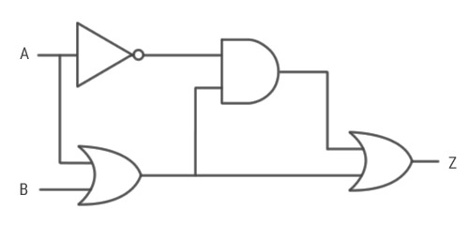

- Considering the Boolean function shown below, draw an equivalent Logic circuit diagram.
$Y=AB + BC(B+C)$ (5 Marks)

- Convert the following binary numbers, into Decimal Number. (3 Marks)
1010101.1010101₂ Show all the working.
- Convert the following Decimal numbers, into Binary Number. (3 Marks)
135.135₁₀ Show all the working.
- Compare the combination logic circuits and the sequential logic circuits. (2 Marks)

SECTION B (ANSWER ANY TWO QUESTIONS)

Question (2) - (15Marks)
- The modern computers are able to process both digital and analog signals/data.
Discuss how this is achieved in voice processing of mobile phone devices. (3 Marks)

- Evaluate the following numbers Conversions, into the indicate formats.
NB: Show all the working, marks awarded on only working, not answers. (10 Marks)

- 11101010110001_{bin} into Hexadecimal number.
- 11111111_{bin} into Gray code.
- 10101010_{bin} into decimal number.
- ABCD _{hex} into octal number.
- 1010 _{dec} into binary number.

- Compare encoders and decoders. (2 Marks)

Question (3) - (15 Marks)
- Design a half adder from the first principle of digital circuit designing. (6 Marks)

- Digital logic circuits require simplification after designing using any appropriate method like Boolean Simplification or Karnaugh Mapping technique. Justify by giving FOUR reasons. (4 Marks)

- State the difference between the Multiplexers and De-multiplexers? (2 Marks)

- Compare the binary numbers system and Gray code. (3 Marks)

Question (4) - (15 Marks)
- State and describe five levels of integrations used in integrated chips design and fabrication. (5 Marks)
- Simplify the logic circuit below; and hence draw the simplified logic circuit. (6 Marks)

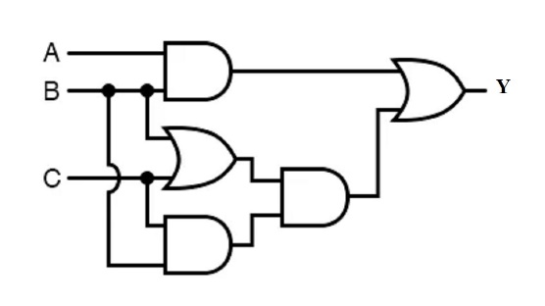

- Using suitable truth tables; prove the De-Morgan’s theorems. (4 Marks)

Question (5) - (15 Marks)

- Explain what the team universal logic gates, and give two examples of universal logic gates. (4 Marks)

- State TWO types of ADCs and TWO types of DACs. (4 Marks)

- Name and draw SEVEN basic types of Logic gates and derive their truth tables.

(7 Marks)

END

