
UNIVERSITY EXAMINATIONS
EXAMINATION FOR SEPTEMBER / DECEMBER 2024/2025 DIPLOMA IN COMPUTER SCIENCE/DIPLOMA IN INFORMATION TECHNOLOGY/DIPLOMA IN BUSINESS INFORMATION TECHNOLOGY/DIPLOMA IN CYBER SECURITY
COURSE CODE: RCS 016 / RCT 003 COURSE TITLE: INTRODUCTION TO DIGITAL ELECTRONICS.

DATE -- / 12 / 2024 TIME: 2 HOURS
GENERAL INSTRUCTIONS:
Students are NOT permitted to write on the examination question paper during examination time.
This is a closed book examination. Text book/Reference books/notes are not permitted.

SPECIAL INSTRUCTIONS:
This examination paper consists Questions in Section A followed by section B.
Answer Question 1 and any Other Two questions.
QUESTIONS in ALL Sections should be answered in answer booklet(s).

PLEASE start the answer to EACH question on a NEW PAGE.

Keep your phone(s) switched off at the front of the examination room.

Keep ALL bags and caps at the front of the examination room and DO NOT refer to ANY unauthorized material during the course of the examination.

ALWAYS show your working.

Marks indicated in parenthesis i.e. ( ) will be awarded for clear and logical answers.

Write your REGISTRATION No. clearly on the answer booklet(s).

For the Questions, write the number of the question on the answer booklet cover page in the order you answered them.
- DO NOT use your PHONE as a CALCULATOR.
- YOU are ONLY ALLOWED to leave the exam room 1 hour to the end of the Exam.
- DO NOT write on the QUESTION PAPER. Use the back of your BOOKLET for any calculations or rough work.
- Scientific CALCULATOR will be required.

SECTION A (COMPULSORY)

Question (1) - (30Marks)
- Describe the following terms as used in digital logics. (4 Marks)
- Bit.
- Byte.
- Digital Signals.
- Analog Signals.

- Considering the following units of measurement used to measure electrical quantities, state the electrical quantities corresponding to each. (7 Marks)
- Ohms.
- Volts.
- Watts.
- Hertz.
- Weber.
- Amperes.
- Coulombs.

- Derive the Boolean function for the circuit shown below. (4 Marks)
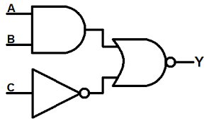

- Considering the Boolean function shown below, draw an equivalent Logic circuit diagram, and then simplify the circuit to its simplest form.
$Y=AB + BC(B+C)$ (5 Marks)

- Convert the following binary numbers, into Decimal Number. (3 Marks)
1010101.1010101₂ Show all the working.
- Convert the following Decimal numbers, into Binary Number. (3 Marks)
1357. 245₁₀ Show all the working.
- Compare the combination logic circuits and the sequential logic circuits. (4 Marks)

SECTION B (Answer Any Two Questions)

Question (2) - (15Marks)
- The modern computers are able to process both digital and analog signals/data.
Discuss how this is achieved in voice processing of mobile phone devices. (3 Marks)

- Evaluate the following numbers Conversions, into the indicate formats.
NB: Show all the working, marks awarded on only working, not answers. (10 Marks)

- 1010 _{dec} into binary number.
- ABCD _{hex} into octal number.
- 11111111_{bin} into gray code.
- 10101010_{bin} into decimal number.
- 11101010110001_{bin} into hexadecimal number.

- Compare encoders and decoders. (2 Marks)

Question (3) - (15 Marks)
- Design a half adder from the first principle of digital circuit designing. (4 Marks)

- Compare the binary numbers system and gray code. (3 Marks)

- Simplify the logic circuit below; and hence draw the simplified logic circuit. (4 Marks)
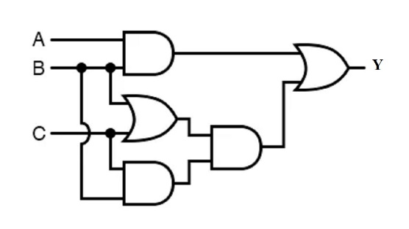
- State the difference between the Multiplexers and De-multiplexers? (4 Marks)

Question (4) - (15 Marks)
- Name and draw SEVEN basic types of Logic gates and derive their truth tables.
(7 Marks)

- Using suitable truth tables; prove the De-Morgan’s theorems. (4 Marks)

- Digital logic circuits require simplification after designing using any appropriate method like Boolean Simplification or Karnaugh Mapping technique. Justify by giving FOUR reasons. (4 Marks)

Question (5) - (15 Marks)
- State and describe five levels of integrations used in integrated chips design and fabrication. (5 Marks)

- Explain what the team universal logic gates, and give two examples of universal logic gates. (2 Marks)

- State TWO types of ADCs and TWO types of DACs. (4 Marks)

- Considering the logic circuit below;

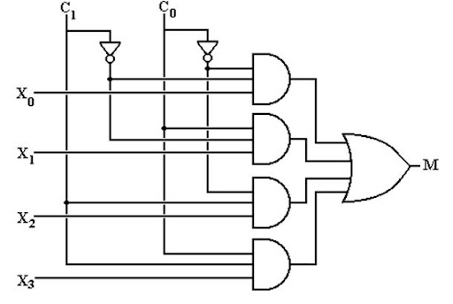

- Explain the functionality of the circuit. (2 Marks)

- What is the application of the circuit? (2 Marks)

END

