
UNIVERSITY EXAMINATIONS

EXAMINATION FOR MAY - AUGUST 2020 /2021 FOR DIPLOMA IN COMPUTER SCIENCE / INFORMATION TECHNOLOGY

COURSE CODE: RIT/RCS 017
COURSE UNIT: OBJECT ORIENTED PROGRAMMING C++/JAVA

DATE: 12TH AUGUST, 2021 TIME: 2 HOURS

GENERAL INSTRUCTIONS:
Students are NOT permitted to write on the examination paper during examination time.
This is a closed book examination. Text book/Reference books/notes are not permitted.

SPECIAL INSTRUCTIONS:
This examination paper consists Questions in Section A followed by section B.
Answer Question 1 and any Other Two questions.
QUESTIONS in ALL Sections should be answered in answer booklet(s).

PLEASE start the answer to EACH question on a NEW PAGE.

Keep your phone(s) switched off at the front of the examination room and NOT on your person.

Keep ALL bags and caps at the front of the examination room and DO NOT refer to ANY unauthorized material before or during the course of the examination.

ALWAYS show your working.

Marks indicated in parenthesis i.e. ( ) will be awarded for clear and logical answers.

Write your REGISTRATION No. clearly on the answer booklet(s).

For the Questions, write the number of the question on the answer booklet(s) in the order you answered them.
- DO NOT use your PHONE as a CALCULATOR.
- YOU are ONLY ALLOWED to leave the exam room 30minutes to the end of the Exam.
- DO NOT write on the QUESTION PAPER. Use the back of your BOOKLET for any calculations or rough work.

SECTION A (COMPULSORY)

QUESTION 1 ( 30 Marks)

- Functions or methods define object behaviour. Write a simple C++ or Java function called students that returns an integer. ( 3 Marks)

- Define the following terms: ( 4 Marks)
- Object File
- Base Class
- Dynamic Binding
- Constructor

- List two advantages Assembly language over Java. ( 2 Marks)

- Differentiate between ( 4 Marks)
- Main function and other member functions.
- Sentinel value and counter controlled loops.

- Describe the three common types of errors encountered in programming. ( 3 Marks)

- List three benefits of Object Oriented Programming (OOP). ( 3 Marks)

- Study the JFrame form displayed below.

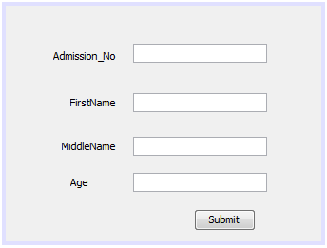
Explain how you will enable this form to update a Java DB table Students using the following SQL statement. ( 5 Marks)

INSERT INTO Students(Admission_No, FirstName,MiddleName,Age) VALUES('AdmissionNoText.getText()','FirstNameText.getText()','MiddleNameText.getText()','AgeText.getText()')

- Identify any three javax.swing components which have been used to create the following graphical user interface. ( 3 Marks)

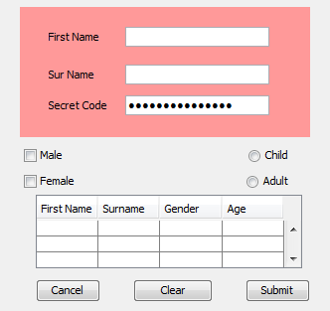

- What public, protected, private access modifiers? ( 3 Marks)

SECTION B (Answer ANY Two Questions)

QUESTION 2 (15 Marks)

- With examples, define: ( 3 Marks)
- Polymorphism
- Namespace as used in C++

- Do I need to import java.lang package any time? Why? ( 2 Marks)

- Using a program segment with all the parts, explain the structure and output of a do while loop control structure. ( 5 Marks)

- Explain the meaning of the term memory management and discuss why memory management is a necessary part of computer programming. ( 2 Marks)

- With a reason, what will be the output of the following Java statement? ( 2 Marks)
System.out.println ("1" + 4);

- Describe one application of polymorphism. ( 1 Marks)

QUESTION 3 (15 Marks)

- Define ( 2 Marks)
- Abstraction
- Multiple Inheritance

- Differentiate: ( 4 Marks)
- Array element and array index
- Method overloading and method overriding

- Explain for loop control structure. Sketch the flow chart. ( 4 Marks)

- What happens when a function throws an exception that was not specified by an exception specification for this function in Java? ( 1 Mark)

- Give the uses of the following ( 2 Marks)
- Destructor
- Garbage Collector

- Describe one application of inheritance. ( 2 Mark)

QUESTION 4 (15 Marks)

- Define ( 2 Marks)
- Public Inheritance
- Class scope

- Give the uses of the following ( 4 Marks)
- Integrated Development Environment (IDE)
- Compiler
- Pointers
- Comments in a program

- Using a program segment with all the parts, explain the structure and output of a while loop control structure. ( 4 Marks)

- Expound on the following types of blocks used in exception handling in Java.
( 3 Marks)
- Try block
- Throw block
- Catch block

- Describe one application of encapsulation. ( 2 Marks)

QUESTION 5 (15 Marks)

- Discuss the software development life cycle (SDLC). ( 5 Marks)

- If you execute the following C++ code;

#include <iostream>
using namespace std;

int main () {
// local variable declaration as used in University grading:
char juice = 'G';
switch(grade) {
case 'A' : cout << "Apple!" << endl;
break;
case 'O' : case 'C' : cout << "Orange" << endl;
break;
case 'P' : cout << "Pineapple!" << endl;
break;
case 'X' : cout << "Order another drink!" << endl;
break;
default : cout << "Unregistered drink!" << endl;
}
cout << "Your choice is " << juice << endl;
return 0;
}

- Explain the output of the above code. ( 2 Marks)

- Change the char grade from char juice = ‘G’ to char juice = ‘D’. Describe the new output of the executed code. ( 2 Marks)

- What is the importance of break statement? ( 2 Mark)

- If the following Java code is executed.
// First Program
public class Program1{
public static void main(String args []){
int i;
String s1;
s1 = "1";
System.out.println(s1);

for(i=2;i < 11;i++) {
s1 = s1 + " " + i;
System.out.println(s1);
};
}
}

- Describe how this program works. ( 2 Marks)

- With reasons, what will be the output? ( 2 Marks)

