
UNIVERSITY EXAMINATIONS
EXAMINATION FOR SEPTEMBER-DECEMBER 2024/2025 DIPLOMA IN INFORMATION TECHNOLOGY
RCS 024: WEB DEVELOPMENT
DATE: __________ TIME: 2 HOURS
GENERAL INSTRUCTIONS:
Students are NOT permitted to write on the examination question paper during exam time.
This is a closed book examination. Text book/Reference books/notes are not permitted.
SPECIAL INSTRUCTIONS:
This examination paper consists Questions in Section A followed by section B.
Answer Question 1 and any Other Two questions.
QUESTIONS in ALL Sections should be answered in answer booklet(s).

PLEASE start the answer to EACH question on a NEW PAGE.

Keep your phone(s) switched off at the front of the examination room.

Keep ALL bags and caps at the front of the examination room and DO NOT refer to ANY unauthorized material during the course of the examination.

ALWAYS show your working.

Marks indicated in parenthesis i.e. ( ) will be awarded for clear and logical answers.

Write your REGISTRATION No. clearly on the answer booklet(s).

For the Questions, write the number of the question on the answer booklet cover page in the order you answered them.
- DO NOT use your PHONE as a CALCULATOR.
- YOU are ONLY ALLOWED to leave the exam room 1hour to the end of the Exam.
- DO NOT write on the QUESTION PAPER. Use the back of your BOOKLET for any calculations or rough work.

SECTION A (COMPULSORY)
QUESTION ONE (30 Marks)
- Differentiate between Local Area Network and Wide Area Network. [2 Marks]
- Explain the following CSS selector options
- Name selector
- ID selector
- Class selector [3 Marks]
- Write JavaScript program to implements a function SubNumbers, that subtract two numbers and returns the results. [5 Marks]
- Explain Four benefits of an intranet in an organization [4 Marks]
- Differentiate between front-end and back-end part of a web application. [2 Marks]
- Explain the following stages during a web application development process
- Analysis,
- Design
- Development,
- Testing and review,
- Deployment,
- Maintenance [6 Marks]
- List Any Four Top Level Domains [4 Marks]
- Explain the effect of each of the following CSS script on a table.
width: 80%;
border: 3px solid green;
background-color: yellow;
font-size: 14px;
[4 Marks]
SECTION B (Answer ANY Two Questions)
QUESTION TWO (15 marks)
- Explain the use of the following JavaScript popup dialog boxes
- Alert box
- Prompt box
- Confirm box [3 Marks]
- Differentiate between block and inline elements in HTML. [2 Marks]
- Write HTML script that would generate the following nested list on a page
- Premier League Teams
- Liverpool
- Man United
- Serie A Teams
- Napoli
- Inter Milan [6 Marks]
- Differentiate between cell padding and cell spacing as used in HTML tables [2 Marks]
- Explain the use of float property when placing images on a HTML page [2 Marks]
QUESTION THREE (15 Marks)
- Explain Five uses of internet in the education sector [5 Marks]
- Write HTML script that would produce the following table
Sports Club Members
Member Name | Telephone | Date Joined | Status
Peter | 0722222222 | 20/09/2017 | Active
Judy | 0723333333 | 19/10/2016 | Active
Richard | 0724444444 | 22/06/2022 | Inactive
[5 Marks]
- Explain the following attributes of HTML form’s input elements.
- Readonly
- Autofocus
- Required
- Placeholder
- Multiple [5 Marks]
QUESTION FOUR (15 Marks)
- Differentiate between relative path name and absolute path name. [2 Marks]
- List Four input elements that can be used on a HTML form. [4 Marks]
- Explain the following methods of inserting a style sheet
- Internal
- Inline
- External [3 Marks]

- Explain the outcome of each of the following CSS statements
table, th, td {vertical-align:top; }
a:hover { color: green; }
textarea{overflow:scroll;}
p { text-align: right; color : blue; } [4 Marks]
- Write a JavaScript statement that displays a string “Programming Languages” on a Heading 3 element that has an ID language [2 Marks]

QUESTION FIVE (15 Marks)
- List any Five events that can be utilized when writing programs in JavaScript. [3 Marks]
- Explain Three risks that internet users can be exposed to. [3 Marks]
- Differentiate between Domain name and Domain name server [2 Marks]
- Write a HTML code that can generate the following form
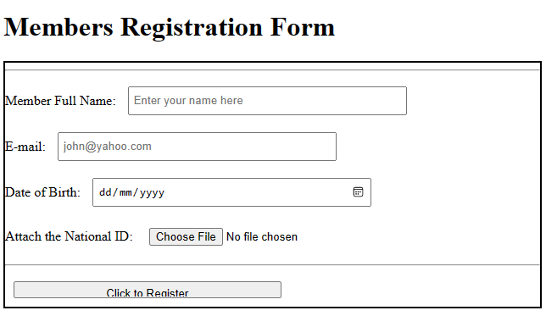
[7 Marks]

