
UNIVERSITY EXAMINATIONS
EXAMINATION FOR SEPTEMBER/DECEMBER 2023/2024 FOR BACHELOR OF SCIENCE IN COMPUTER SCIENCE
COURSE CODE: RCS 203 COURSE UNIT: COMPUTER ARCHITECTURE
DATE: -- /-- /2023. TIME: 2 HOURS
GENERAL INSTRUCTIONS:
Students are NOT permitted to write on the examination paper during examination time.
This is a closed book examination. Text book/Reference books/notes are not permitted.

SPECIAL INSTRUCTIONS:
This examination paper consists Questions in Section A followed by section B.
Answer Question 1 and any Other Two questions.
QUESTIONS in ALL Sections should be answered in answer booklet(s).

PLEASE start the answer to EACH question on a NEW PAGE.

Keep your phone(s) switched off at the front of the examination room.

Keep ALL bags and caps at the front of the examination room and DO NOT refer to ANY unauthorized material before or during the course of the examination.

ALWAYS show your working.

Marks indicated in parenthesis i.e. ( ) will be awarded for clear and logical answers.

Write your REGISTRATION No. clearly on the answer booklet(s).

For the Questions, write the number of the question on the answer booklet(s) in the order you answered them.
- DO NOT use your PHONE as a CALCULATOR.
- YOU are ONLY ALLOWED to leave the exam room 30minutes to the end of the Exam.
- DO NOT write on the QUESTION PAPER. Use the back of your BOOKLET for any calculations or rough work.
- Calculators may be required.

SECTION A (COMPULSORY)

Question (1) - (30Marks)

- Define the following terms as used in computer architecture. (8 marks)
- N.U.M.A.
- Pipelining.
- Hypervisor.
- Hyper-threading.
- Multi-processing.
- Parallel-processing.
- Multi-programming.
- Parallel-Computing.

- State FOUR differences between computer architecture and computer organization?
(4 marks)
- Outline FIVE differences between RISC and CISC CPU architectures. (5 marks)

- Discuss how CACHE may improve computation performance. (4 marks)

- Explain how D.M.A. may improve computer performances. (2 marks)

- State and describe FOUR common components of a typical microprocessor. (4 marks)

- Outline THREE differences between Von-Neumann & Harvard architectures? (3 marks)

SECTION B (Answer Any Two Questions)

Question (2) - (15 Marks)
- Describe THREE primary bus signals and their purposes. (3 marks)

- Explain what Bus-Arbitration refers to, and why it may be necessary in modern computer systems. (2 marks)

- Differentiate between the Centralized and Distributed bus Arbitration. (2 marks)

- Name and describe THREE different arbitration schemes used in the centralized bus Arbitration. (6 marks)

- State the functions of BIU and EU, in x-86 based architecture? (2 marks)

Question (3) - (15 Marks)
- Considering the ARM and the X-86 CPUs, outline FIVE major differences based on design, power and applications of the two types of microprocessors. (5 marks)

- Explain what memory Segmentation is, as referenced from the x-86 Architecture.
(2 marks)
- Name and describe FOUR segments used in intel 8086 microprocessors, and hence state the purpose of each. (4 marks)

- Describe the Flynn’s taxonomy in instruction set architecture classification. (4 marks)

Question (4) - (15 Marks)
- Define the following.
- Cache. (1 marks)
- Cache Hit. (1 marks)
- Cache Miss. (1 marks)
- Cache Coherence. (2 marks)

- Discuss FOUR design factors to consider when designing a microprocessor; that influence the performance of the central processing unit (CPU). (4 marks)

- State and Describe THREE types of interrupts. (6 marks)

Question (5) - (15 Marks)

- Compare Segmented Memory Model and Flat Memory Model as used in the memory organization of computer systems. (2 marks)

- Considering the X-86 based processors architecture shown below, describe the specific registers indicated in the diagram. (8 marks)

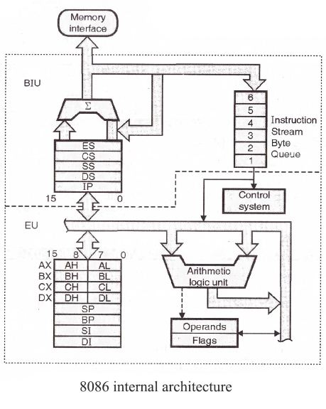

- Explain the concepts / operations of Big Endian and Little Endian. (2 marks)

- Differentiate between Temporal and Spatial locality with refence to Cache memory. (2 marks)

- Explain the term prefetch in computer architecture. (1 marks)

END

