
UNIVERSITY EXAMINATIONS
EXAMINATION FOR MAY/AUGUST 2020/2021 FOR BACHELOR OF SCIENCE IN COMPUTER SCIENCE
COURSE CODE: RCS 210: COURSE TITLE: INTRODUCTION TO EMBEDDED SYSTEMS.
DATE _____________ TIME: 2 HOURS
GENERAL INSTRUCTIONS:
Students are NOT permitted to write on the examination paper during examination time.
This is a closed book examination. Text book/Reference books/notes are not permitted.

SPECIAL INSTRUCTIONS:
This examination paper consists Questions in Section A followed by section B.
Answer Question 1(Mandatory) and any other two questions.
QUESTIONS in ALL Sections should be answered in answer booklet(s).

PLEASE start the answer to EACH question on a NEW PAGE.

Keep your phone(s) switched off at the front of the examination room.

Keep ALL bags and caps at the front of the examination room and DO NOT refer to ANY unauthorized material before or during the course of the examination.

ALWAYS show your working.

Marks indicated in parenthesis i.e. ( ) will be awarded for clear and logical answers.

Write your REGISTRATION No. clearly on the answer booklet(s).

For the Questions, write the number of the question on the answer booklet(s) in the order you answered them.
- Calculator may be required, DO NOT use your PHONE as a CALCULATOR.
- YOU are ONLY ALLOWED to leave the exam room 30minutes to the end of the Exam.
- DO NOT write on the QUESTION PAPER. Use the back of your BOOKLET for any calculations or rough work.

SECTION A (COMPULSORY)

Question (1) - (30Marks)

- With respect to embedded systems, describe / define the following terms. (5 Marks)

- Embedded System.
- Bootloader.
- Firmware.
- S.O.C.
- D.S.P.

- What is the differences between serial and parallel communication? Explain. (2 Marks)

- With respect to memory used in microcontrollers, discus THREE types memories and purposes / applications. (6 Marks)

- State and describe various types/categories of embedded systems, based on the performance, micro-controller used and functionality. (7 Marks)

- Discus FIVE real-life applications of Embedded System stating what category of embedded system each fall under. (5 marks)

- With respect to micro-controllers architectures, discus differences between the Von-Neumann and Harvard Architectures. (3 marks)

- Describe the concept of internet of things giving examples of IoT system. (2 marks)

SECTION B (Answer Any Two Questions)

Question (2) - (20Marks)

- Describe in details the following communication protocols as used in the embedded systems. Consider the concepts of parallel/serial, number of devices supported, error correction, buses width / lines, speed etc. (10 Marks)
- S.P.I.
- I₂C.
- U.A.R.T.
- U.S.A.R.T.
- U.S.B.

- Discus types of operating systems best suited for embedded systems and justify. (4 Marks)

- In details explain how embedded system are interfaced to the inputs and outputs of real world systems, that analog in nature. (6 Marks)

Question (3) - (20Marks)
- Which criterion / factors are appropriate for choosing the right microcontroller for use in particular embedded system / application? Discus any FIVE factors. (5 Marks)

- Why should and embedded engineer chose to deploy drivers to interface motors in an embedded system? Give four reasons. (4 Marks)

- State the differences and comparison of the following motors types as used in embedded systems. W.r.t, speed, torque, control, interface, proposes, etc (4 Marks)
- A.C. Motors.
- D.C. Motors.
- Servo Motors.
- Stepper Motors.

- Considering Real time clock and Watch dog timers.
- What is the differences between the two? (2 Marks)
- Discus their applications, stating examples suitable for deployment (2 Marks)

- Discus the G.P.I.O.s found in controllers, in comparison to common primary busses, found in processors. (3 Marks)

Question (4) - (20Marks)

- Discus the purpose of following components of an embedded system environment. (6 Marks)
- Signal conditioners.
- Micro-Controller.
- Transducer.
- Actuators.
- Sensors.
- Drivers.

- With respect to components of an embedded systems, state FOUR examples of Sensors and FOUR examples of Actuators. (4 Marks)

- Most of the micro-controller architectures are based on the RISC architecture rather than the CISC.
- Justify why most embedded systems are RISC architecture based. (2 Marks)
- Discus in details, FIVE major differences between the two architectures. (5 Marks)

- Differentiate between passive and active sensors, giving an example in each. (3 Marks)

Question (5) - (20Marks)

- State two types of ADC converter used in micro-controllers and explain how each of them works from the basic principles. (4 Marks)

- With respect to micro-controllers in built hardware.
- Define P.W.M. and hence, (1 Marks)
- Discus how it works, as well as, (3 Marks)
- The purpose / function in micro-controllers. (1 Marks)

- After designing a system interfaced with measurable physical quantities (Eg mass, weight, current, voltage, liquid flow, speed, time etc) a design engineer may need to perform systems calibration. Discus reasons / purposes and justify. (3 Marks)

- The embedded circuitry shown below is to be used in controlling speed of a Direct Current (DC) Motor, in an industrial experiment. It consist of a numerical keypad for values entry, a two characters seven segment display, DC motor driver and a motor as well as required power supplies.

Considering the circuitry below,

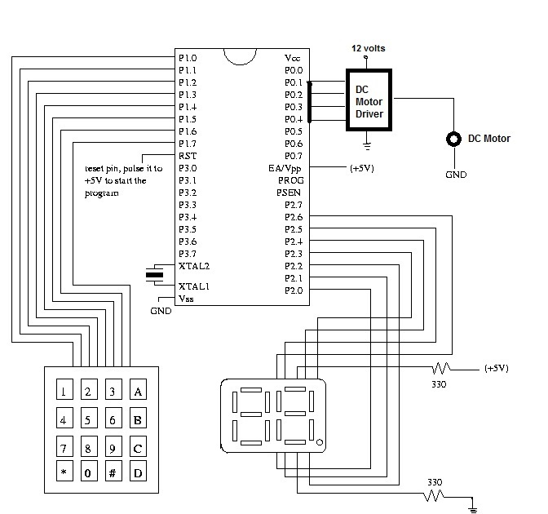

Design simple algorithms/pseudocode to be used in,
- Reading entering values using the numerical keyboard. (2 Marks)
- Display numerical values entered by the user. (2 Marks)
- Implement speed control on the motor. (2 Marks)
Supposing you notices that the actual speed of the motor is differing from the values displayed, as designer, what would you do to correct the problem? (2 Marks)

