
UNIVERSITY EXAMINATIONS
EXAMINATION FOR SEPT/DEC 2023/2024 FOR BACHELOR OF SCIENCE IN COMPUTER SCIENCE
RCS207: DATABASE SYSTEMS
DATE: 2ND DECEMBER 2024 TIME: 2 HOURS
GENERAL INSTRUCTIONS:
Students are NOT permitted to write on the examination question paper during examination time.
This is a closed book examination. Text book/Reference books/notes are not permitted.

SPECIAL INSTRUCTIONS:
This examination paper consists Questions in Section A followed by section B.
Answer Question 1 and any Other Two questions.
QUESTIONS in ALL Sections should be answered in answer booklet(s).

PLEASE start the answer to EACH question on a NEW PAGE.

Keep your phone(s) switched off at the front of the examination room.

Keep ALL bags and caps at the front of the examination room and DO NOT refer to ANY unauthorized material before or during the course of the examination.

ALWAYS show your working.

Marks indicated in parenthesis i.e. ( ) will be awarded for clear and logical answers.

Write your REGISTRATION No. clearly on the answer booklet (s).

For the Questions, write the number of the question on the answer booklet (s) in the order you answered them.
- DO NOT use your PHONE as a CALCULATOR.
- YOU are ONLY ALLOWED to leave the exam room 1 hour to the end of the Exam.
- DO NOT write on the QUESTION PAPER. Use the back of your BOOKLET for any calculations or rough work.

SECTION A (COMPULSORY)
QUESTION ONE (COMPULSORY, 30 MARKS).
- Study the Sales table below showing the order data, region, representative, time, Units, unit cost and total and write Sql statements to do the following
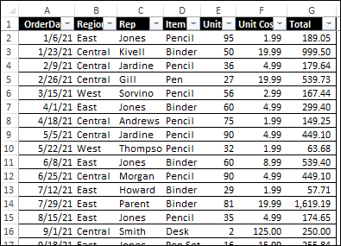
  - To select order date, region, representative for units between 45 to 60 in number (3 marks)
  - To select order date, region, representative for units ordered before June 2021 by Jones
(4 marks)
  - Display the average units per region. (4 marks)
- Introduce a field in the above table that would serve as a primary key (1 mark)
- Describe the steps that would need to be followed to achieve the third normal form for the above relation (3 marks)
- You have been contracted to develop a computerized database for Riara Group of schools. They are currently using a legacy system. Upon completion of the new system, describe the various costs associated with this development and transition (4 marks)
- Using relevant examples explain the difference between a One to One, One to Many and Many to Many relationships. (3 marks)
- Highlight the states involved in the life cycle of a database (8 marks)

SECTION B (ANSWER ANY TWO QUESTIONS)
QUESTION TWO
Case Study
The registrar at a small college wants an application that will help their department keep track of the schedule of classes, the courses and lecturers appearing in the schedule, and the students registering for courses according to the schedule.

Courses are scheduled every semester and this is documented in the schedule of classes, which also documents the lecturers assigned to each schedule of a class. Students register for courses according to the schedule of classes.

Required.
- Draw an entity relationship diagram for the above scenario showing cardinality and participation constraints (6 marks)
- Draw a logical design of the above system and propose some possible fields (4 marks)

- Explain the term referential integrity and how it can be implemented by the DBMS in the database schema above. (2 marks)
- List three different views that would be implemented in such a system assuming that the application will be hosted online. (3 marks)

QUESTION THREE (15 MARKS)
- List 5 common data definition statements as used in sql and give an example of how they can be used. (10 marks)

- Describe the application of 5 datatypes as used in SQL (5 marks)

QUESTION FOUR (15 MARKS)
- With the aid of a diagram discuss the ANSI-SPARC Architecture (6 marks)

- Briefly explain the relationships below.
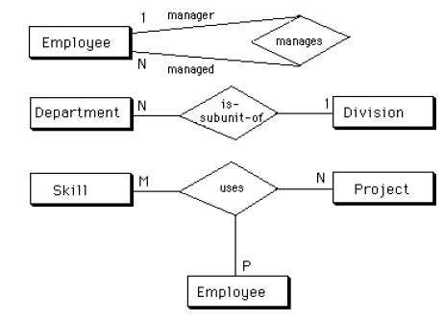 (6 marks)

- Describe the word abstract entity and give two examples for the same (3 marks)

QUESTION FIVE (15 MARKS)
- Given the scenario below for data extracted from sales records, draw a functional dependency diagram. (6 Marks)
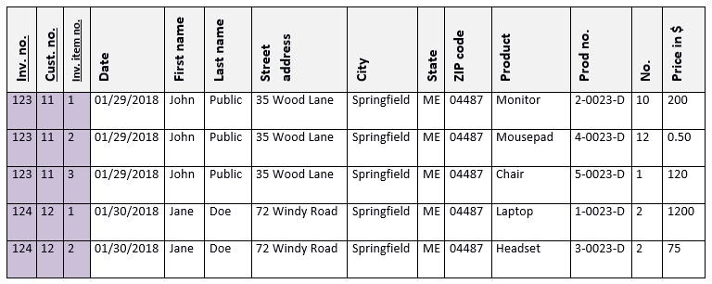
- From the functional dependency diagram, draw a logical schema showing all the field, including the primary and foreign keys. (5 marks)
- Discuss the activities involved in Logical database design. (4 marks)

