
UNIVERSITY EXAMINATIONS

EXAMINATION FOR JANUARY/APRIL 2023 /2024 FOR BACHELOR OF SCIENCE IN COMPUTER SCIENCE / BUSINESS INFORMATION TECHNOLOGY

RCS 307: EVENT PROGRAMMING/ PROGRAMMING LANGUAGES

DATE: 12TH APRIL, 2024 TIME: 2 HOURS

GENERAL INSTRUCTIONS:
Students are NOT permitted to write on the examination paper during examination time.
This is a closed book examination. Text book/Reference books/notes are not permitted.

SPECIAL INSTRUCTIONS:
This examination paper consists Questions in Section A followed by section B.
Answer Question 1 and any Other Two questions.
QUESTIONS in ALL Sections should be answered in answer booklet(s).

PLEASE start the answer to EACH question on a NEW PAGE.

Keep your phone(s) switched off at the front of the examination room and NOT on your person.

Keep ALL bags and caps at the front of the examination room and DO NOT refer to ANY unauthorized material before or during the course of the examination.

ALWAYS show your working.

Marks indicated in parenthesis i.e. ( ) will be awarded for clear and logical answers.

Write your REGISTRATION No. clearly on the answer booklet(s).

For the Questions, write the number of the question on the answer booklet(s) in the order you answered them.
- DO NOT use your PHONE as a CALCULATOR.
- YOU are ONLY ALLOWED to leave the exam room 30minutes to the end of the Exam.
- DO NOT write on the QUESTION PAPER. Use the back of your BOOKLET for any calculations or rough work.

SECTION A (COMPULSORY)

QUESTION ONE (30 Marks)

- List three benefits of Events Driven Programming Languages. (3 marks)

- Study the JFrame form displayed below.

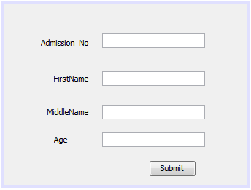
Explain the sequence of events required to enable this form to update a database table Patients using the following SQL statement. (4 marks)

INSERT INTO Students(Patient_No, FirstName,MiddleName,Age) VALUES('PatientNoText.getText()','FirstNameText.getText()','MiddleNameText.getText()','AgeText.getText()')

- Define the following terms in event programming: (4 marks)
- Event
- Container Class
- MouseMotionListener
- Java Foundation Class(JFC)

- List two advantages of event driven programs over program driven programs.
(2 marks)

- Functions or methods define object behaviour. Considering the components in either AWT of Swing class hierarchy, enumerate some of the methods in Java, used to work with or format components. (2 marks)

- In event driven programming, applications wait for unpredictable user input and responding to an event depends on a trigger. Illustrate a scenario that highlights this.
(3 marks)

- Differentiate between (4 marks)
- KeyEvents and ActionEvents
- Event Loops and Event Queues
- Sentinel value and counter controlled loops.

- Discuss the MVC approach to designing Event Driven solutions. Include a diagram.
(5 marks)

- Describe the three common types of errors encountered in event driven programming.
(3 marks)

SECTION B (Answer ANY Two Questions)

QUESTION TWO (15 Marks)

- Define: (2 marks)
- ActionListener
- Event Listener

- Differentiate between: (4 marks)
- Adjustment Events and
- Top level Containers and General Purpose Containers

- Computer networks play a critical role in communication. List any two network events. (2 marks)

- If you execute the following Java code used when creating event driven interfaces;

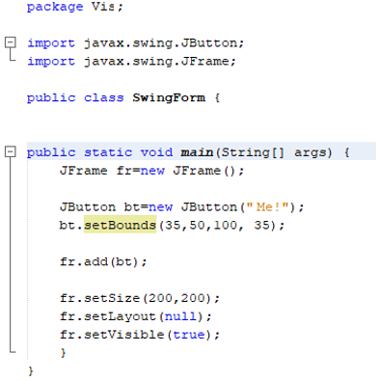
- Explain the output of the above code when it is executed. (3 marks)

- If the following Java code is executed.
package keyboardkeys;

import java.awt.event.KeyEvent;
import java.awt.event.KeyListener;
import javax.swing.JFrame;
import javax.swing.JPanel;
import javax.swing.JTextField;

public class KeyboardKeys {

public static class KeyListenerTest implements KeyListener{

public void keyTyped(KeyEvent e){
System.out.println("You typed: " + e.getKeyChar());
}
public void keyPressed(KeyEvent e){
System.out.println("You pressed: " + e.getKeyChar());
}
public void keyReleased(KeyEvent e){
System.out.println("You Released: " + e.getKeyChar());
}
}
public static void main(String[] args) {
JFrame frame=new JFrame();
JPanel panel=new JPanel();
JTextField field = new JTextField(15);
field.addKeyListener(new KeyListenerTest());
panel.add(field);
frame.getContentPane().add(panel);

frame.setDefaultCloseOperation(JFrame.DISPOSE_ON_CLOSE);
frame.setSize(300,300);
frame.setVisible(true);
}
}

- Describe how this program works. (2 marks)

- With reasons, what will be the output? (2 marks)

QUESTION THREE (15 Marks)

- Define (3 marks)
- Event Handler
- FocusListener
- Trigger Events

- Identify the parts labelled A, B, C and D of GUI used in event driven applications that require user interactions. (4 marks)
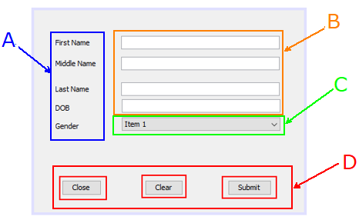

- Give the uses of the following (2 marks)
- JPanel
- BorderLayout

- Using a program segment with all the parts, explain the structure and output of a while loop control structure. (3 marks)

- Explain the following types of blocks used in exception handling when implementing event driven programs in Java.
(3 marks)
- Try block
- Throw block
- Catch block

QUESTION FOUR (15 Marks)

- With examples, define: (2 marks)
- Event Sources
- Adjustment Listener

- List two autonomous event sources that provide inputs to an event-driven program.
(2 marks)

- Describe the SUBMIT code shown: (2 marks)
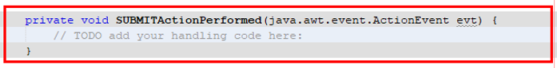

- Discuss AWT class hierarchy in Java. (4 marks)

- Using a program segment with all the parts, explain the structure and output of a do while loop control structure. (3 marks)

- Explain the meaning of the term memory management and discuss why memory management is a necessary part of event computer programming. (2 marks)

QUESTION FIVE (15 Marks)

- Define (4 marks)
- FlowLayout
- KeyListener
- Event Initiator
- Non-Functional features of Event Driven programs

- Differentiate: (4 marks)
- Label and JLabel components
- Polling and Delegating models of event handling

- Explain for loop control structure. Sketch the flow chart. (3 marks)

- Discuss Swing class hierarchy in Java. (4 marks)

