RIARA UNIVERSITY LIBRARY
MyLOFT User Guide

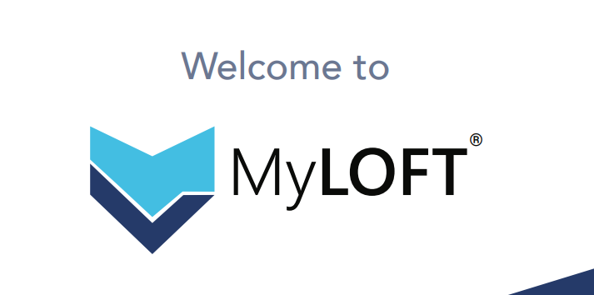

Why MyLOFT
MyLOFT stands for “My Library On Fingertips,”. MyLOFT is a web and mobile application designed for seamless access to your library subscribed e-resources.
MyLOFT serves as a personal library space to access, organize, download, share, and read a wide range of content online and offline.

DESKTOP

For desktop, you can use either Google Chrome or Microsoft Edge


DESKTOP SIGN UP
- Open Google Chrome or Microsoft Edge
Open the MyLOFT WebApp using the following URL: https://app.myloft.xyz
- Select your institution from the list: Riara University

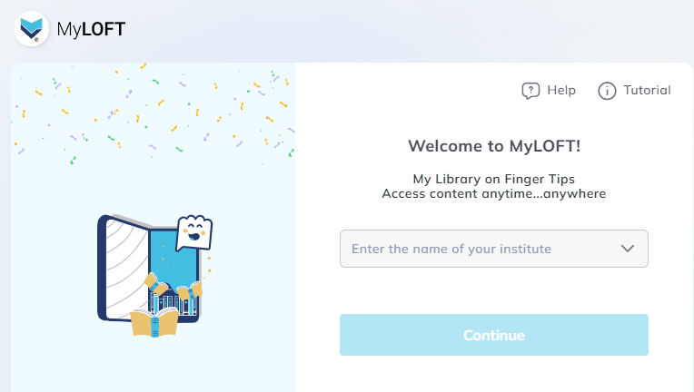
- Fill in your details (make sure you use Riara email address). Then Check the box to accept the terms of service and privacy policy. Click on Sign Up link.

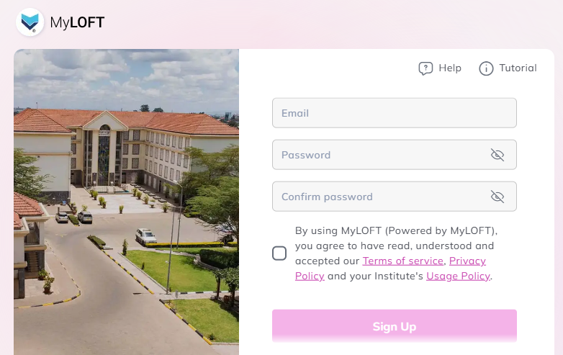

Your browser will display the message below.
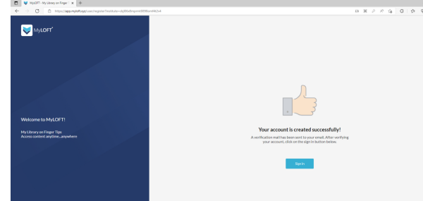

- Upon receiving an email from MyLOFT, follow prompt and click on Verify Your Email
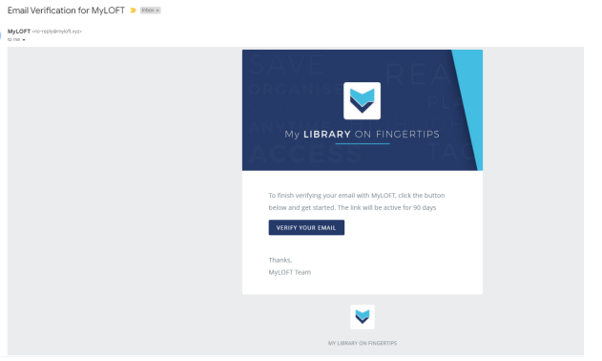

- After email verification, you will be automatically logged into MYLOFT.
- Your browser may prompt you to add an extension. Click on Add Extension.
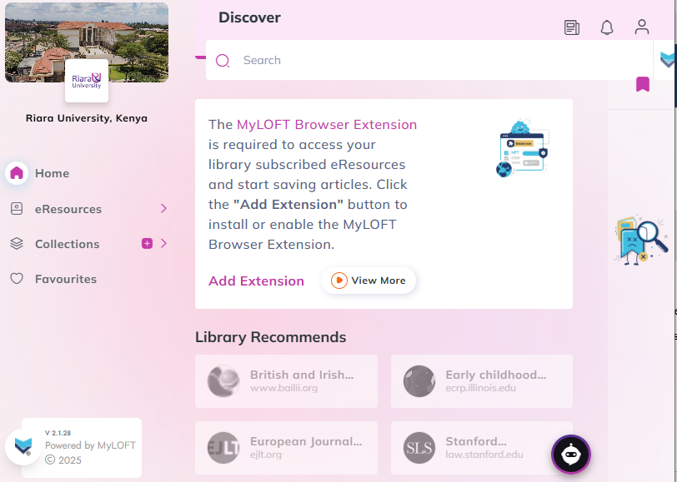

- You are now ready to use MYLOFT to search, retrieve, and share e-resources.
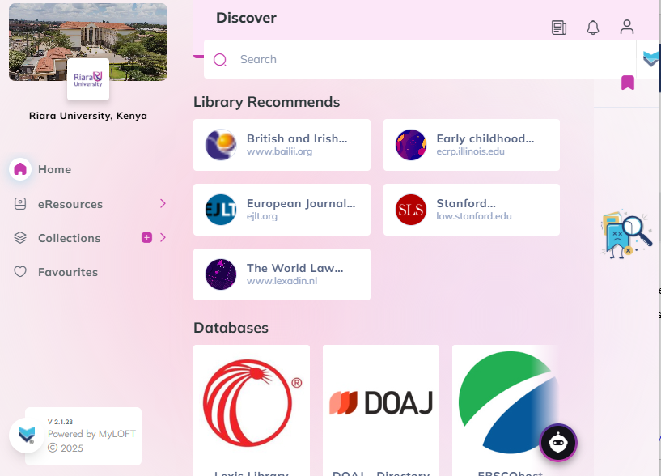

DESTOP SIGN IN
- Open Google Chrome or Microsoft Edge
Open the MyLOFT WebApp using the following URL: https://app.myloft.xyz
- Select your institution from the list: Riara University
- Enter your Registration Number, Full Name, and Riara email address and the password you had created for MYLOFT to sign in
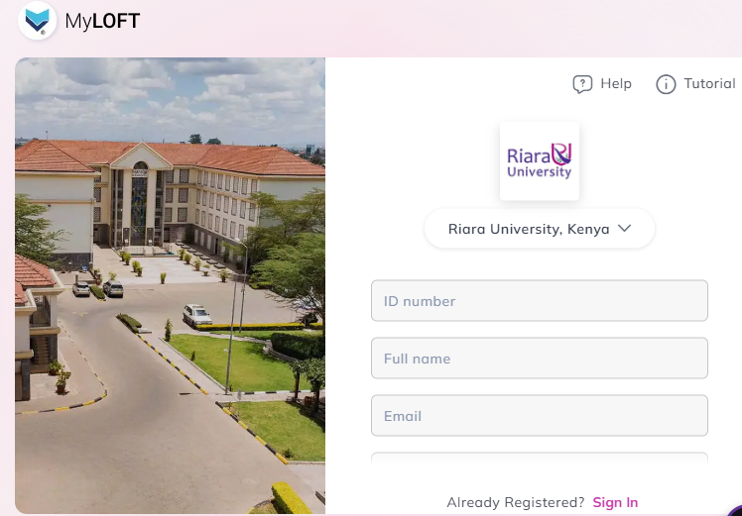

- You are now ready to use MYLOFT to search and retrieve e-resources.

FOR MOBILE DEVICES
For smartphones or tablets, download the MyLOFT app from:


MOBILE SIGN UP
- Go to Play Store and search, install and open MyLOFT App

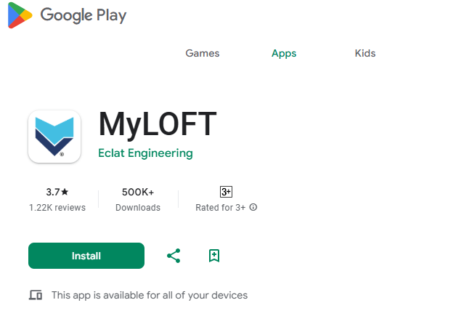

- Select your institution from the list:
Riara University
- Fill in your details (make sure you use Riara email address). Click on Sign Up link

- Upon receiving an email from MyLOFT, Click on Verify Your Email
- After email verification, you will be automatically logged into MyLOFT

MOBILE SIGN IN
- Open MyLOFT app on your mobile
- Select your institution from the list:
Riara University

- Enter your Riara email address and the password you had created for MYLOFT

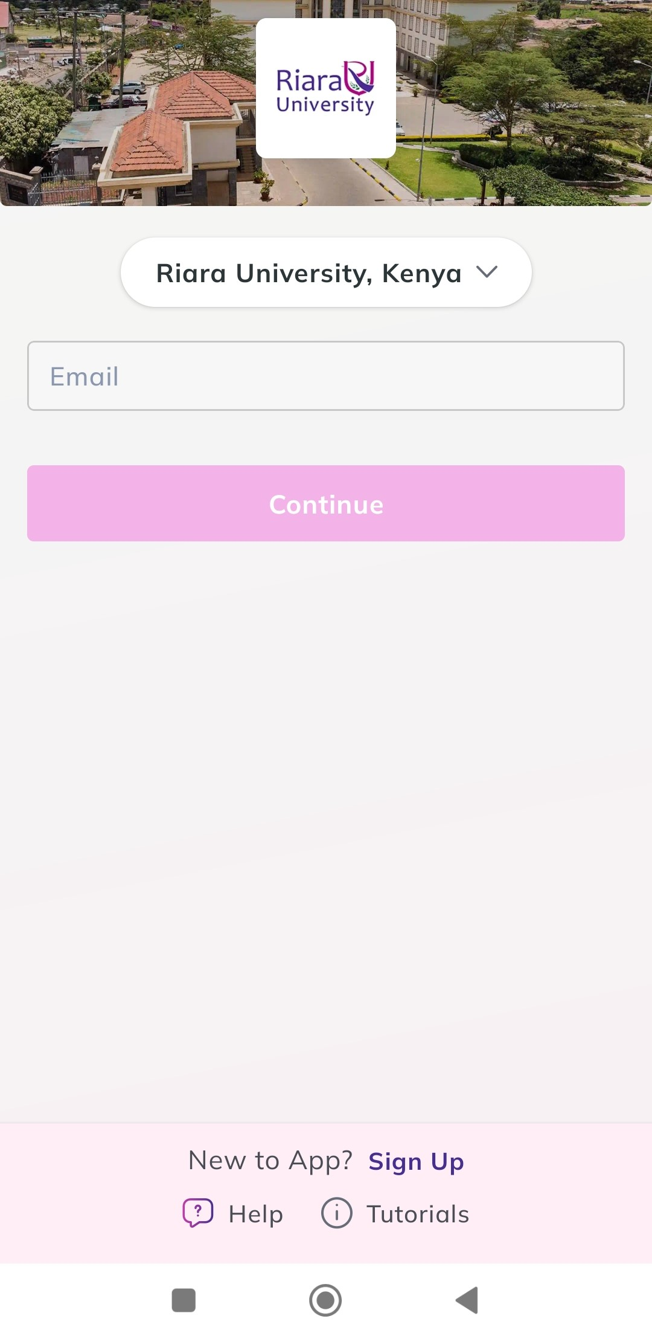
- Click on Sign in

- You are now ready to use MYLOFT to search and retrieve e-resources.

