
UNIVERSITY EXAMINATIONS
EXAMINATION FOR JANUARY / APRIL 2024/2025 FOR BACHELOR OF SCIENCE IN COMPUTER SCIENCE
COURSE CODE: RCS 210 COURSE TITLE: INTRODUCTION TO EMBEDDED SYSTEMS.

DATE: -- /-- /2025. TIME: 2 HOURS
GENERAL INSTRUCTIONS:
Students are NOT permitted to write on the examination paper during examination time.
This is a closed book examination. Text book/Reference books/notes are not permitted.

SPECIAL INSTRUCTIONS:
This examination paper consists Questions in Section A followed by section B.
Answer Question 1 and any Other Two questions.
QUESTIONS in ALL Sections should be answered in answer booklet(s).

PLEASE start the answer to EACH question on a NEW PAGE.

Keep your phone(s) switched off at the front of the examination room.

Keep ALL bags and caps at the front of the examination room and DO NOT refer to ANY unauthorized material during the course of the examination.

ALWAYS show your working.

Marks indicated in parenthesis i.e. ( ) will be awarded for clear and logical answers.

Write your REGISTRATION No. clearly on the answer booklet(s).

For the Questions, write the number of the question on the answer booklet cover page in the order you answered them.
- DO NOT use your PHONE as a CALCULATOR.
- YOU are ONLY ALLOWED to leave the exam room 1 hour to the end of the Exam.
- DO NOT write on the QUESTION PAPER. Use the back of your BOOKLET for any calculations or rough work.

SECTION A (COMPULSORY)

Question (1) - (30Marks)
- State FIVE technological fields / applications that embedded systems are deployed due to their desirable features. (5 Marks)

- Explain the following technologies as used in embedded system. (8 Marks)
- IoT.
- SoC.
- A.S.I.C.
- F.P.G.A.

- Define the following terms/abbreviations as used in the embedded systems. (8 Marks)
  - Sensors.
  - Actuators.
  - Transducers.
  - Microcontroller.

- State FIVE characteristics / classifications of embedded systems. (5 Marks)

- An Embedded systems designer needs to interface about 10 LCD displays (16 X 2 dot matrix), and a micro-SD card to a system in their project in a console room where workers can monitor and record various parameters of their systems.
- As embedded specialist, which communication protocols would you use, for interfacing, in both cases? (2 Marks)

- Justify your choices / options in the question above. (2 Marks)

SECTION B (Answer Any Two Questions)
Question (2) - (15 Marks)

- Discuss any FIVE components of an embedded system environments and their purpose as well as elaborate on how they operate generally. (5 Marks)

- Explain the purposes of the following hardware components of a typical Microcontroller. (8 Marks)
  - CPU.
  - Flash.
  - JTAG.
  - SRAM.
  - Timers.
  - Register.
  - Oscillator.
  - EEPROM.

- Describe boot loaders, as used in the embedded systems. (2 Marks)

Question (3) - (15 Marks)
- Define the term P.W.M. (1 Marks)

- Using suitable diagrams explained in details, how P.W.M. work. (4 Marks)
- How is P.W.M. used? state it’s applications in embedded systems. (2 Marks)

- Explain the purposes of the following in-built components of microcontrollers? (8 Marks)
- I.C.S.P.
- RC Oscillator.
- Real time clock.
- Watch dog timers.

Question (4) - (15 Marks)
- State FIVE, hardware related major factors to consider when choosing a microcontroller for use in an embedded system. (5 Marks)

- In details discuss how the actuators and sensors are interfaced as inputs and outputs of an embedded systems in a real-world environment. (6 Marks)

- With reference to programmable input and outputs GPIOs of microcontrollers.
- What is the purpose of DDR register. (2 Marks)
- Compare the G.P.I.O. to primary buses in microprocessors. (2 Marks)

Question (5) - (15 Marks)
- Describe the following communication protocols stating how they facilitate communication between microcontrollers, or other connected devices. (8 Marks)

- I²C.
- SPI.
- USART.
- UART.

- As an embedded system designer, you are required to develop an embedded system to incorporate a micro-controller to a multiplexed display system having 4 seven segment displays, as shown in the figure below.

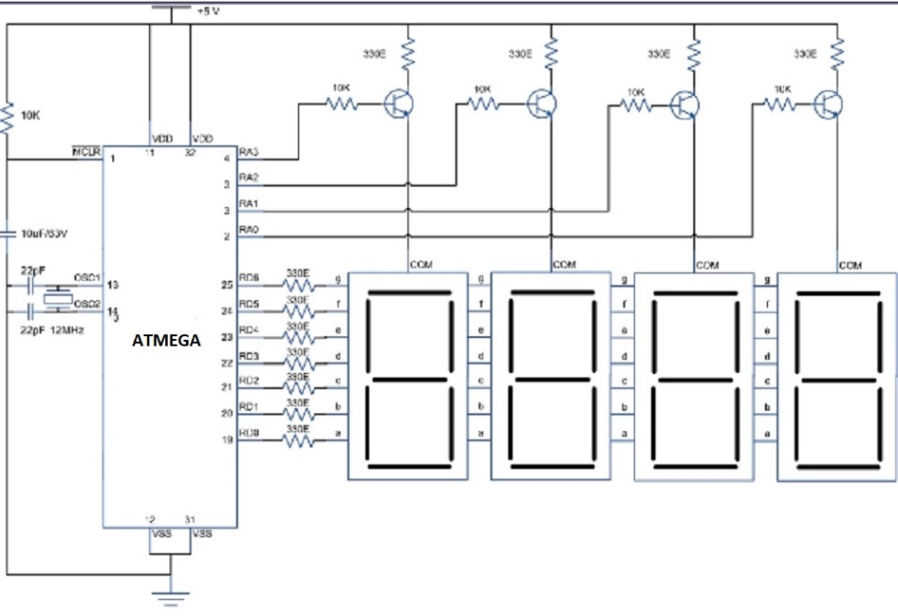

- Develop algorithms and pseudocode you would deploy to display four numerical characters on the multiplexed display shown above. (3 Marks)

- Write a simple program in any prevalent language used in embedded, systems to count numerically from [ 0000 to 9999], progressively. (4 Marks)

END

