
UNIVERSITY EXAMINATIONS

EXAMINATION FOR MAY/AUGUST 2022 /2023 FOR DIPLOMA IN COMPUTER SCIENCE / INFORMATION TECHNOLOGY

COURSE CODE: RCS 017
COURSE UNIT: OBJECT ORIENTED PROGRAMMING C++/JAVA

DATE: 31st JULY, 2023 TIME: 2 HOURS

GENERAL INSTRUCTIONS:
Students are NOT permitted to write on the examination paper during examination time.
This is a closed book examination. Text book/Reference books/notes are not permitted.

SPECIAL INSTRUCTIONS:
This examination paper consists Questions in Section A followed by section B.
Answer Question 1 and any Other Two questions.
QUESTIONS in ALL Sections should be answered in answer booklet(s).

PLEASE start the answer to EACH question on a NEW PAGE.

Keep your phone(s) switched off at the front of the examination room and NOT on your person.

Keep ALL bags and caps at the front of the examination room and DO NOT refer to ANY unauthorized material before or during the course of the examination.

ALWAYS show your working.

Marks indicated in parenthesis i.e. ( ) will be awarded for clear and logical answers.

Write your REGISTRATION No. clearly on the answer booklet(s).

For the Questions, write the number of the question on the answer booklet(s) in the order you answered them.
- DO NOT use your PHONE as a CALCULATOR.
- YOU are ONLY ALLOWED to leave the exam room 30minutes to the end of the Exam.
- DO NOT write on the QUESTION PAPER. Use the back of your BOOKLET for any calculations or rough work.

SECTION A (COMPULSORY)

QUESTION 1 ( 30 marks)

- Describe the SUBMIT code shown: ( 2 marks )
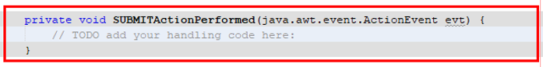
- Define the following terms: ( 3 marks)
- Object
- Algorithm
- Dynamic Binding

- Study the JFrame form displayed below.

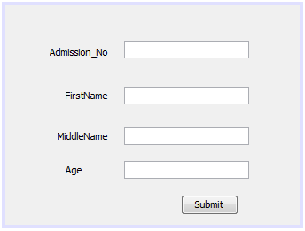
Explain the sequence of events required to enable this form to update a database table Students using the following SQL statement. ( 4 marks)

INSERT INTO Students(Admission_No, FirstName,MiddleName,Age) VALUES('AdmissionNoText.getText()','FirstNameText.getText()','MiddleNameText.getText()','AgeText.getText()')

- List two benefits of object oriented programming approach ( 2 marks)

- Functions or methods define object behaviour. Write a simple C++ or Java function called students that returns an integer. ( 3 marks)

- Identify the parts labelled A, B, C and D of GUI used in event driven applications that require user interactions. ( 4 marks)
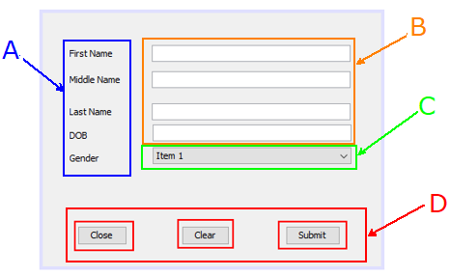

- Differentiate between ( 4 marks)
- Main function and other member functions.
- Sentinel value and counter controlled loops.

- Explain the following terminologies as used in Object Oriented Programming (OOP)
( 3 marks)
- Modularity
- Extensibility
- Reusability

- What public, protected, private access modifiers? ( 3 marks)
- Give the uses of the following ( 2 marks)
- Destructor
- Garbage Collector

SECTION B (Answer ANY Two Questions)

QUESTION 2 (15 marks)

- With examples, define: ( 3 marks)
- Polymorphism
- Dereferencing an object

- Explain the output of the following Java code when it is executed. ( 3 marks)

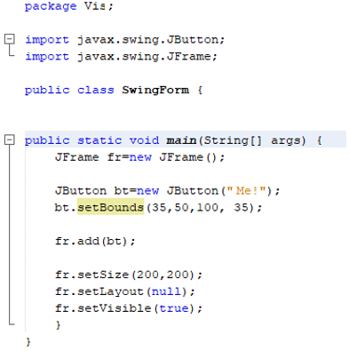

- Using a program segment with all the parts, explain the structure and output of a do while loop control structure. ( 5 marks)

- Explain the meaning of the term memory management and discuss why memory management is a necessary part of computer programming. ( 2 marks)

- Describe one application of polymorphism. ( 2 marks)

QUESTION 3 (15 marks)

- Define ( 2 marks)
- Object File
- Multiple Inheritance

- With a reason, what will be the output of the following Java statement? ( 2 marks)
System.out.println ("7" + 8);

- Differentiate between method overloading and method overriding ( 2 marks)

- Explain for loop control structure. Sketch the flow chart. ( 4 marks)

- What happens when a function throws an exception that was not specified by an exception specification for this function in Java? ( 1 mark)

- Describe the output of the following code segment ( 2 marks)
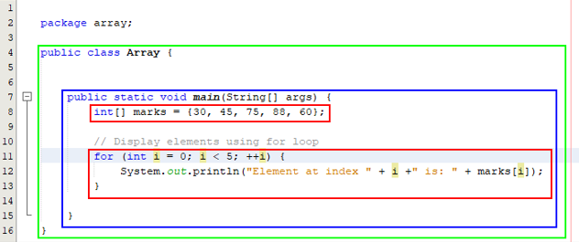

- Describe one application of inheritance. ( 2 mark)

QUESTION 4 (15 marks)

- Define ( 2 marks)
- Public Inheritance
- Exception Handling

- Describe the output of the following code. ( 3 marks)
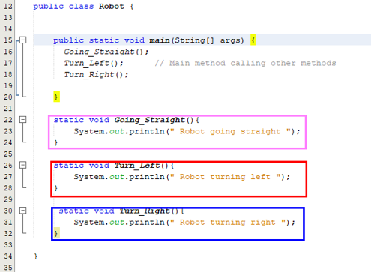
- Give the uses of the following ( 2 marks)
- Compiler
- Pointers

- Using a program segment with all the parts, explain the structure and output of a while loop control structure. ( 3 marks)

- Expound on the following types of blocks used in exception handling in Java.
( 3 marks)
- Try block
- Throw block
- Catch block

- Describe one application of encapsulation. ( 2 marks)

QUESTION 5 (15 marks)

- Define a Class scope ( 1 mark)

- If you execute the following C++ code;

#include <iostream>
using namespace std;

int main () {
// local variable declaration as used in a car showroom:
char car = 'G';
switch(car) {
case 'T' : cout << "Toyota!" << endl;
break;
case 'S' : case 'C' : cout << "Subaru" << endl;
break;
case 'N' : cout << "Nissan!" << endl;
break;
case 'X' : cout << "Order another car!" << endl;
break;
default: cout << "Unregistered car!" << endl;
}
cout << "Your choice is " << car << endl;
return 0;
}

- Explain the output of the above code. ( 2 marks)

- Change the char grade from char juice = ‘G’ to char car = ‘N’. Describe the new output of the executed code. ( 2 marks)

- What is the importance of break statement? ( 2 mark)

- Discuss the software development life cycle (SDLC). ( 3 marks)

- If the following Java code is executed.
package keyboardkeys;

import java.awt.event.KeyEvent;
import java.awt.event.KeyListener;
import javax.swing.JFrame;
import javax.swing.JPanel;
import javax.swing.JTextField;

public class KeyboardKeys {

public static class KeyListenerTest implements KeyListener{

public void keyTyped(KeyEvent e){
System.out.println("You typed: " + e.getKeyChar());
}
public void keyPressed(KeyEvent e){
System.out.println("You pressed: " + e.getKeyChar());
}
public void keyReleased(KeyEvent e){
System.out.println("You Released: " + e.getKeyChar());
}
}
public static void main(String[] args) {
JFrame frame=new JFrame();
JPanel panel=new JPanel();
JTextField field = new JTextField(15);
field.addKeyListener(new KeyListenerTest());
panel.add(field);
frame.getContentPane().add(panel);

frame.setDefaultCloseOperation(JFrame.DISPOSE_ON_CLOSE);
frame.setSize(300,300);
frame.setVisible(true);
}
}

- Describe how this program works. ( 3 marks)

- With reasons, what will be the output? ( 2 marks)

