

Riara School of Business

Nurturing business innovators

JANUARY-APRIL 2026 TRIMESTER EXAMINATIONS

EVENING PROGRAMME

EXAMINATION FOR BACHELOR OF BUSINESS ADMINISTRATION

RBHR 7421: STRATEGIC HUMAN RESOURCE MANAGEMENT

DATE: APRIL 2026 TIME: 2 HOURS

GENERAL INSTRUCTIONS:

Students are NOT permitted to write on the examination paper during reading time.
This is a closed book examination. Text book/Reference books/notes are not permitted.

SPECIAL INSTRUCTIONS:

- Write your REGISTRATION NO. Clearly on the answer booklet(s).
- Answer Question ONE (COMPULSORY) and Any other Two Question.
- Questions in all sections should be answered in answer booklet(s).
- Marks allocated to each question are shown at the end of the question.
- PLEASE start the answer to EACH question on a NEW PAGE.
- For the questions, write the number of the question on the answer booklet(s) in the order you answered them.
- Write your answers in paragraph form unless stated otherwise.
- Keep your phone(s) SWITCHED OFF at the front of the examination room and NOT on your person.
- Keep ALL bags and caps at the front of the examination room and do not refer to any unauthorized material before or during the course of the examination.
- You are only allowed to leave the examination room 30minutes to the end of the Examination.

QUESTION ONE - 30 MARKS

NexGen Solutions Ltd is a fast-growing digital services company operating in East Africa. The firm competes on innovation, speed, and superior customer experience. In recent years, NexGen has expanded into cloud computing, e-commerce solutions, and digital consulting.
Despite its growth, NexGen faces significant HR challenges. Employee turnover is high, training initiatives are inconsistent, performance management focuses mainly on short-term targets, and leadership succession planning is weak. Additionally, the organization has recently adopted a hybrid working model, but managers lack the skills to effectively manage virtual and distributed teams.
Senior management now intends to transform the HR department into a strategic partner that supports long-term organizational success. They seek to strengthen strategic alignment, workforce planning, HR analytics, leadership development, diversity and inclusion, and sustainable HR practices.

Questions:
- Explain FIVE Strategic Human Resource Management practices that NexGen Solutions Ltd should adopt in order to align its HR systems with its business strategy.
(10 marks)

(i) Analyze THREE mechanisms through which NexGen can achieve vertical alignment between its business strategy and HR practices. (6 marks)
(ii) Illustrate TWO ways in which NexGen can achieve horizontal alignment among its HR practices. (4 marks)
- Strategic HRM Crossword Puzzle (10 marks)
Complete the crossword puzzle below by providing the correct Strategic HRM terms.
Across
3. Organizational values, beliefs, and shared assumptions shaping behavior. (C)
- HR approach that focuses on internal consistency among HR practices. (H)
- Alignment between HR practices and business strategy. (V)
- A bundle of HR practices designed to improve organizational performance. (H)
- Planned approach to acquiring, developing, and retaining high-performing employees. (T)
- Long-term approach to managing people for organizational success. (S)

Down
- System used to assess and improve employee performance. (P)
- The process of forecasting future human resource requirements. (W)
4. Systematic use of HR data for evidence- based decision-making. (A)
8. Compensation provided to employees in return for their contribution. (R)

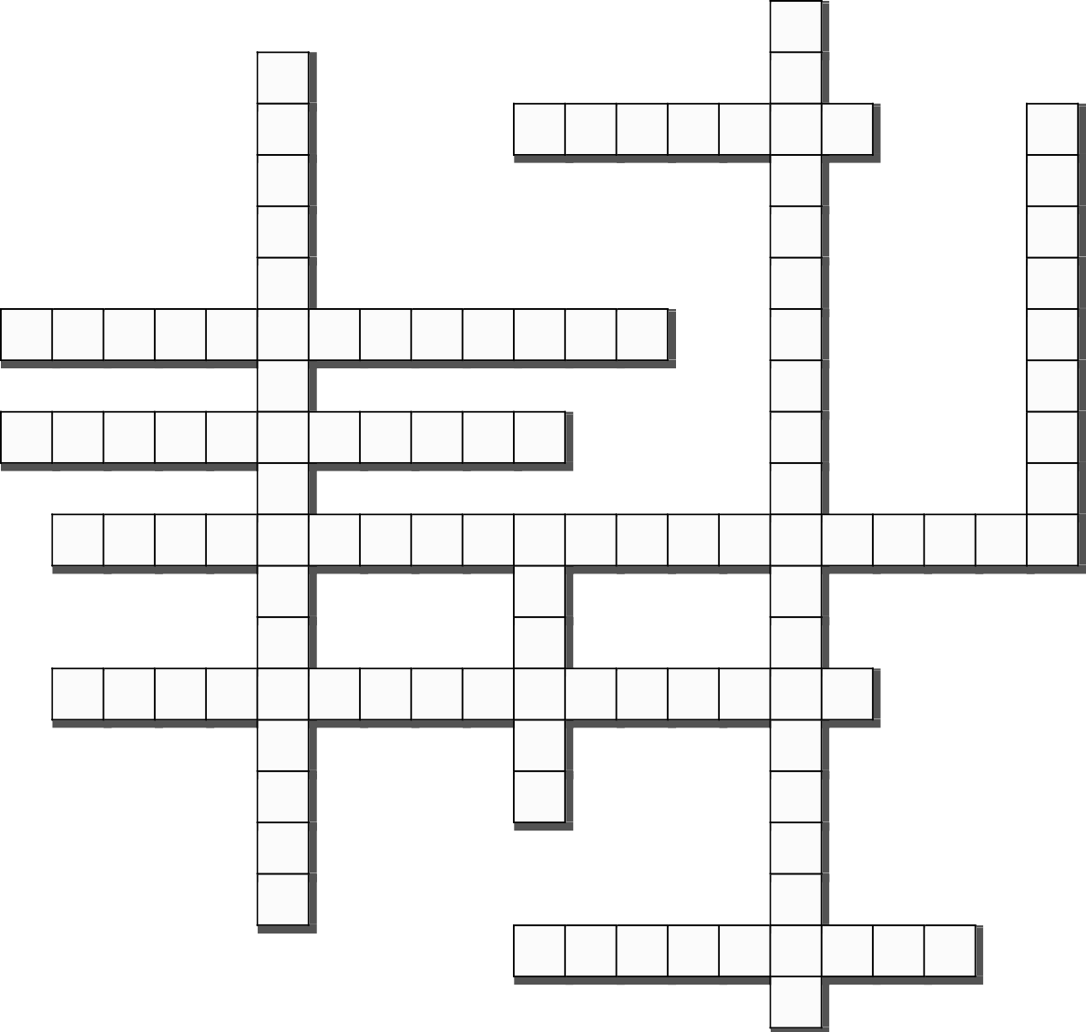
1
2
3
4
5
6
7
8
9
10

NB: First word clue provided after each cue statement above.

QUESTION TWO

- Assess FIVE strategic benefits of workforce planning in achieving organizational effectiveness. (10 marks)
- Discuss FIVE talent management practices that organizations use to enhance employee performance and retention. (10 marks)

QUESTION THREE
- Analyze FIVE impacts of hybrid work arrangements and HR digital technologies on strategic HR decision making. (10 marks)
- Propose FIVE strategic HR initiatives that organizations can implement to advance diversity, equity and inclusion (DEI) and sustainable HRM (ESG) objectives. (10 marks)
QUESTION FOUR
- Evaluate FIVE ways in which strategic reward systems influence employee motivation, commitment and productivity. (10 marks)
- Examine FIVE roles of performance management systems in achieving organizational strategic objectives. (10 marks)

