
UNIVERSITY EXAMINATIONS
EXAMINATION FOR SEPTEMBER/DECEMBER 2023/2024 DIPLOMA IN COMPUTER SCIENCE AND DIPLOMA IN INFORMATION TECHNOLOGY

RCS/RIT 019: INTRODUCTION TO STATISTICS
DATE: 27TH NOVEMBER, 2023
GENERAL INSTRUCTIONS:
Students are NOT permitted to write on the examination paper during examination time. This is a closed-book examination. Textbooks/Reference books/notes are not permitted.
SPECIAL INSTRUCTIONS:
This examination paper consists of Questions in Section A followed by Section B. Answer Question 1 and any Other Two questions.
QUESTIONS in ALL Sections should be answered in the answer booklet(s).
- PLEASE start the answer to EACH question on a NEW PAGE.
- Keep your phone(s) switched off at the front of the examination room.
- Keep ALL bags and caps at the front of the examination room and DO NOT refer to ANY unauthorized material before or during the course of the examination.
- ALWAYS show your workings.
- Marks indicated in parenthesis i.e. ( ) will be awarded for clear and logical answers.
- Write your REGISTRATION No. clearly on the answer booklet(s).
- For the Questions, write the number of the question on the answer booklet(s) in the order you answered them.
- DO NOT use your PHONE as a CALCULATOR.
- YOU are ONLY ALLOWED to leave the exam room 30 minutes to the end of the Exam.
- DO NOT write on the QUESTION PAPER. Use the back of your BOOKLET for any calculations or rough work.

SECTION A (COMPULSORY) QUESTUION ONE (30 Marks)
- Differentiate between Discrete and Continuous Variables giving examples in each
(4 Marks)
- What is a Time Series?
(1 Mark)
- State the differences between primary and secondary data. State the methods used to collect each type of data.
(4 Marks)
- Define the following terminologies as used in statistics.
(3 Marks)
- Data
- Information
- Parameter
- A company is analyzing the monthly incomes of its employees. They collect data from a random sample of 100 employees and find that the mean monthly income is Kshs 50,000, while the median income is Kshs 42,000.
- Based on this information, do you think the income data is positively skewed, negatively skewed, or roughly symmetrical? Give a reason for your answer
(2 Marks)
- Explain why understanding the skewness of income data is important for the company's financial planning and employee compensation strategies.
(2 Marks)
- Differentiate between Population and Sample giving an example in each
(4 Marks)
- Briefly explain the four time series components in time series analysis
(4 Marks)
- When is Laspeyres most appropriate and when is Paasche the better choice? Explain using their advantages and disadvantages.
(4 Marks)
- Distinguish the two categories of applied statistics.
(2 Marks)

SECTION B (ANSWER ANY TWO QUESTIONS – TOTAL: 30 MARKS)

QUESTION TWO (15 MARKS)
- Distinguish the Exclusive Method from the Inclusive Method of class interval determination. (4 Marks)

- The following data represents coffee weights for 50 farmers in a particular week, weights range from 0 to 100.
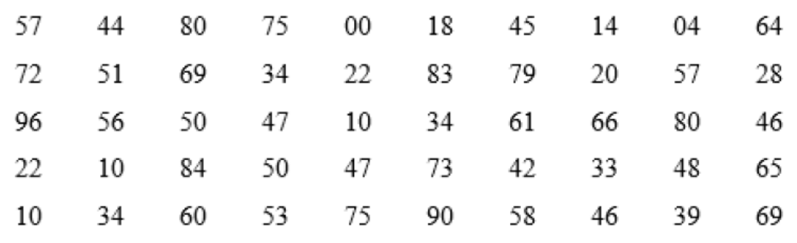
- Calculate class interval given that weights are grouped into 10 classes
(2 Marks)
- Using the class width in (i) above, create a frequency distribution table. Use Exclusive Method. (5 Marks)

- Discuss Any Two types of classifications giving examples in each
(4 Marks)

QUESTION THREE (15 MARKS)
- Explain the significance of statistics in the fields of business, economics, and government. (6 Marks)

- Imagine you are an economic analyst working for a government agency. Your task is to provide a comprehensive report on the uses of the Consumer Price Index (CPI) to inform policymakers and the public. Identify four specific real-world scenarios or situations where the CPI plays a crucial role in economic decision-making. (5 Marks)

- Imagine you are working as a data analyst for a marketing research firm. Your client is a company launching a new product in a competitive market. They have requested a comprehensive market analysis report. Explain the stages of statistical investigation you will use and how each stage is crucial in conducting a market analysis for your client. Provide specific examples and scenarios to illustrate each stage's significance in ensuring the product launch's success. (10 Marks)

QUESTION FOUR (15 MARKS)
- Differentiate between positive and negative correlations, and provide a real-world example for each type. (4 Marks)

- Explain three key steps for analyzing the relationship between different series of data in correlation analysis. (3 Marks)

- Explain Any Two methods for measuring the secular trend in a time series. (4 Marks)

- A set of values has a mean of 22 and a standard deviation of 3. Find the z-score for a value of 24. Interpret the z-score. (4 Marks)

QUESTION FIVE (15 MARKS)
- The following scores represent students' marks in a statistics class;
50, 60, 75, 68, 80, 65, 60, 75, 82
- Determine the mode and state which type of mode it is. (2 Marks)
- Calculate;
Median (2 Marks)

Mean (2 Marks)

Variance (2 Marks)

Lower quartile (3 Marks)

Upper quartile (2 Marks)

Interquartile range (2 Marks)

