
UNIVERSITY EXAMINATIONS
EXAMINATION FOR SEP/DEC 2024/2025 FOR BACHELOR OF SCIENCE IN COMPUTER SCIENCE AND BACHELOR OF BUSINESS INFORMATION TECHNOLOGY
RCS303: WIRELESS NETWORKS
DATE: 11TH DECEMBER 2024 TIME: 2 HOURS
GENERAL INSTRUCTIONS:
Students are NOT permitted to write on the examination question paper during examination time.
This is a closed book examination. Text book/Reference books/notes are not permitted.

SPECIAL INSTRUCTIONS:
This examination paper consists Questions in Section A followed by section B.
Answer Question 1 and any Other Two questions.
QUESTIONS in ALL Sections should be answered in answer booklet(s).

PLEASE start the answer to EACH question on a NEW PAGE.

Keep your phone(s) switched off at the front of the examination room.

Keep ALL bags and caps at the front of the examination room and DO NOT refer to ANY unauthorized material during the course of the examination.

ALWAYS show your working.

Marks indicated in parenthesis i.e. ( ) will be awarded for clear and logical answers.

Write your REGISTRATION No. clearly on the answer booklet(s).

For the Questions, write the number of the question on the answer booklet cover page in the order you answered them.
- DO NOT use your PHONE as a CALCULATOR.
- YOU are ONLY ALLOWED to leave the exam room 1 hour to the end of the Exam.
- DO NOT write on the QUESTION PAPER. Use the back of your BOOKLET for any calculations or rough work.

SECTION A: Answer ALL questions in this section.

QUESTION ONE (30 Marks)
- Discuss the meaning of following terminologies in relations to Wireless Networks (10Marks)

- Wireless Network’s Performance
- Reliability of Wireless Network
- Wireless Networks Protocol
- Wireless Network Access Point
- Wireless Networks Middleware Software

- Explain THREE critical issues that should be included in effective and efficient wireless network policy in an organization (Give examples for each issue stated). (6 Marks)

- The performance of a wireless network is strongly influenced by five major characteristics: the bandwidth of the network (that is, how many bits/sec it can transport) and the latency (that is, how many seconds it takes for the first bit to get from the client to the server). Compare and contrast TWO examples of a network that exhibits high bandwidth but also has high latency with one that has both low bandwidth and low latency
(5 Marks)

- One disadvantage of an IP broadcast subnetting in a wireless network is the capacity wastage when multiple hosts attempt to access the channel at the same time. Explain how it is possible for a sequence of packets transmitted through a wide area wireless network to arrive at their destination in an order that differs from that in which they were sent in comparison to a local LAN network (5 Marks)

- Describe the FOUR critical differences between the physical networks mediums for fixed-wireless Ethernet, Wi-Fi, Zigbee and Bluetooth in wireless networks (4 Marks)

SECTION B: Answer any Two questions. Use short answers (40 Marks).

QUESTION TWO (20 Marks)

- Explain how a smartphone user who arrives at Standard Gauge Railway (SGR) station that s/he has never visited before would be capable of using the same wireless network IP Address without alighting from the SGR coach (5 Marks)

(b) Discuss how the smartphone user could be provided with information about the local services and amenities at that SGR railway station without entering the station’s name or attributes (10 Marks)
(c) Describe technical challenges the smartphone user may need to overcome in his/her journey (5 Marks)
QUESTION THREE (20 Marks)
(a) Compare and contrast THREE challenges you may face when implementing a Wireless Network Project in an institution such as Riara University. Suggest example of your mitigation for each challenge (6 Marks)
(b) Explain what happens to your device MAC address and the IP address when your wireless device is moved from one WLAN location to another WLAN location withing the campus compound (4 Marks)
(c) Discuss the role of communication security, digital signature and authentication protocols in a Wireless Networks (6 Marks)

(d) In a largely wireless network environment, such as Kenya, where everyone who has a personal mobile device is connected to Internet, instant public referendums on important pending legislation will become possible. Ultimately, existing legislatures could be eliminated to let the will of the people be expressed directly. The negative aspects of such a direct democracy are fairly obvious; discuss FOUR of the positive aspects. (4 Marks)

QUESTION FOUR (20 Marks)
(a) Discuss the THREE main advantages of wireless network data processing in comparison to the physical systems (6 Marks)

(b) Describe how the Wireless Networks implement fault tolerance and recovery processes (4 Marks)

(d) Figure 3.1 below is a sample of a ticket recently obtained from one of the toll stations along the Nairobi Moja Expressway Road services. Describe FIVE ways in which the management have adopted the emerging communication technologies (10 Marks)


Figure 3.1. Nairobi Expressway
Payment Voucher

QUESTION FIVE (20 Marks)
(a) Wireless Network devices and services are known to leave traceable digital footprints whenever they have been used. Discuss FIVE ways into which a digital device usage may be tracked. Give examples (10 Marks)

(b) Figure 5.1 is a proposal for Wireless Network Project concept designed for connecting an upcoming Riara University (RU) Annex Campus along Raila Odinga Road just across the Main Campus. Compare and contrast FOUR challenges you may face when implementing the new project (include the mitigation procedures) (10 Marks)


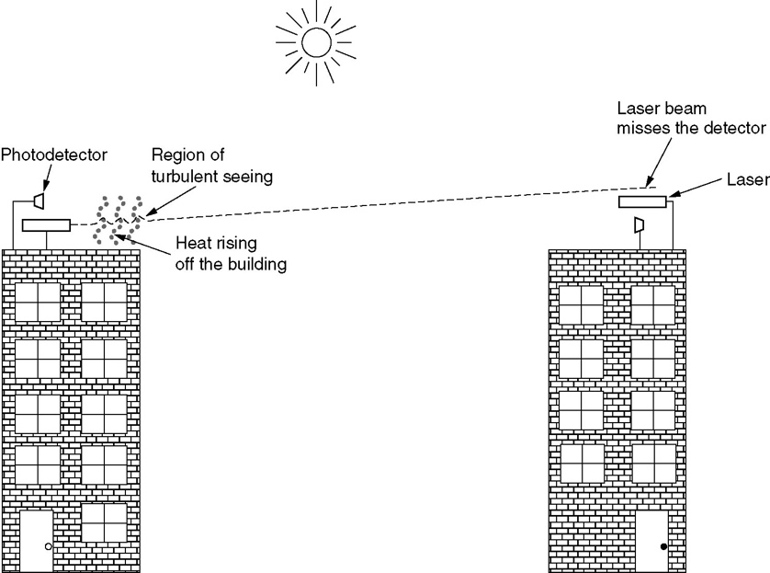
Main RU
Campus
Annex Campus
Block
Access Point B
Access Point A
Raila Odinga Road

Figure 5.1 New RU Wireless Network Project Design

