
UNIVERSITY EXAMINATIONS
EXAMINATION FOR JANUARY/APRIL 2025/2026 MASTERS OF SCIENCE IN COMPUTER SCIENCE

MRDC 9211: ADVANCED STATISTICAL METHODS FOR DATA SCIENCE

DATE : 7TH APRIL 2026 TIME: 2 HOURS

GENERAL INSTRUCTIONS:
Students are NOT permitted to write on the examination question paper during examination time.
This is a closed book examination. Text book/Reference books/notes are not permitted.

SPECIAL INSTRUCTIONS:
This examination paper consists of FOUR questions. Attempt Any Three Questions.
QUESTIONS selected should be answered in answer booklet(s).

PLEASE start the answer to EACH question on a NEW PAGE.

Keep your phone(s) switched off at the front of the examination room.

Keep ALL bags and caps at the front of the examination room and DO NOT refer to ANY unauthorized material during the course of the examination.

ALWAYS show your working.

Marks indicated in parenthesis i.e. ( ) will be awarded for clear and logical answers.

Write your REGISTRATION No. clearly on the answer booklet(s).

For the Questions, write the number of the question on the answer booklet cover page in the order you answered them.
- DO NOT use your PHONE as a CALCULATOR.
- YOU are ONLY ALLOWED to leave the exam room 1 hour to the end of the Exam.
- DO NOT write on the QUESTION PAPER. Use the back of your BOOKLET for any calculations or rough work.

QUESTION ONE (TWENTY MARKS)
- (i). What is time series. (1 Mark)
(ii). What is a time series data? (1 Mark)
(ii). State any four uses of time series (2 Marks)

- Using the following foreign exchange rates observed for the last twelve
months for The Euro and Kshs. Forecast the exchange price for January
next year using the exponential smoothing with a smoothing index of
.

Month Exchange Price(Y)
January 99
February 104
March 112
April 97
May 95
June 98
July 94
August 91
September 87
October 111
November 103
December 106
(7 Marks)

- A questionnaire titled “Women Executives: The Road to the Top” was given to the students of statistics. The respondent gave a score of 0- 10 for each of the three questions. The questions are summarized below:

- Track record is the most important success factor in a woman’s career.
- Women are likely to be more successful in-service industries.
- To succeed, a woman must appear as tough as a man.

The collected data is presented below.

Question
______________________________________

Respondent 1 2 3
______________________________________
1 8 6 6
2 6 5 2
3 9 7 4
4 3 5 3
5 3 4 5
6 4 3 7
Obtain
- the mean vector (3 marks)
- the sample covariance matrix (6 marks)

QUESTION TWO (TWENTY MARKS)
- (i). What is the goal of descriptive determinant analysis? (2 Marks)
(ii). Define discriminant function. (2 Marks)

- Perspiration for 10 healthy females was analyzed. The three components,
sweat rate
sodium content
potassium content
were measure and the results are as provided below.

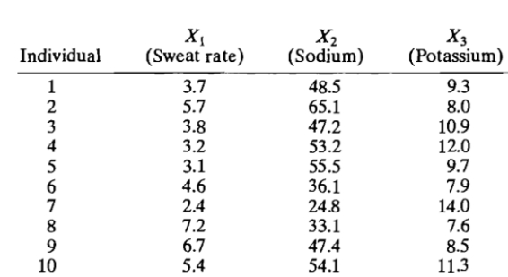

Test at $α=10 \%$ level of significance $H_{0}: \underline{μ}=(4, 50, 10)$
against $H_{1}: \underline{μ}≠(4, 50, 10)$. Given $T_{0.1,3,9}^{2}=32.5980$ (16 Marks)

QUESTION THREE (TWENTY MARKS)

- (i). Why do we need smoothing of a time series? (1 Marks)

(ii). Using moving averages differentiate between, weighted and un-weighted,
smoothing of time series. (4 Marks)

- (i). Describe method of Ordinary Least squares as used in fitting trend in
time series analysis. (3 Marks)

(ii). The following data shows the price of the stock from January to December of a given year. Forecast the price for January next year by use of Ordinary Least Squares.

Month Price(Y)
January 40
February 38
March 39
April 41
May 36
June 41
July 34
August 37
September 35
October 37
November 40
December 41
(12 Marks)

QUESTION FOUR (TWENTY MARKS)
- Differentiate between;
- A statistic and a parameter. (2 Marks)
- Simple random sampling and systematic random sampling. (2 Marks)

- Consider a population of 5 units, taking values 0, 2, 11, 5, 21.

- Write down all samples of size 2 with their respective means when sampling without replacement. (2 Marks)
- Compute then Grand mean and standard error. (6 Marks)

- An advertising firm, interested in determining how much to emphasize television advertising in a certain country decides to conduct a sample survey to estimate the average number of hours each week that households within that country watch television. The country has two towns, A and B, and a rural area C. Town A is built around a factory and most households contain factory workers with school-aged children. Town B contains mainly retirees and the rural area C are mainly farmers. There are 155 households in town A, 62 in town B and 93 in the rural area, C. The firm decides to select 20 households from Town A, 8 households from Town Band 12 households from the rural area.

The data are given in the following table

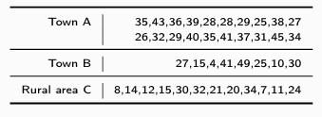

Using stratified random sampling notations

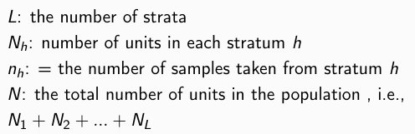

- compute the overall mean for this example is (2 Marks)
- Compute the overall variance of the estimator of mean. (2 Marks)
- Provide a 95% CI for µ and also a 95% CI for τ. (use$t=21$)
(4 Marks)

