
UNIVERSITY EXAMINATIONS
EXAMINATION FOR MAY-AUGUST 2024/2025 DIPLOMA IN COMPUTER SCIENCE /INFORMATION TECHNOLOGY/INFORMATION & CYBER SECURITY
RCS 024: WEB DEVELOPMENT
DATE: __________ TIME: 2 HOURS
GENERAL INSTRUCTIONS:
Students are NOT permitted to write on the examination paper during exam time.
This is a closed book examination. Text book/Reference books/notes are not permitted.
SPECIAL INSTRUCTIONS:
This examination paper consists Questions in Section A followed by section B.
Answer Question 1 and any Other Two questions.
QUESTIONS in ALL Sections should be answered in answer booklet(s).

PLEASE start the answer to EACH question on a NEW PAGE.

Keep your phone(s) switched off at the front of the examination room.

Keep ALL bags and caps at the front of the examination room and DO NOT refer to ANY unauthorized material before or during the course of the examination.

ALWAYS show your working.

Marks indicated in parenthesis i.e. ( ) will be awarded for clear and logical answers.

Write your REGISTRATION No. clearly on the answer booklet(s).

For the Questions, write the number of the question on the answer booklet(s) in the order you answered them.
- DO NOT use your PHONE as a CALCULATOR.
- YOU are ONLY ALLOWED to leave the exam room 30minutes to the end of the Exam.
- DO NOT write on the QUESTION PAPER. Use the back of your BOOKLET for any calculations or rough work.

SECTION A (COMPULSORY)
QUESTION ONE (30 Marks)
- Differentiate between peer to peer and client-server computer network architectures. [2 Marks]
- Explain the following CSS selector options
- Name selector
- ID selector
- Class selector [ 3 Marks]
- Write JavaScript program to implements a function ComputeArea, that calculates area of a rectangle and display the results on the page. [5 Marks]
- Explain Four Html Tags that used to define the structure of a page. [4 Marks]
- Explain the purpose of following stages during a web application development.
- Analysis,
- Design,
- Development,
- Testing and review,
- Deployment,
- Maintenance [6 Marks]
- List and explain any Three JavaScript events that can be used in front-end development. [3 Marks]
- Explain the effect of each of the following CSS script on a form’s input elements.
input {
width: 80%;
border: 3px solid green;
background-color: pink;
font-size: 18px;
} [4 Marks]
- Outline any Three qualities of a professional website [3 Marks]
SECTION B (Answer ANY Two Questions)
QUESTION TWO (15 Marks)
- Explain the following PHP code segment line by line
- <?php
- $fname = "Mark";
- $age = 22;
- echo "first name: $fname";
- echo "Aged: $age";
?> [5 Marks]
- Differentiate between the Internet and the intranet. [2 Marks]
- Write HTML script that would generate the following nested list.
- Dekstop computers
- HP
- Dell
- Laptops
- Lenovo
- Toshiba [6 Marks]
- Explain the outcome of the following style application
<body style="background-color:blue;" > [2 Marks]
QUESTION THREE (15 Marks)
- Outline Five benefits of having an intranet at Riara University. [5 Marks]
- Write HTML script that would generate the table below
Patient Admission Records
Patient Name | Admission No. | Age | Gender
Alice | P0001 | 18 | Female
Mohamed | P0002 | 30 | Male
Mike | P0003 | 23 | Male
[5 Marks]
- Explain Three values associated with the Overflow property of a textarea element. [3 Marks]
- Differentiate between inline and block elements, giving an example for each. [2 Marks]
QUESTION FOUR (15 Marks)
- Differentiate between relative path name and absolute path name. [2 Marks]
- Explain the following methods of styling in CSS.
- Internal
- inline
- External [3 Marks]

- Explain the outcome of each of the following CSS statements
table, th, td { border: 4px dotted green; }
a:hover { color: blue; }
h6, p { text-align: right; color : yellow; } [3 Marks]
- Write a JavaScript code statement that outputs your full name on an alert dialog box [2 Marks]
- Explain the outcome of setting the following attributes on HTML input elements.
- Readonly
- Autofocus
- Required
- Placeholder
- Multiple [ 5 Marks]
QUESTION FIVE (15 Marks)
- Discuss Four risks that internet users can be exposed to when accessing the internet. [4 Marks]
- Explain the following domain levels, giving 1 example for each level
- Top level domain
- Country level domain [4 Marks]
- Write a HTML code that can generate the following form
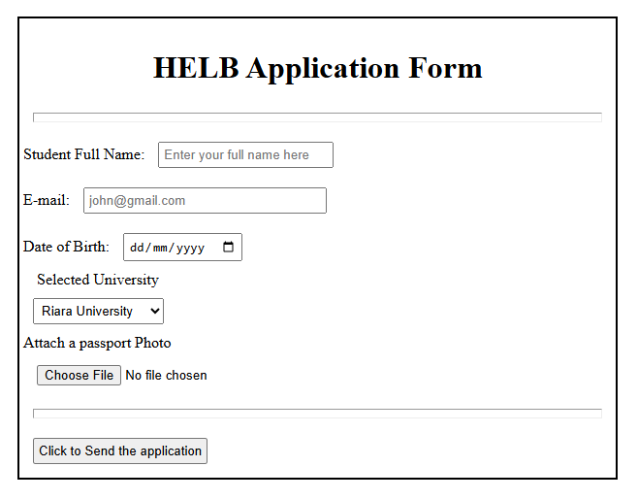
[7 Marks]

