
UNIVERSITY EXAMINATIONS
EXAMINATION FOR MAY/AUGUST 2023/2024 DIPLOMA IN COMPUTER SCIENCE/DIPLOMA IN INFORMATION TECHNOLOGY/ DIPLOMA IN BUSINESS INFORMATION TECHNOLOGY
RCS 024 / RCS 039: WEB DEVELOPMENT
DATE: 11TH AUGUST 2023 TIME: 2 HOURS
GENERAL INSTRUCTIONS:
Students are NOT permitted to write on the examination paper during examination time.
This is a closed book examination. Text book/Reference books/notes are not permitted.
SPECIAL INSTRUCTIONS:
This examination paper consists Questions in Section A followed by section B.
Answer Question 1 and any Other Two questions.
QUESTIONS in ALL Sections should be answered in answer booklet(s).

PLEASE start the answer to EACH question on a NEW PAGE.

Keep your phone(s) switched off at the front of the examination room.

Keep ALL bags and caps at the front of the examination room and DO NOT refer to ANY unauthorized material before or during the course of the examination.

ALWAYS show your working.

Marks indicated in parenthesis i.e. ( ) will be awarded for clear and logical answers.

Write your REGISTRATION No. clearly on the answer booklet(s).

For the Questions, write the number of the question on the answer booklet(s) in the order you answered them.
- DO NOT use your PHONE as a CALCULATOR.
- YOU are ONLY ALLOWED to leave the exam room 30minutes to the end of the Exam.
- DO NOT write on the QUESTION PAPER. Use the back of your BOOKLET for any calculations or rough work.

QUESTION ONE (30 marks)
- Briefly explain the following terms. (10 marks)
- Blockchain
- CSS
- HTML
- E-technology
- WWW

- Explain 2 principles of user interface design? (4 marks)
- Briefly state and discuss fundamentals of a good web design ,giving example (6 marks)
- Outline five factors to consider when choosing content to be included on a web page? (5 marks)
- Describe the key elements of a good website. (5 marks)
QUESTION TWO (20 marks)
- Briefly explain any FOUR qualities of a good website (8 marks)
- Create a code in HTML to achieve the following: (4 marks)

- Set the title of the webpage as an image and create a horizontal line.
- Set the background color of the webpage to red.
- Display an image named "kenya.jpeg" and make it clickable, redirecting to the Riara University website.
- Write out a HTML code you would use to display the page as shown (8 marks)
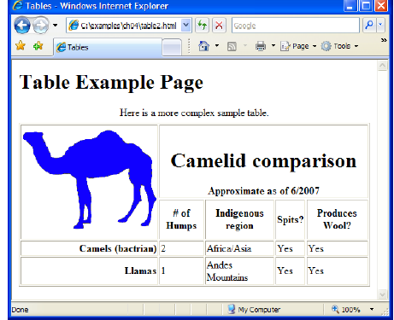

QUESTION THREE (20 marks)
- Outline with clear examples HTML tags that can be used to display the following items on a webpage.
    - An image
    - A link
    - A heading of a page
    - Paragraph (4 marks)
- Describe the difference between HTML and CSS ( 4 marks)
- Highlight three security concerns of the internet today (6 marks)
- The internet is implemented using a layering protocol known as the TCP/IP. Draw the model and discuss it briefly (6 marks)

QUESTION FOUR (20 marks)
- Discuss five Website design consideration? (10 marks)
- Briefly explain why the internet can be defined as “An international market” (4 marks)
- List sections of an HTML document (2 marks)
- Briefly discuss the global name spaces for domains (4 marks)

QUESTION FIVE ((20 marks)
- With the aid of an example, explain the components of a URL (4 marks)
- Create a simple but functional website to present information about yourself, department or other interest using HTML (8 marks)
- Describe the difference between the following terms, giving examples ;( 4marks)
- HTML Title and HTML Heading
- HTML Ordered list and Unordered list
- Explain four differences between java programming and JavaScript
(4 marks)

