
UNIVERSITY EXAMINATIONS
EXAMINATION FOR JANUARY-APRIL 2024/2025 FOR BACHELOR OF SCIENCE IN COMPUTER SCIENCE

COURSE: RCS 201 - DATA STRUCTURES AND ALGORITHM

DATE: 10TH APRIL, 2025 TIME: 2 HOURS

GENERAL INSTRUCTIONS:
Students are NOT permitted to write on the examination paper during exam time.
This is a closed book examination. Text book/Reference books/notes are not permitted.
SPECIAL INSTRUCTIONS:
This examination paper consists Questions in Section A followed by section B.
Answer Question 1 and any Other Two questions.
QUESTIONS in ALL Sections should be answered in answer booklet(s).

PLEASE start the answer to EACH question on a NEW PAGE.

Keep your phone(s) switched off at the front of the examination room.

Keep ALL bags and caps at the front of the examination room and DO NOT refer to ANY unauthorized material before or during the course of the examination.

ALWAYS show your working.

Marks indicated in parenthesis i.e. ( ) will be awarded for clear and logical answers.

Write your REGISTRATION No. clearly on the answer booklet(s).

For the Questions, write the number of the question on the answer booklet(s) in the order you answered them.
- DO NOT use your PHONE as a CALCULATOR.
- YOU are ONLY ALLOWED to leave the exam room 30minutes to the end of the Exam.
- DO NOT write on the QUESTION PAPER. Use the back of your BOOKLET for any calculations or rough work.

SECTION A (COMPULSORY)

QUESTION ONE (30 Marks)
- Explain the stack content at top(), isEmpty(), size() and push(8). ( 4 Marks)

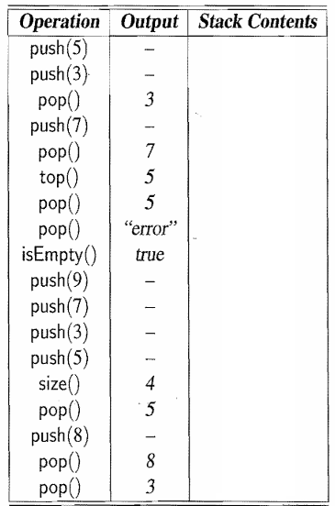

- Enumerate three characteristics of Data Structures. ( 3 Marks)

- Networking is linking two or more computers for exchange of messages. Demonstrate how prefix matching in tries is applied in computer networks. ( 3 Marks)

- Show how the insertion operation is achieved when a new value 25 is added into the MAX Heap shown below. ( 3 Marks)
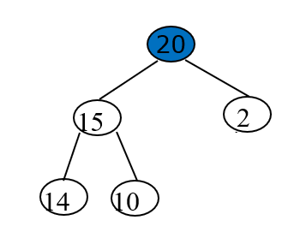

- Represent the following code using a flow chart. ( 4 Marks)

#include <iostream>
using namespace std;

int main() {
int num, sum;
sum = 0;
cout << "Enter a positive integer: ";
cin >> num;

for (int i = 1; i <= num; ++i) {
sum += i;
}

cout << "Sum = " << sum << endl;

return 0;
}

- Demonstrate how heap sort algorithm is used to sort this array of 10 values.
26 5 77 1 61 11 59 15 48 19 ( 5 Marks)

- What are the asymptotic analysis orders representing the following growth functions?
( 3 Marks)
- 12n² + 16n² + 15n + 6
- 3n + 50n³
- 4log23

- Describe the tree data structure by identifying the depth, degree, leaves, siblings and height. ( 5 Marks)
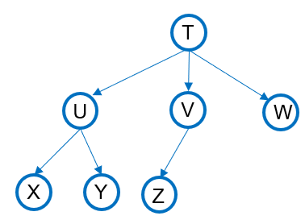

SECTION B (Answer ANY Two Questions)

QUESTION TWO (15 Marks)
- Describe an exhaustive search. ( 2 Marks)

- Explain why quadratic algorithms do not scale well as the input size grows. Give an example. ( 3 Marks)

- Demonstrate deletion operation from a compressed Trie data structure. ( 3 Marks)

- Using a diagram, describe ( 4 Marks)
- A balanced tree
- Strongly Connected Graph
- Using an example, explain how Quick sort works. ( 3 Marks)

QUESTION THREE (15 Marks)
- Illustrate a directed and weighted graph data structure. ( 3 Marks)

- Define an AVL tree. Include an example. ( 2 Marks)

- Describe the output of the ADT shown below. ( 4 Marks)

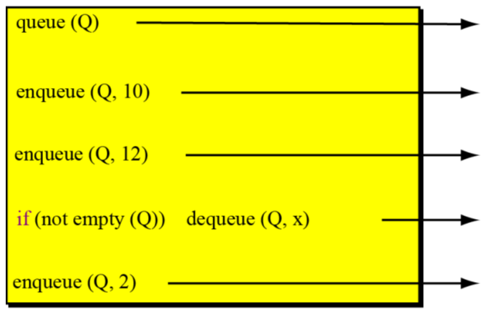

- Explain how you can convert a decimal number to binary using stack ADT.
( 3 Marks)

- There are different graph traversal algorithms. Discuss the Depth First Search (DFS). Include an example. ( 3 Marks)

QUESTION FOUR (15 Marks)
- Define a non-linear data structure. Give an example. ( 2 Marks)

- List three reasons why we use compression algorithms in data structures. ( 3 Marks)

- Show what will happen when 20 is removed from the MAX heap shown below.
( 3 Marks)
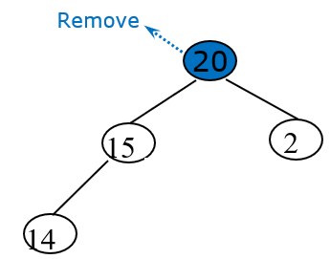

- Including an example, describe the steps in taken when using merge sorting approach.
( 3 Marks)

- State two advantages of a greedy algorithms. ( 2 Marks)

- Sort the array 7, 12, 9, 11, 3 of data using Bubble Sorting Algorithm. ( 2 Marks)

QUESTION FIVE (15 Marks)
- Define ( 3 Marks)
- Expansion Nodes
- Occurrence List as used in Tries
- Dynamic Data Structure

- Show the sequence of movement when traversing the tree using the following strategies. ( 6 Marks)
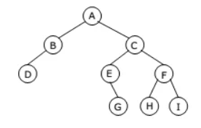
- Inoder Traversal
- Preorder Traversal
- Inorder Traversal

- Study the below diagram and state three goals of backtracking.
( 3 Marks)
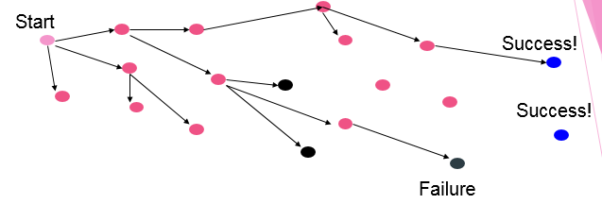

- Explain how recursive backtracking is used in a sack problem when you have different fruit sizes so that it is filled fully. These fruits are mangoes, watermelons and lemons. ( 3 Marks)

