
UNIVERSITY EXAMINATIONS
EXAMINATION FOR JANUARY/APRIL 2023/2024 FOR BACHELOR OF SCIENCE IN COMPUTER SCIENCE
RCS207: DATABASE SYSTEMS
DATE _____________ TIME: 2 HOURS
GENERAL INSTRUCTIONS:
Students are NOT permitted to write on the examination question paper during examination time.
This is a closed book examination. Text book/Reference books/notes are not permitted.

SPECIAL INSTRUCTIONS:
This examination paper consists Questions in Section A followed by section B.
Answer Question 1 and any Other Two questions.
QUESTIONS in ALL Sections should be answered in answer booklet(s).

PLEASE start the answer to EACH question on a NEW PAGE.

Keep your phone(s) switched off at the front of the examination room.

Keep ALL bags and caps at the front of the examination room and DO NOT refer to ANY unauthorized material before or during the course of the examination.

ALWAYS show your working.

Marks indicated in parenthesis i.e. ( ) will be awarded for clear and logical answers.

Write your REGISTRATION No. clearly on the answer booklet (s).

For the Questions, write the number of the question on the answer booklet (s) in the order you answered them.
- DO NOT use your PHONE as a CALCULATOR.
- YOU are ONLY ALLOWED to leave the exam room 1 hour to the end of the Exam.
- DO NOT write on the QUESTION PAPER. Use the back of your BOOKLET for any calculations or rough work.

SECTION A (COMPULSORY)
QUESTION 1 (COMPULSORY, 30 MARKS).
- Study the books table below and write Sql statements to do the following
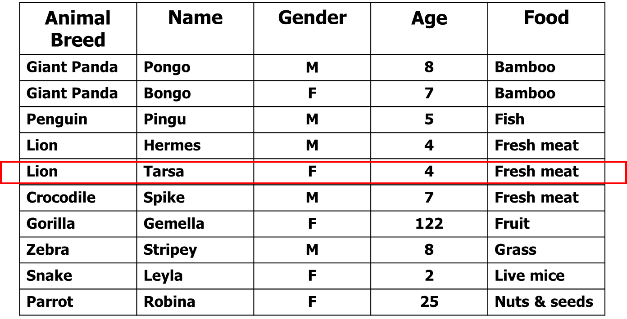
  - To select name, gender, age for Lions and snakes (3 Marks)
  - To select name, gender, age for animals that eat fresh meat and fruit (3 Marks)
  - To select name, gender, age for animals whose age is between 5-10 years (3 Marks)
- Briefly explain the three phases of Database design methodology (6 Marks)
- Explain how RAID technology could assist in attaining fault-tolerance (3 Marks)
- Explain the term unary relationship and illustrate such a relationship using a diagram (4 Marks)
- A transaction log file is very important in data recovery. List the different records that would be contained is such a file in relation to a transaction. (4 Marks)
- Define the term check pointing and explain why it is important in a database (4 Marks)

SECTION B (ANSWER ANY TWO QUESTIONS)
Case Study
A division operates many departments, but each department is operated by only one division. Each division must have at least one department and each department must belong to a division. A department employs many employees, but there may be a department with no employees.
Majority of employees called “dept_emps” are employed by a department. However, there are
also employees known as “free_lance_emps” who are not assigned to any department. A department may own many projects, but there may be a department with no projects. Each
project is existentially and identification dependent on only one department. Both dept_emps and free_lance_emps can work on many projects, but there are employees who do not work on any project. A project has at least one employee working on it. One of dept_emps manages a department. Each department must have a manager. One of the employees runs a division. Each division must have someone running it.
Required.
- Draw an entity relationship diagram for the above scenario showing cardinality and participation constraints (6 Marks)
- Draw a logical design of the above system and propose some possible fields (4 Marks)
- Explain the term referential integrity and how it can be implemented by the DBMS in the database schema above. (2 Marks)
- List three different views that would be implemented in such a system assuming that the application will be hosted online. (3 Marks)

QUESTION 3 (20 MARKS)
- Expand the acronym ACID and explain each of the components. (5 Marks)
- Study the scenario below and answer the following questions
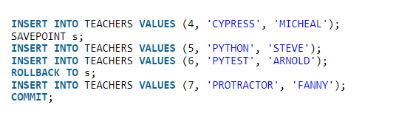
- Explain the effects of the commit statement above. (2 Marks)
- Explain the effects of the “Savepoint s” statement. (2 Marks)
- Explain the effects of the Rollback to “Savepoint s” statement above. (2 Marks)
- After the commit statement, if the DBA runs the statement select * from Teachers, which records of the four (4,5,6 and 7) would appear in the results? (2 Marks)
- Justify your results for item iv above (2 Marks)

QUESTION 4 (20 MARKS)
- Describe Five strategies that an administrator can employ in securing a database using computer based controls. (10 Marks)
- Explain the two different types of locks that can be applied in a database and their implications (4 marks)
- Briefly describe the difference between a database and a database management system. (1 Marks)
QUESTION 5 (20 MARKS)
- Given the scenario below for data extracted from a students’ university records, draw a functional dependency diagram. (6 Marks)
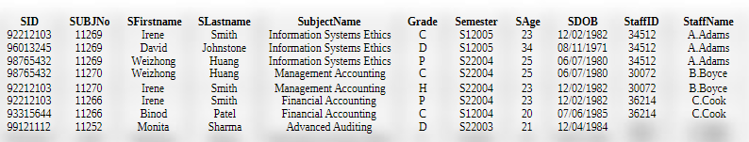
- From the functional dependency diagram, draw a logical schema showing all the field, including the primary and foreign keys. (5 marks)
- Describe the four normal formal forms and what is achieved in each NF. (4 marks)

