
UNIVERSITY EXAMINATIONS
EXAMINATION FOR MAY/AUGUST 2022/2023 FOR BACHELOR OF SCIENCE IN COMPUTER SCIENCE
RCS207: DATABASE SYSTEMS
DATE _____________ TIME: 2 HOURS
GENERAL INSTRUCTIONS:
Students are NOT permitted to write on the examination question paper during examination time.
This is a closed book examination. Text book/Reference books/notes are not permitted.

SPECIAL INSTRUCTIONS:
This examination paper consists Questions in Section A followed by section B.
Answer Question 1 and any Other Two questions.
QUESTIONS in ALL Sections should be answered in answer booklet(s).

PLEASE start the answer to EACH question on a NEW PAGE.

Keep your phone(s) switched off at the front of the examination room.

Keep ALL bags and caps at the front of the examination room and DO NOT refer to ANY unauthorized material before or during the course of the examination.

ALWAYS show your working.

Marks indicated in parenthesis i.e. ( ) will be awarded for clear and logical answers.

Write your REGISTRATION No. clearly on the answer booklet (s).

For the Questions, write the number of the question on the answer booklet (s) in the order you answered them.
- DO NOT use your PHONE as a CALCULATOR.
- YOU are ONLY ALLOWED to leave the exam room 1 hour to the end of the Exam.
- DO NOT write on the QUESTION PAPER. Use the back of your BOOKLET for any calculations or rough work.

SECTION A (COMPULSORY)
QUESTION 1 (COMPULSORY, 20 MARKS).

- You have been contracted to develop and implement a database system to manage the Riara Matatu sacco. Discuss the various costs that would be involved. (8 marks)

- Study the image below and answer the questions that follow.
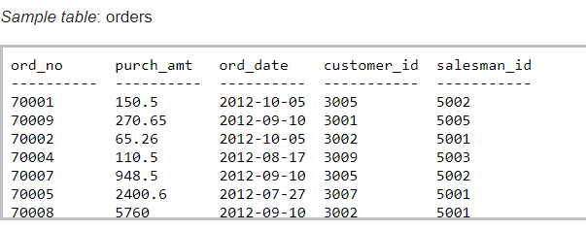
- Write an SQL command to create the table below without inserting any records
(3 marks)

- Write an sql command to insert records into the above table (2 marks)

- Write an sql command to select orderno, purch_amt, order_date where the purch_amt is more than 100 (3 marks)

- Highlight the various DBMS facilities that assist with recovery (4 marks)

SECTION B (ANSWER ANY TWO QUESTIONS)
QUESTION 2 (20 MARKS)
- Draw a functional dependency diagram for the university table below and then map out the relations that should have achieved the 3rd normal form. Draw a relational schema for the 3rd normal form relations showing the primary and foreign key relationships. (8 Marks)
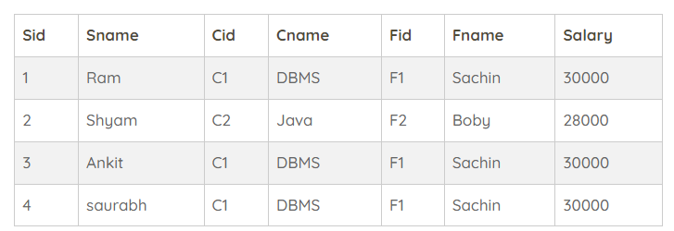

- Draw an entity relationship diagram for the above scenario showing cardinality (2 Marks)

- Highlight four techniques that are employed in achieving integrity in a database. (4 Marks)

- With the aid of an example, explain how the lost update problem occurs (4 Marks)
- Discuss an effective approach that can be used to avoid the lost update problem (2 Marks)

QUESTION 3 (20 MARKS)

- The objective of the three-level architecture is to separate the users’ view(s) of the database from the way that it is physically represented. Highlight five reasons why this is desirable.
(10 marks)

- Explain the following database terms (10 Marks)
- Normalization
- Database locking
- Starvation
- Shadow Paging
- Checkpoint

QUESTION 4 (20 MARKS)
- Study the snapshot below and answer the questions that follow
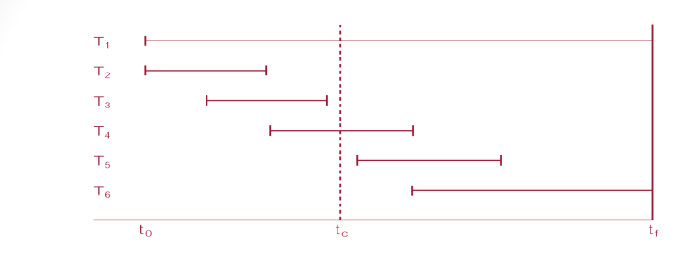
- DBMS starts at time t0, but fails at time tf . Assume data for transactions T2 and T3 have been written to secondary storage. With valid justifications explain the action needs to be taken in order to leave the database in a stable state in the in absence of any other information (6 Marks)

- Describe the DBMS tools and mechanisms that would support the actions involved in stabilizing the above database. (8 Marks)

- Describe the three phases of Database design methodology (6 Marks)

QUESTION 5 (20 MARKS)
Case Study: Riara resort located in Diani offers packages for tourists around the world. The resort management works with several tour operators distributing the resort's packages. Each tour operator is described by its ID, name of the company and contact phone. A tour operator may work with one or more airlines to bring tourists to the resort. An airline is described by its name, phone, and website. Each tour operator has representatives at the resort who arrange guest transportation, additional excursions, and deal with guests' concerns. A representative is described by their ID, name, and phone number. Tour operator's representatives are assigned to take care of several guests for the entire stay of the guests. This assignment is important for the resort management.

The resort accommodates guests in 33 2- and 3-storey buildings. Some of the buildings face the ocean. Buildings are numbered from 1 to 33 and are described by their number, category (2- or 3-storey), and view (ocean, forest, or other buildings). Each building contains from 8 to 12 rooms. Rooms are numbered from 1 to the maximal number of rooms in the building, and are described by the number of beds in the room and a category, e.g., standard, executive, etc..

- Draw an entity relationship diagram using Chen notation for the above scenario showing cardinality (8 Marks)

- State any two assumptions that you have made in question (a) above (2 Marks)

- Draw a logical design of the above system and propose some possible fields (4 Marks)

- Discuss the role Discretionary Access Control plays in database security (6 marks)

