

UNIVERSITY EXAMINATIONS
EXAMINATION FOR JANUARY/APRIL 2024/2025 DIPLOMA IN COMPUTER SCIENCE AND DIPLOMA IN INFORMATION TECHNOLOGY
RCS 019: INTRODUCTION TO STATISTICS
DATE: 17TH APRIL 2025
GENERAL INSTRUCTIONS:
Students are NOT permitted to write on the examination paper during examination time. This is a closed-book examination. Textbooks/Reference books/notes are not permitted.
SPECIAL INSTRUCTIONS:
This examination paper consists of Questions in Section A followed by Section B. Answer Question 1 and any Other Two questions.
QUESTIONS in ALL Sections should be answered in the answer booklet(s).
- PLEASE start the answer to EACH question on a NEW PAGE.
- Keep your phone(s) switched off at the front of the examination room.
- Keep ALL bags and caps at the front of the examination room and DO NOT refer to ANY unauthorized material before or during the course of the examination.
- ALWAYS show your workings.
- Marks indicated in parenthesis i.e. ( ) will be awarded for clear and logical answers.
- Write your REGISTRATION No. clearly on the answer booklet(s).
- For the Questions, write the number of the question on the answer booklet(s) in the order you answered them.
- DO NOT use your PHONE as a CALCULATOR.
- YOU are ONLY ALLOWED to leave the exam room 30 minutes to the end of the Exam.
- DO NOT write on the QUESTION PAPER. Use the back of your BOOKLET for any calculations or rough work.

SECTION A (Compulsory) Question One (30 Marks)
- Differentiate between Discrete and Continuous Variables giving examples in each
(4 Marks)
- What is a Time Series?
(1 Mark)
- State the differences between primary and secondary data. State the methods used to collect each type of data.
(4 Marks)
- Define the following terminologies as used in statistics.
(3 Marks)
- Data
- Information
- Parameter
- A company is analyzing the monthly incomes of its employees. They collect data from a random sample of 100 employees and find that the mean monthly income is Kshs 50,000, while the median income is Kshs 42,000.
- Based on this information, do you think the income data is positively skewed, negatively skewed, or roughly symmetrical? Give a reason for your answer
(2 Marks)
- Explain why understanding the skewness of income data is important for the company's financial planning and employee compensation strategies.
(2 Marks)
- Differentiate between Population and Sample giving an example in each
(4 Marks)
- Briefly explain the four-time series components in time series analysis
(4 Marks)
- When is Laspeyres most appropriate and when is Paasche the better choice? Explain using their advantages and disadvantages.
(4 Marks)
- Distinguish the two categories of applied statistics.
(2 Marks)

SECTION B (Answer Any Two questions – Total: 30 Marks)

Question Two (15 Marks)
- Distinguish the Exclusive Method from the Inclusive Method of class interval determination.
(4 Marks)
- The following data represents coffee weights for 50 farmers in a particular week, weights range from 0 to 100.
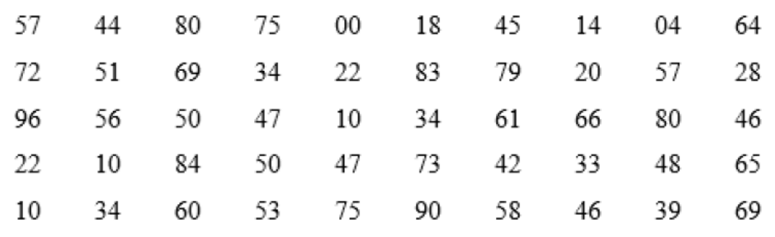
- Calculate class interval given that weights are grouped into 10 classes
(2 Marks)
- Using the class width in (i) above, create a frequency distribution table. Use Exclusive Method
(5 Marks)
- Discuss Any Two types of classifications giving examples in each
(4 Marks)

Question Three (15 Marks)
- Identify FOUR specific real-world scenarios or situations where the CPI plays a crucial role in economic decision-making
(5 Marks)
- Imagine you are working as a data analyst for a marketing research firm. Your client is a company launching a new product in a competitive market. They have requested a comprehensive market analysis report. Explain the stages of statistical investigation you will use and how each stage is crucial in conducting a market analysis for your client. Provide specific examples and scenarios to illustrate each stage's significance in ensuring the product launch's success.
(10 Marks)

Question Four (15 Marks)
- Differentiate between positive and negative correlations, and provide a real-world example for each type.
(4 Marks)
- Explain three key steps for analyzing the relationship between different series of data in correlation analysis
(3 Marks)
- Explain Any Two methods for measuring the secular trend in a time series.
(4 Marks)
- A set of values has a mean of 22 and a standard deviation of 3. Find the z-score for a value of 24. Interpret the z-score
(4 Marks)

Question Five (15 Marks)
- The following scores represent students' marks in a statistics class;
50, 60, 75, 68, 80, 65, 60, 75, 82
- Determine the mode and state which type of mode it is
(2 Marks)
- Calculate;
Median
(2 Marks)
Mean
(2 Marks)
Variance
(3 Marks)
Lower quartile
(2 Marks)
Upper quartile
(2 Marks)
interquartile range
(2 Marks)

