
UNIVERSITY EXAMINATIONS
EXAMINATION FOR JANUARY/APRIL 2025/2026 FOR BACHELOR OF SCIENCE IN COMPUTER SCIENCE

RBCS 7123 - PROBABILITY AND STATISTICS

DATE: 13TH APRIL, 2026 TIME: 2 HOURS

GENERAL INSTRUCTIONS:
Students are NOT permitted to write on the examination paper during exam time.
This is a closed book examination. Text book/Reference books/notes are not permitted.
SPECIAL INSTRUCTIONS:
This examination paper consists Questions in Section A followed by section B.
Answer Question 1 and any Other Two questions.
QUESTIONS in ALL Sections should be answered in answer booklet(s).

PLEASE start the answer to EACH question on a NEW PAGE.

Keep your phone(s) switched off at the front of the examination room.

Keep ALL bags and caps at the front of the examination room and DO NOT refer to ANY unauthorized material before or during the course of the examination.

ALWAYS show your working.

Marks indicated in parenthesis i.e. ( ) will be awarded for clear and logical answers.

Write your REGISTRATION No. clearly on the answer booklet(s).

For the Questions, write the number of the question on the answer booklet(s) in the order you answered them.
- DO NOT use your PHONE as a CALCULATOR.
- YOU are ONLY ALLOWED to leave the exam room 30minutes to the end of the Exam.
- DO NOT write on the QUESTION PAPER. Use the back of your BOOKLET for any calculations or rough work.

SECTION A (COMPULSORY)
QUESTION 1 (30 Marks)
- Identify two situations where standard deviation is commonly applied in real life.
- Mark)

- Define the following terminologies. (2 Marks)
- Random Variable
- Standard Error

- Sketch the output of the following R Code when executed. (3 Marks)

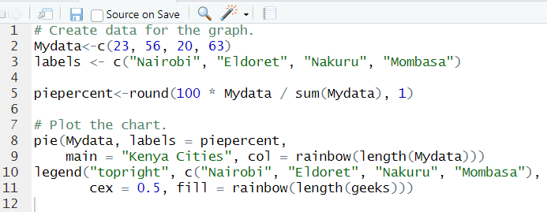

- State any three properties of the normal distribution. (3 Marks)

- A box contains 5 red balls, 3 blue balls, and 2 green balls. Three balls are drawn one after another without replacement
- What is the probability that all three balls drawn are red? (3 Marks)
- What is the probability that exactly two balls are red? (3 Marks)
- What is the probability that at least one green ball is drawn? (3 Marks)

- Compare statistical fallacies and statistical limitations. ( 2 Marks)

- An industry has 3 machines A, B, and C. They produce 30%, 50%, and 20% of total items respectively. Defect rates are 2%, 1%, and 3%. An item is chosen at random and found to be defective. Calculate:
- The probability the defective item was produced by machine A. (3 Marks)
- The overall probability of getting a defective item. (3 Marks)
- What is the probability the item is not defective? (3 Marks)

SECTION B (Answer ANY Two Questions)

QUESTION 2 (15 Marks)

- Write Python code that demonstrates permutation of events occurrences.
(3 Marks)

- Define Sampling Distribution. (2 Marks)

- Explain Poisson Distribution (3 Marks)

- A fair die is rolled. Find the probability of getting an even number. (3 Marks)

- Compare probability and non-probability sampling. Give examples. (4 Marks)

QUESTION 3 (15 Marks)
- Write Python that will display a pie chart when executed. (4 Marks)

- In statistics, why is correlation not equal to causation? Include an example.
(3 Marks)

- List the uses of the following functions in Python or R environments. (2 Marks)
- describe() in Python
- Summary( ) in R

- Illustrate a situation where you have a high degree of negative correlation while including value of correlation coefficient r. (3 Marks)

- Differentiate between PMF and PDF in probability. (3 Marks)

QUESTION 4 (15 Marks)
- In a by election, investigation is carried out to identify independent voters. If your probability of success is 0.1, considering Geometric Distribution, what is the probability that you will meet an independent voter on your third try? (2 Marks)

- Determine if the measure is positively or negatively skewed if the Mean = 22, Mode =34, Median=24 and Standard Deviation =2.23. Using Pearson’s first or second Coefficient of Skewness. (3 Marks)

- The mean of a dataset is 42 and the standard deviation is 4. Find the z-score of a value x = 45. (3 Marks)

- Write Python that will display a histogram when executed. (4 Marks)

- A coin is tossed 5 times. Using Binomial distribution, what is the probability of getting exactly 3 heads? (3 Marks)

QUESTION 5 (15 Marks)
- State the purpose of the following functions in data analysis. (2 Marks)
- pandas.read_csv() in Python
- mean() in R

- Determine the number of classes in a set of data where N is the number of observations, calculate the class interval of the salary of 32 employees in a flower farm in which it varies between KES. 2600 and KES. 175, 800. Using Sturge’s rule. (3 Marks)

- State three assumptions of the binomial distribution. (3 Marks)

- Define variance and explain its statistical importance. (2 Marks)

- Explain the concept of independence in probability. (2 Marks)

- Calculate the Interquartile Range (IQR) for the dataset: 12, 18, 25, 30, 32, 35, 40, 45, 50, 55, and 60. ( 3 Marks)

