
EXAMINATION JANUARY/APRIL 2024/2025
RIARA FOUNDATION COURSE
COURSE TITLE: HEALTH AND WELLNESS
COURSE CODE: RFC 113
DATE: 15TH APRIL 2025 TIME: 2 HOURS
GENERAL INSTRUCTIONS:
Students are NOT permitted to write on the examination QUESTION paper during the examination period. This is a closed book examination. Text books/Reference books/notes are not permitted.
SPECIAL INSTRUCTIONS:
QUESTIONS in ALL Sections should be answered in the answer booklet(s). Use the back of your BOOKLET for any calculations or rough work.

PLEASE start the answer to EACH question on a NEW PAGE.

This examination consists of four (4) questions. Question one is compulsory. Answer any other two questions of your choice in Section B (total- 60 marks).

Question one is multiple choice. Answer the multiple choice questions on the answer booklet and NOT on the question paper.
- Keep your phone(s) switched off, all bags should be kept at the front of the exam room
- Write your REGISTRATION No. clearly on the answer booklet(s).
- Indicate the questions done at the bottom of the answer booklet(s) in the order that you answered them.
- YOU are ONLY ALLOWED to leave the examination room 1hour to the end of the exam
QUESTION ONE-Answer both Section A-Part 1 and 2 (This is a Compulsory Question-20 marks)
QUESTION ONE: Section A-Part 1
Instructions:
True or False Questions-Write whether the answer is True or False. Multiple choice questions- select the Correct Answer (a, b, c or d). The CORRECT answer MUST be written down on the final examination booklet and NOT on the question paper. (10 Marks)
- At present the reasonable approach to initiate antiretroviral therapy to anyone is
- All symptomatic patients
- Pregnant women
- CD4 count below 250U/L
- Any of the above

- All of the following except one are CD4₊ Cells
- Monocytes
- T- helper cells
- T-Cytotoxic cells
- Macrophages

- Which type of strength is essential in shot put?
- Maximum strength
- Explosive strength
- Strength endurance
- Dynamic strength

- The duration taken by the body to respond immediately after stimulus during a game
- Power
- Reaction time
- Speed
- Agility

- Which of the following is the main purpose of carbohydrates in the body?
- They repair and build body tissues
- They regulate hormones and maintain body temperature within the body
- They strengthen the immune system
- They are the main source of energy for our bodies

- Which of the following is the indigestible portion of our diet essential to the health of the digestive system?
- Proteins
- Roughage
- Carbohydrates
- Fats

- Which is not a positive symptom of schizophrenia?
- Hallucinations
- Delusions
- Disorganized speech
- Lack of motivation

- Which alkaloid is found in tobacco?
- Caffeine
- Morphine
- Nicotine
- Cocaine

- The drug ecstasy is classified as
- Hallucinogen
- Stimulant
- Depressant
- Tranquilizer

- Which of the following is not a risk factor for mother-to-child transmission of HIV?
- A high maternal viral load
- Advanced maternal age
- A low maternal CD4 count
- A history of stillbirth
- Prolonged rupture of membranes

QUESTION ONE- Section A: Part 2- It is compulsory to answer both questions in this section

- Illustrate using examples the following health-illness continuum (4 marks)
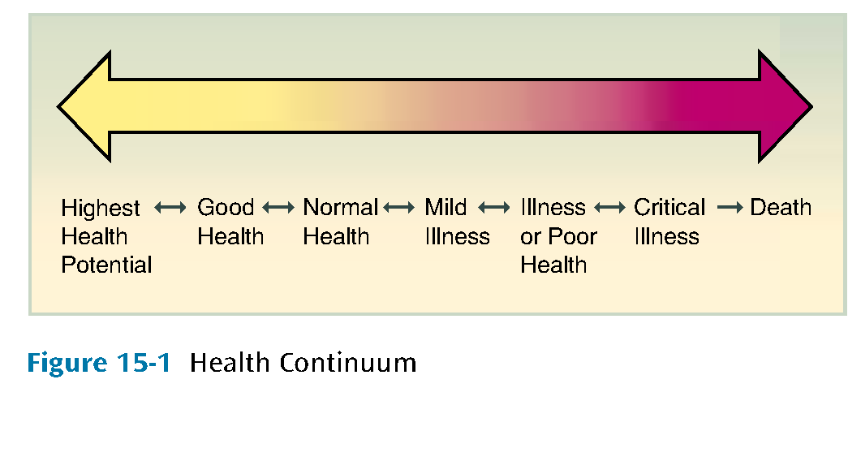
- Discuss the three meanings of health and wellness according to Halbert L. Dunn (6 marks)

SECTION B-CHOOSE ANY TWO QUESTIONS OF YOUR CHOICE

QUESTION TWO

- Determine five importance of physical activity (10 marks)

- Explain four opportunistic infections common in people living with HIV and AIDS (4 marks)

- Elaborate three gymnasium equipment and the muscles that they target to keep a person physically fit
(6 marks)

QUESTION THREE
- Analyze four eating disorders common among adolescents and youth globally (8 marks)
- Assess six importance of drinking the recommended amount of water on a daily basis (12 marks)

QUESTION FOUR
- Examine five risk factors associated with development of mood disorders
(10 marks)

- Evaluate the process of drug addiction (10 marks)

-END-

