
UNIVERSITY EXAMINATIONS

EXAMINATION FOR MAY/AUGUST 2020/2021 DIPLOMA IN COMPUTER SCIENCE/DIPLOMA IN INFORMATION TECHNOLOGY/DIPLOMA IN BUSINESS INFORMATION TECHNOLOGY

RCS 029, RCT 007, RIT 022 & RCS 038: DATA COMMUNICATIONS & NETWORKING

MARKING SCHEME

SECTION A
QUESTION ONE COMPULSORY (30 MARKS)
- Distinguish between the following:
- Analog and digital signals. (4 Marks)
    - Digital Signals
    - Digital signals are discrete in nature and represent a sequence of voltage pulses. Digital signals are used within the circuitry of a computer system.
    - Analog Signals
    - Analog signals are in continuous wave form and are represented by continuous electromagnetic waves.
- Guided and unguided transmission media (4 Marks)
  - Guided Media
    - All communication wires or cables are guided media.
    - They include UTP, coaxial cables, and fiber optics.
    - The sender and receiver are directly connected and the information is sent (guided) through it.
  - Unguided Media
    - Wireless or open air space is said to be unguided media, because there is no connectivity between the sender and receiver.
    - Information is spread over the air, and anyone including the actual recipient may collect the information.
- Explain four forms of transmission impairment. (8 Marks)
  - Attenuation
    - For the receiver to interpret the data accurately, the signal must be sufficiently strong.
    - When the signal passes through the medium, it tends to get weaker and as it covers distance, it loses strength.
  - Dispersion
    - As signal travels through the media, it tends to spread and overlap. The amount of dispersion depends upon the frequency used.
  - Delay distortion
    - Signals are sent over media with pre-defined speed and frequency.
    - If the signal speed and frequency do not match, there are possibilities that the signal reaches intended destination in an arbitrary fashion.
  - Noise
    - This is the random disturbance or fluctuation in analog or digital signal which may distort the actual information being carried.
- Explain three factors that affect the capacity of a channel to transmit data. (6 Marks)
  - Bandwidth: Maximum amount of data transmitted over an internet connection in a given time. It is the physical limitation of underlying media.
  - Error-rate: Incorrect reception of information because of noise.
  - Encoding: The number of levels used for signaling.
- Using a diagram, distinguish between NRZ-Level and NRZ-Invert as used in the NRZ line encoding scheme. (8 Marks)
  - NRZ-L changes voltage level when a different bit is encountered whereas NRZ-I changes voltage when a 1 is encountered.
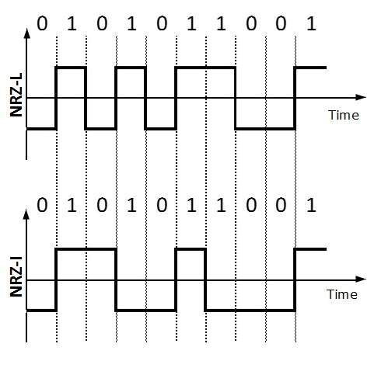

SECTION B (ANSWER ANY 2 QUESTIONS)

QUESTION TWO (20 MARKS)
- Explain the purpose of twists in twisted pair cables. (2 Marks)
- If the two wires are parallel, the effect of these unwanted signals is not the same in both wires because they are at different locations relative to the noise or crosstalk sources (e,g., one is closer and the other is farther). This results in a difference at the receiver.
- By twisting the pairs, a balance is maintained. For example, suppose in one twist, one wire is closer to the noise source and the other is farther; in the next twist, the reverse is true.
- Twisting makes it probable that both wires are equally affected by external influences (noise or crosstalk). This means that the receiver, which calculates the difference between the two, receives no unwanted signals. The unwanted signals are mostly canceled out.
- Discuss the pros and cons of fiber optic cable. (10 Marks)
Pros:
  - Higher bandwidth. Fiber-optic cable can support higher bandwidths (and hence higher data rates) than either twisted-pair or coaxial cable. Currently, data rates and bandwidth utilization over fiber-optic cable are limited not by the medium but by the signal generation and reception technology available.
  - Less signal attenuation. Fiber-optic transmission distance is significantly greater than that of other guided media. A signal can run for 50 km without requiring regeneration. We need repeaters every 5 km for coaxial or twisted-pair cable.
  - Immunity to electromagnetic interference. Electromagnetic noise cannot affect fiber-optic cables.
  - Resistance to corrosive materials. Glass is more resistant to corrosive materials than copper.
  - Light weight. Fiber-optic cables are much lighter than copper cables.
  - Greater immunity to tapping. Fiber-optic cables are more immune to tapping than copper cables. Copper cables create antenna effects that can easily be tapped.
Disadvantages:
  - Installation and maintenance. Installation and maintenance require expertise that is not available everywhere.
  - Unidirectional light propagation. Propagation of light is unidirectional. If we need bidirectional communication, two fibers are needed.
  - Cost. The cable and the interfaces are more expensive than those of other guided media. If the demand for bandwidth is not high, often the use of optical fiber cannot be justified.
- Discuss four factors to consider in the design of transmission media. (8 Marks)
  - Bandwidth
    - The bandwidth mainly refers to the capacity of data-carrying in a medium otherwise a channel. So, high BW communication channels mainly support high data rates.
  - Radiation
    - The radiation refers to the signal leakage from the medium because of its unwanted electrical characteristics.
  - Absorption of Noise
    - The absorption of noise refers to the vulnerability of the media to exterior electrical noise. This noise can cause data signal distortion.
  - Attenuation
    - Attenuation refers to the energy loss when signal broadcasts externally. The loss of energy amount mainly depends on frequency. Radiation, as well as physical media characteristics, contributes to attenuation.
QUESTION THREE (20 MARKS)
- Explain five responsibilities undertaken by data link layer. (10 Marks)
  - Framing. The data link layer divides the stream of bits received from the network layer into manageable data units called frames.
  - Physical addressing. If frames are to be distributed to different systems on the network, the data link layer adds a header to the frame to define the sender and/or receiver of the frame. If the frame is intended for a system outside the sender's network, the receiver address is the address of the device that connects the network to the next one.
  - Flow control. If the rate at which the data are absorbed by the receiver is less than the rate at which data are produced in the sender, the data link layer imposes a flow control mechanism to avoid overwhelming the receiver.
  - Error control. The data link layer adds reliability to the physical layer by adding mechanisms to detect and retransmit damaged or lost frames. It also uses a mechanism to recognize duplicate frames. Error control is normally achieved through a trailer added to the end of the frame.
  - Access control. When two or more devices are connected to the same link, data link layer protocols are necessary to determine which device has control over the link at any given time.
- Using a diagram, explain how a message switched network operates. (10 Marks)
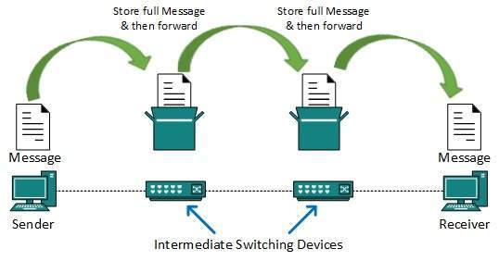
  - In message switching, the whole message is treated as a data unit and is switched / transferred in its entirety.
  - A switch working on message switching, first receives the whole message and buffers it until there are resources available to transfer it to the next hop.
- If the next hop is not having enough resource to accommodate large size message, the message is stored and the switch waits.
QUESTION FOUR (20 MARKS)
- State four fundamental characteristics that determine the effectiveness of a data communications system. (4 Marks)
  - Delivery, accuracy, timeliness, and jitter.
- Distinguish between polar encoding and bipolar encoding schemes. (4 Marks)
  - Polar encoding scheme uses multiple voltage levels to represent binary values while bipolar encoding uses three voltage levels; positive, negative and zero. Zero voltage represents binary 0 and bit 1 is represented by alternating positive and negative voltages.
- Explain two differences between IPv4 and IPv6. (4 Marks)
IPv4 | IPv6
32-bit address | 128-bit address
Uses numeric dot-decimal notation | Uses alphanumeric hexadecimal notation
Uses DHCP or manual configuration | Supports auto configuration

- Given the IP address 172.30.15.12 with a subnet mask of 255.255.0.0, determine the network ID of the host. (8 Marks)
QUESTION FIVE (20 MARKS)
- State two similarities between OSI and TCP/IP reference models. (2 Marks)
  - Both are based on the concept of a stack of independent protocols.
  - In both models the layers up through and including the transport layer are there to provide an end-to-end, network-independent transport service to processes wishing to communicate.
  - In both, the layers above transport are application-oriented users of the transport service.
- Describe the steps of pulse code modulation. (6 Marks)
- Sampling
  - The analog signal is sampled after every T interval.
  - The most important factor in sampling is the rate at which an analog signal is sampled.
  - According to Nyquist Theorem, the sampling rate must be at least two times the highest frequency of the signal.
- Quantization
  - Sampling yields a discrete form of a continuous analog signal.
  - Every discrete pattern shows the amplitude of the analog signal at that instance.
  - Quantization is used to convert a continuous-amplitude sample into a discrete-time signal and is done between the maximum amplitude value and the minimum amplitude value. It presents an approximation of the instantaneous analog value.
- Encoding
  - In encoding, each approximated value is converted into binary format.
- Use a diagram to describe each of the following digital to analog conversion techniques. (12 Marks)
- Amplitude Shift Keying
  - In this technique, the amplitude of an analog carrier signal is modified to reflect binary data.
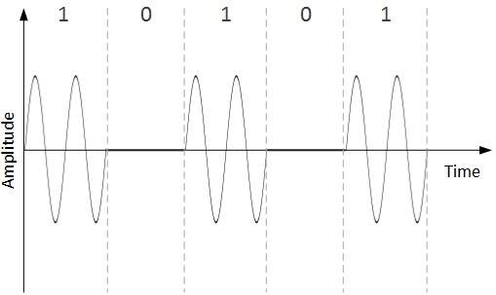
  - When binary data represents digit 1, the amplitude is held; otherwise it is set to 0. Both frequency and phase remain same as in the original carrier signal.
- Frequency Shift Keying
  - In this conversion technique, the frequency of the analog carrier signal is modified to reflect binary data.
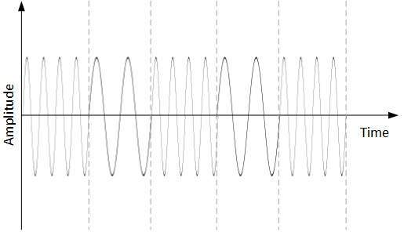
  - This technique uses two frequencies, f1 and f2. One of them, for example f1, is chosen to represent binary digit 1 and the other is used to represent binary digit 0. Both amplitude and phase of the carrier wave are kept intact.
- Phase Shift Keying
  - In this conversion scheme, the phase of the original carrier signal is altered to reflect the binary data.
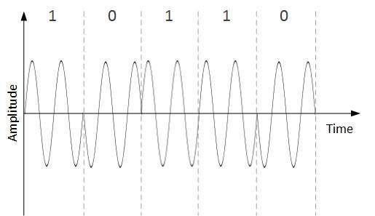
  - When a new binary symbol is encountered, the phase of the signal is altered. Amplitude and frequency of the original carrier signal is kept intact.

END OF EXAM

