
UNIVERSITY EXAMINATIONS
EXAMINATION FOR SEPTEMBER/DECEMBER 2023/2024 FOR BACHELOR OF SCIENCE IN COMPUTER SCIENCE
RCS 104::SYSTEM ANALYSIS AND DESIGN
DATE: 1ST DECEMBER 2023 TIME: 2 HOURS
GENERAL INSTRUCTIONS:
Students are NOT permitted to write on the examination question paper during examination time.
This is a closed book examination. Text book/Reference books/notes are not permitted.

SPECIAL INSTRUCTIONS:
This examination paper consists Questions in Section A followed by section B.
Answer Question 1 and any Other Two questions.
QUESTIONS in ALL Sections should be answered in answer booklet(s).

PLEASE start the answer to EACH question on a NEW PAGE.

Keep your phone(s) switched off at the front of the examination room.

Keep ALL bags and caps at the front of the examination room and DO NOT refer to ANY unauthorized material during the course of the examination.

ALWAYS show your working.

Marks indicated in parenthesis i.e. ( ) will be awarded for clear and logical answers.

Write your REGISTRATION No. clearly on the answer booklet(s).

For the Questions, write the number of the question on the answer booklet cover page in the order you answered them.
- DO NOT use your PHONE as a CALCULATOR.
- YOU are ONLY ALLOWED to leave the exam room 1 hour to the end of the Exam.
- DO NOT write on the QUESTION PAPER. Use the back of your BOOKLET for any calculations or rough work.

SECTION A (COMPULSORY)

QUESTION ONE (30 MARKS)
- Explain why the “Systems thinking” concept is important for the designers of Computer Based Information Systems? (3 marks)
- Highlight any four reasons as to why user involvement is critical for the success of Information Systems projects. (4 marks)
- Describe how Rapid Application Development methodology is different from the typical SDLC model? (2 marks)
- A closed system does not interact with its environment and is isolated from the external influences. Explain why a completely closed system is rare in reality. (2 marks)
- Describe the basic process of User Interface Design and the role that prototyping plays in this process. (2 marks)
- List and describe any three types of Information Systems (6 marks)
- A patient calls the clinic and makes an appointment for a yearly checkup. The receptionist finds the nearest empty timeslot in the appointment book and schedules an appointment for that time slot. Generate a use case diagram for this scenario. (5 marks)
- List any two attributes of a good software design. (2 marks)
- Highlight any two characteristics of a good Software Project manager.

(2 marks)
- Explain any two types of System maintenance as used in System analysis and design. (2 marks)

SECTION B (ANSWER ANY TWO QUESTIONS)

QUESTION TWO (20 Marks)

Case Study: Video Library System

Clients borrow videos from Dennis-Prit Video Library. The Library has many DVDs. When clients come to the library, they can request a DVD to be issued. Staff checks the library hard copy records if the DVD is available and not on hold for another client. If the DVD is not on hold, it is issued to the client for a period of 2 to 7 days. Clients pay for borrowing the video after it is returned to the library. The owner has invited a system analyst who will assist in the development of an Information System that will fully automate the business processes at the Video library.
- List any two specific roles of a system analyst. (2 marks)

- Explain any three data collection methods that can be used during the analysis stage.
(6 marks)
- Represent the scenario of Dennis-Prit video library with an E-R diagram. (6 marks)

- Explain any three changeover methods that can be used to implement the newly developed Information System for this video library. (6 marks)

QUESTION THREE [20 Marks]
Case Study: Golden Racquet Tennis Club
Golden Racquet is a tennis club in England. The club has a number of playing courts. Most of the members of the club are local people. The club is opened daily from 10.00am to 8.00pm. New members are approved and registered by the club manager. When registered, new members provide their name, address, telephone number, etc. and after the registration they are given a unique member number. The club encourages its members to join teams, although each member can only belong to one team. When a member decides to join a team he/she should contact a receptionist either by phone or at the club, and he/she will carry out the appropriate procedure. Playing sessions (one hour long) can be booked by either a team leader or by an individual member. Each session belongs to a specific price band according to its time, day of the week, etc. The session booking may subsequently be cancelled by the person who booked it. In such a case, the session will become available for rebooking. Session records are created by the manager a few weeks in advance i.e. members have a couple of weeks to book sessions. Each session is identified by its date, time and court number. Session records are deleted 6 months after their dates.
- Produce a list of requirements for a system to support the Golden Racquet tennis club’s business processes shown in the scenario. (9 marks)
- Using examples from part (a) to illustrate your answer, explain two differences between functional and non-functional requirements. (4 marks)
- Produce an Activity diagram with swim lanes to represent the tennis club’s activities and processes. (7 marks)

QUESTION FOUR (20 MARKS)
Case Study: Medical Appointments System
More than 2000 patients are registered with a local health Centre. The Centre employs a number of general practitioners (i.e. doctors) and a few receptionists. Patients are officially registered with one doctor but can arrange appointments with any available one. These appointments may subsequently be cancelled. Some appointments result in one or more prescriptions. New patients are registered by a receptionist. When a patient is registered he/she provides his/her details such as name, date of birth, address, etc., and receives a unique patient number. To book an appointment, a patient should contact a receptionist. The patient provides his/her number (or date of birth) and the receptionist provides a list of available time slots for appointments. The appointment is booked with the patient’s doctor or with any available doctor, if the patient’s doctor is not available. The date and time of the booked appointment are given to the patient as a confirmation. Patients can cancel booked appointments by contacting a receptionist who will cancel appointments on behalf of patients. A patient who attends an appointment should check in first using a special terminal located in the waiting area of the Health Centre. The patient inputs his/her number (or date of birth). The system checks the details and confirms that the patient has been checked in.

Doctors record appointment outcomes and details of prescriptions (if any) during the appointments i.e. all prescriptions issued by doctors are recorded on the patient’s record. Patients who leave the area where the Health Centre is located are de-registered by receptionists

  - Produce a logical top-level data flow diagram of the Medical Appointments System. (8 marks)
  - Explain two ways in which a data flow diagram can help a system analyst in the choice of computer hardware. (4 marks)

  - The table below shows an example of a list of appointments arranged with doctors.
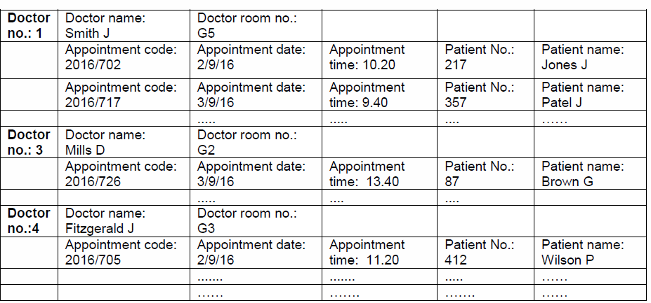

  - Normalize the table to produce a set of relations in the Third Normal Form.

You must show all of your working explaining each step. (8 marks)

QUESTION FIVE (20 MARKS)

Case Study: Mobile app for predicting Commuting time

“TKG mobile app” is a system that assists Kenyatta University students in predicting their commuting time from the main campus hostels to the medical school located in Westlands. If the students leave at 8am, the commute time is automatically long. If the students leave at 10am and there are no cars stalled on the road, then the commute time is short. If the students leave at 10am and there are cars stalled on the road, then the commute time is long. If the students leave at 9am and there is an accident along the route, then the commute time is medium. If the students leave at 9am and there is no accident along the route, then the commute time is long.
- List and explain any five elements of a system. (10 marks)

- Create a decision tree to represent the above scenario. (6 marks)

- Explain any two drawbacks of decision trees. (4 marks)

