
UNIVERSITY EXAMINATIONS
EXAMINATION FOR SEPTEMBER/DECEMBER 2021/2022 FOR BACHELOR OF SCIENCE IN COMPUTER SCIENCE
COURSE CODE: RCS 304: COURSE UNIT: COMPUTER SIMULATION AND MODELLING
DATE _____________ TIME: 2HRS
GENERAL INSTRUCTIONS:
Students are NOT permitted to write on the examination paper during examination time.
This is a closed book examination. Text book/Reference books/notes are not permitted.

SPECIAL INSTRUCTIONS:
This examination paper consists Questions in Section A followed by section B.
Answer Question all questions in section A and two questions in Section B .
QUESTIONS in ALL Sections should be answered in answer booklet(s).

PLEASE start the answer to EACH question on a NEW PAGE.

Keep your phone(s) switched off at the front of the examination room.

Keep ALL bags and caps at the front of the examination room and DO NOT refer to ANY unauthorized material before or during the course of the examination.

ALWAYS show your working.

Marks indicated in parenthesis i.e. ( ) will be awarded for clear and logical answers.

Write your REGISTRATION No. clearly on the answer booklet(s).

For the Questions, write the number of the question on the answer booklet(s) in the order you answered them.
- DO NOT use your PHONE as a CALCULATOR.
- YOU are ONLY ALLOWED to leave the exam room 30minutes to the end of the Exam.
- DO NOT write on the QUESTION PAPER. Use the back of your BOOKLET for any calculations or rough work.

SECTION A: ANSWER ALL QUESTIONS: 30 MARKS
QUESTION 1
- Describe the steps that are followed when conducting Simulation and Modelling study
(6 Marks)
- Using appropriate examples explain the difference between Deterministic or Stochastic Simulation Models (6 Mark)
- The table below shows the demand for a particular brand of razor in a shop for each of the last nine months. Calculate a three-month moving average for months three to nine. What would be your forecast for the demand in month ten? ( 5 Marks)

    - Month 1 2 3 4 5 6 7 8 9
    - Demand 10 12 13 17 15 19 20 21 20

- Explain the factors that affects the selection method for forecasting models
(5 Marks)
- Judy is a manager of a mobile factory company. Her factory has been quite successful the past three years. She is wondering whether or not it is a good idea to expand her factory this year. The cost to expand her factory is $1.5M. If she does nothing and the economy stays good and people continue to buy lots of gadgets she expects $3M in revenue; while only $1M if the economy is bad. If she expands the factory, she expects to receive $6M if economy is good and $2M if economy is bad. She also assumes that there is a 40% chance of a good economy and a 60% chance of a bad economy. Using Decision Tree determine if Ann should expand the factory or not ( 8 Marks)

SECTION B : ANSWER TWO QUESTION

QUESTION 2 (20 Marks)

- Assume we have 3 processes that we need to run in the order they arrive (FIFO). The first process (P1) takes 5 seconds to finish, the second process (P2) takes 15 seconds and the third process (P3) takes 10 seconds. Calculate throughput and the average waiting time
(6 Marks)
- Explain areas of performance evaluation in simulation and modelling ( 4 Marks )
- Highlight the steps involved in carrying out a simulation exercise ( 10 Marks)

QUESTION 3 (20 Marks)
- Explain how an activity duration may be specified ( 6 Marks)
- Briefly explain any three common techniques used to generate random numbers ( 4 Marks)
- Consider with the following bank with the following customers. Determine Average waiting time ,Probability wait , Probability idle server (10 Marks)
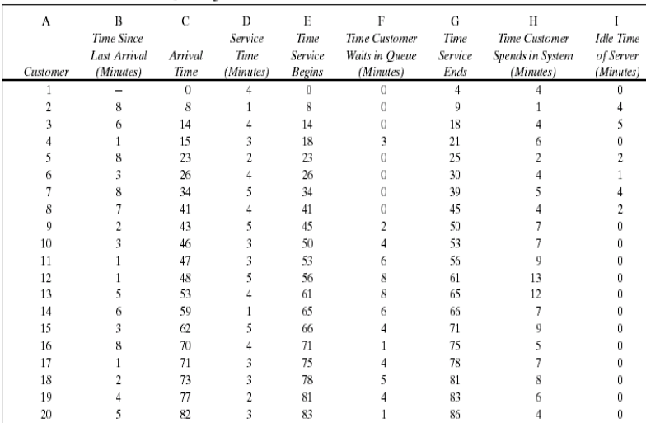

QUESTION 4 (20 Marks)

- Simulation run of 100 customers in a Grocery shop had 174 minutes as total waiting time in the queue. The number of customers who wait were 46 and the total service time was 317 Minutes. Calculate the following: - Average waiting time, Probability that a customer has to wait and Average service time (6 Marks)
- Consider a Queuing Systems for a production company. Draw flow diagram indicating all steps. (8 marks)

- What are the three categories of software used to develop simulation models (6 Marks)

QUESTION 5 (20 Marks)

- Discuss the common random number generators commonly is use ( 3 marks)
- Briefly discuss application of simulations and Modelling in business and logistics process simulation (5 Marks )
- Explain areas of performance evaluation in simulation and modelling (6 Marks )
- Highlight the steps involved in carrying out a simulation exercise (6 marks)

