
UNIVERSITY EXAMINATIONS
EXAMINATION FOR MAY-AUGUST 2020/2021 FOR DIPLOMA IN COMPUTER SCIENCE / INFORMATION TECHNOLOGY

COURSE CODE: RCS 012
COURSE UNIT: DATA STRUCTURES AND ALGORITHM

DATE: 9Th August, 2021 TIME: 2 HOURS

GENERAL INSTRUCTIONS:
Students are NOT permitted to write on the examination paper during exam time.
This is a closed book examination. Text book/Reference books/notes are not permitted.
SPECIAL INSTRUCTIONS:
This examination paper consists Questions in Section A followed by section B.
Answer Question 1 and any Other Two questions.
QUESTIONS in ALL Sections should be answered in answer booklet(s).

PLEASE start the answer to EACH question on a NEW PAGE.

Keep your phone(s) switched off at the front of the examination room.

Keep ALL bags and caps at the front of the examination room and DO NOT refer to ANY unauthorized material before or during the course of the examination.

ALWAYS show your working.

Marks indicated in parenthesis i.e. ( ) will be awarded for clear and logical answers.

Write your REGISTRATION No. clearly on the answer booklet(s).

For the Questions, write the number of the question on the answer booklet(s) in the order you answered them.
- DO NOT use your PHONE as a CALCULATOR.
- YOU are ONLY ALLOWED to leave the exam room 30minutes to the end of the Exam.
- DO NOT write on the QUESTION PAPER. Use the back of your BOOKLET for any calculations or rough work.

SECTION A (COMPULSORY)

QUESTION 1 (30 Marks)
- Define ( 5 Marks)
- Traversal
- Algorithms
- Abstraction
- Data Structure
- Asymptotic Analysis of Algorithms

- With examples, enumerate four ways in which algorithms can be represented.
(4 Marks)

- Discuss the following terms in relation to the rate of growth as the input size of algorithms grows. ( 2 Marks)
- Constant O(1)
- Linear O(n)

- Differentiate between simple ADTs and Complex ADTs. Give examples. ( 4 Marks)

- Explain the sorting algorithm represented by the diagram shown below. ( 4 Marks)

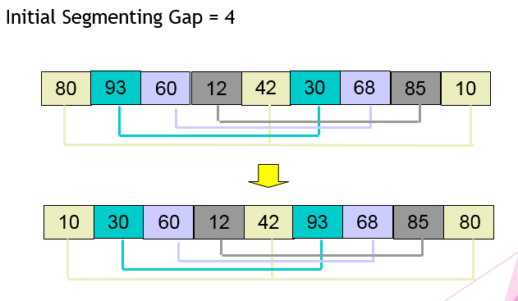
- What are the functions of the following items used in building the Complex Abstract Data Types (ADTs)? Include examples. ( 4 Marks)
- Arrays
- Logical Operators

- Develop an algorithm that helps a humanoid robot learn his environment and find an exit of a room. ( 3 Marks)

- Compare standard Tri with Compressed Tri. ( 2 Marks)

- Describe the following terms as used in analysing the cost of algorithms. ( 2 Marks)
- Resource Complexity
- Operation Complexity

SECTION B (Answer ANY Two Questions)

QUESTION 2 (15 Marks)
- Explain a tree structure. ( 2 Marks)

- A heap is a special kind of balanced tree. Using a diagram, describe ( 6 Marks)
- A balanced tree.
- MAX-heap
- MIN Heap
- Usin an example, discuss how Heap sort works. ( 3 Marks)

- Illustrate a queue ADT. Include all the four operations. ( 4 Marks)

QUESTION 3 (15 Marks)
- Describe the graph data structure. ( 2 Marks)

- Compare the following.
- Directed and undirected graphs. ( 4 Marks)
- Weakly and strongly connected graphs. (4 Marks)

- Using diagrams explain as used in graphs:
i. Depth first traversal search (DFS). (2 Marks)
ii. Breadth first traversal search (BFS) (2 Marks)

- How is a graph used in computer networks? ( 1 Mark)

QUESTION 4 (15 Marks)
- Use a flow chart to represent the insertion sort operations. ( 3 Marks)

- Explain the following terms used in asymptotic analysis of algorithms. ( 3 Marks)
- Best Case
- Average Case
- Worst Case

- Describe the steps in divide-and-conquer approach. ( 2 Marks)

- State a disadvantage and an advantage of a brute force algorithm. ( 2 Marks)

- Using an example illustrate how a merge sort works. ( 3 Marks)

- List the factors to consider when choosing a sorting algorithm. ( 2 Marks)

QUESTION 5 (15 Marks)
- Define ( 3 Marks)
- Recursion
- Backtracking
- Greedy algorithms

- Study the below diagram and state three goals of backtracking.
( 3 Marks)
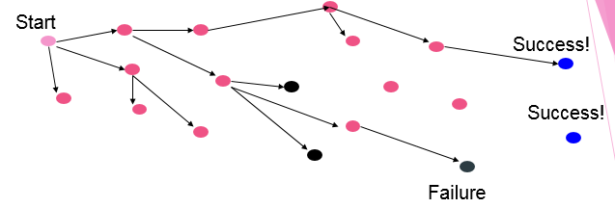

- List two properties of algorithms. ( 2 Marks)

- How are Tries used by Word Processors? ( 2 Marks)

- Draw a stack data structure following sequence: add(A), remove, add(B), remove, add(C), remove, add(D), add(E), remove, add(F), add(G), add (F), remove.( 2 Marks)

- Explain how recursive backtracking is used in a sack problem when you have different fruit sizes so that it is filled fully. These fruits are mangoes, watermelons and lemons. ( 3 Marks)

