
UNIVERSITY EXAMINATIONS
EXAMINATION FOR MAY/AUGUST 2024/2025 DIPLOMA IN COMPUTER SCIENCE/DIPLOMA IN INFORMATION TECHNOLOGY/DIPLOMA IN BUSINESS INFORMATION TECHNOLOGY/DIPLOMA IN CYBER SECURITY
RCS 016 : INTRODUCTION TO DIGITAL ELECTRONICS.

DATE 06 / 08/ 2025 TIME: 2 HOURS
GENERAL INSTRUCTIONS:
Students are NOT permitted to write on the examination question paper during examination time.
This is a closed book examination. Text book/Reference books/notes are not permitted.

SPECIAL INSTRUCTIONS:
This examination paper consists Questions in Section A followed by section B.
Answer Question 1 and any Other Two questions.
QUESTIONS in ALL Sections should be answered in answer booklet(s).

PLEASE start the answer to EACH question on a NEW PAGE.

Keep your phone(s) switched off at the front of the examination room.

Keep ALL bags and caps at the front of the examination room and DO NOT refer to ANY unauthorized material during the course of the examination.

ALWAYS show your working.

Marks indicated in parenthesis i.e. ( ) will be awarded for clear and logical answers.

Write your REGISTRATION No. clearly on the answer booklet(s).

For the Questions, write the number of the question on the answer booklet cover page in the order you answered them.
- DO NOT use your PHONE as a CALCULATOR.
- YOU are ONLY ALLOWED to leave the exam room 1 hour to the end of the Exam.
- DO NOT write on the QUESTION PAPER. Use the back of your BOOKLET for any calculations or rough work.
- Scientific CALCULATOR will be required.

SECTION A (COMPULSORY)

Question (1) - (30Marks)
- Describe the following terms as used in digital logics. (4 Marks)
- A.D.C.
- D.A.C.
- Encoders.
- Decoders.
- Compare the binary numbers system and gray code. (3 Marks)

- Express the circuit below as a Boolean function. (5 Marks)

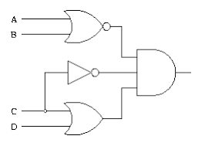
- Considering the Boolean function shown below, draw an equivalent Logic circuit diagram. (5 Marks)

- Design a half adder logic circuit from the first principle and hence implement the logic circuit. (5 Marks)

- Convert the following numbers into the stated format. (4 Marks)

- 17.45₁₀ - into binary number format.
- 10011001.100101₂ - into decimal number format.

- Draw the logic circuit for the following Boolean function. (4 Marks)

$Y_{o} =AB+\left(B⨁C\right)+\overline{A}\overline{C}D$

SECTION B (Answer Any Two Questions)

Question (2) - (15Marks)

- State the De-Morgan’s theorems. (2 Marks)

- Using suitable truth tables or Boolean algebra, prove the De-Morgan’s theorems. (4 Marks)

- Convert the following binary numbers, into Decimal Number. (3 Marks)
11011101.101101₂ Show all the working.
- Convert the following Decimal numbers, into Binary Number. (3 Marks)
146.579₁₀ Show all the working.

- With respect to digital logics, describe the following terminologies. (3 Marks)
- Rise time.
- Fall time.
- Propagation delay.

Question (3) - (15 Marks)

- Considering the Logic Circuit shown below, simplify it and hence implement the simplified logic circuit. (5 Marks)
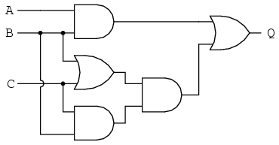

- Evaluate the following calculations / numbers Conversions, into the indicated formats.
NB: Show all the working, marks awarded to only working, not answers. (10 Marks)

- 10101010101010_{bin} into hexadecimal number.
- 11111111_{bin} into gray code.
- 11011010_{bin} into decimal number.
- FEAD_{hex} into octal number.
- 10101_{dec} into binary number.

Question (4) - (15 Marks)
- Derive the Boolean function for the logic circuit below. (5 Marks)
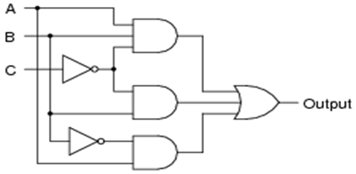

- Design a THREE Bits Binary to Gray code converter. (6 Marks)

- Outline FOUR reasons why designers simplify logic circuits before implementation. (4 Marks)

Question (5) - (15 Marks)
- Define the team universal logic gates. (2 Marks)

- Implement the following logic gates, using any universal logic gates.
- OR - logic gate. (2 Marks)
- AND - logic gate. (2 Marks)
- X- OR - logic gate. (3 Marks)

- Design, from the first principle, a four inputs logic circuit, such that the output will be high, only if three or more inputs are high. Simplify the logic circuit derived and implement the design. (6 Marks)

END

