
UNIVERSITY EXAMINATIONS
EXAMINATION FOR MAY/AUGUST 2020/2021 FOR BACHELOR IN BUSINESS INFORMATION TECHNOLOGY / COMPUTER SCIENCE /
RCS 208: OBJECT ORIENTED ANALYSIS AND DESIGN

DATE: 12TH AUGUST 2021 TIME: 2 HOURS
GENERAL INSTRUCTIONS:
Students are NOT permitted to write on the examination paper during reading time.
This is a closed book examination. Text book/Reference books/notes are not permitted.
SPECIAL INSTRUCTIONS:
This examination paper consists Questions in Section A followed by section B.
Answer Question 1 and any Other Two questions.
QUESTIONS in ALL Sections should be answered in answer booklet(s).
- PLEASE start the answer to EACH question on a NEW PAGE.
- Keep your phone(s) switched off at the front of the examination room and NOT on your person.
- Keep ALL bags and caps at the front of the examination room and DO NOT refer to ANY unauthorized material before or during the course of the examination.
- ALWAYS show your working.
- Marks indicated in parenthesis i.e. ( ) will be awarded for clear and logical answers.
- Write your REGISTRATION No. clearly on the answer booklet(s).
- For the Questions, write the number of the question on the answer booklet(s) in the order you answered them.
- DO NOT use your PHONE as a CALCULATOR.
- YOU are ONLY ALLOWED to leave the exam room 30minutes to the end of the Exam.
- DO NOT write on the QUESTION PAPER. Use the back of your BOOKLET for any calculations or rough work.

SECTION A
QUESTION 1 (COMPULSORY, 30 MARKS).
- Draw a UML class symbol that has the following specification. The class is called “Customer”. It has four attributes: name (which is text), address (also text), balance (a number), and credit rating (type currently unknown). It has one operation: “printStatement()”, which has no parameters or return value. Upload the created diagram. (4 marks)
- Draw a use case diagram of riara university e- learning system(online campus) and upload the document. It should have three actors student,lecturer and administrator. Add relevant use cases at least 3 use cases for each actor. ( 8 marks)
- In the early stages of development it is usually better to identify too many classes than too few. You can then rationalise you choice of classes by removing, modifying and merging them. The following list is of classes that may be considered for deletion or absorption into a new class. Suggest why this might be the case for each example.
(6 marks)
  - Joe James, a student at Riara University
  - Book
  - Car loan
  - Patient
  - Test procedure
  - Red
- Explain the following diagram in detail. Also the diagram is missing multiplicity between the classes. Add multiplicity where necessary and explain why you added it.
(8 marks)
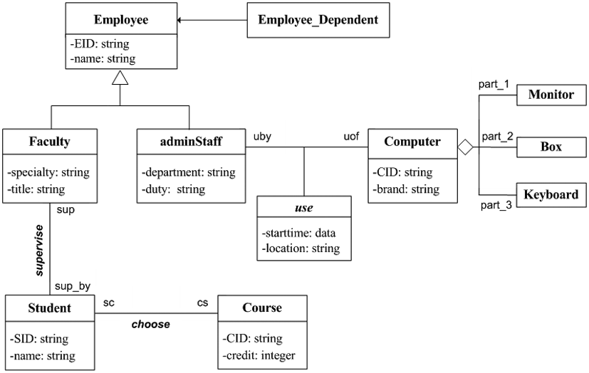
- Consider these three classes: Student, Faculty, and Admin, which are subclasses of a general members’ class. These classes have operations createStudent(), createFaculty(), and createAdmin() respectively. Each of these methods cause the appropriate shape to be drawn. Is this system exhibiting polymorphism or not? Explain your answer.
(4 marks)

ANSWER ANY TWO QUESTIONS
SECTION B (OPTIONAL 2 OUT OF 4)
Question 2 (20 marks)
- Draw a state diagram to illustrate the behavior of a child’s bank account, where no Overdraft is allowed. The account is empty to start with. Money can then be deposited, to put the account in credit, and taken out as long as the account does not become overdrawn. The account can only be closed when the balance is Zero. (8 marks)

- Explain the following component diagram in detail. (4 marks)

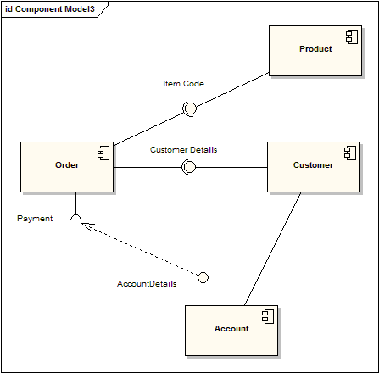

- Briefly explain the difference between the following pairs of terms. You should include small examples to illustrate your answers. (8 marks)
  - Class / object
  - Attribute / operation
  - Association / multiplicity
  - Subclass / superclass
Question 3 (20 Marks).
- Visibility is used to specify which attributes and operations can be seen by the class objects. Discuss the Four levels of Visibility. (4 marks)
- State advantages of object oriented methodology (4 marks)
- Explain different views in UML (4 marks)
- Differentiate: (4 marks)
  - Structural diagrams and behavariol diagrams
  - Object modeling and dyna,mic modelling
- Draw a class diagram for the below scenario: (4 marks)
A dental surgery keeps information about its patients, who may be either private or health service. For each patient the surgery records the name, address, phone number, date of birth and either the health service number or the payment method.

QUESTION FOUR (20 Marks).
- Consider the process of ordering a chapati over the phone.
  - Draw an activity diagram representing each step of the process, from the moment you pick up the phone to the point where you start eating the chapati. Do not represent any exceptions. Include activities that others need to perform.
(12 marks)
  - Explain different types of events within the UML (8 marks)

QUESTION FIVE (20 MARKS)
- Draw a state diagram to illustrate the behavior of a child’s bank account, where no Overdraft is allowed. The account is empty to start with. Money can then be deposited, to put the account in credit, and taken out as long as the account does not become overdrawn. The account can only be closed when the balance is Zero.
(12 marks)
- Explain different types of messages as used in sequence diagrams (8 marks)

