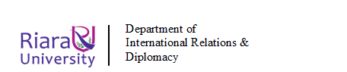
RIARA SCHOOL OF INTERNATIONAL RELATIONS & DIPLOMACY
NURTURING INNOVATORS
SEPTEMBER-DECEMBER 2023 TRIMESTER
FINAL EXAMINATION FOR DEGREE PROGRAM
RIR 114: ENVIRONMENTAL SUSTAINABILITY
DATE: 4TH DECEMBER 2023 DURATION: 2 HOURS
GENERAL INSTRUCTIONS:
- Students are NOT permitted to write on the examination paper during reading time.
- This is a closed book examination. Text book/Reference books/notes are not permitted.
SPECIAL INSTRUCTIONS
- Write your REGISTRATION NO. Clearly on the answer booklet(s).
- Answer Question One and ANY other TWO questions.
- Questions in all sections should be answered in answer booklet(s)
- PLEASE start the answer to EACH question on a NEW PAGE.
- For the questions, write the number of the question on the answer booklet(s) in the order you answered.
- Write on both sides of each leaf and indicate number of each question at the top of each page.
- Write the answers in a paragraph form unless stated otherwise.
- Marks allocated to each question are shown at the end of the question.
- All rough work must be done on the answer booklet and crossed through!
- Use supplementary pages only when you have exhausted those in this book.
- Fasten the supplementary pages to the inside back cover of this booklet.

SECTION A: COMPULSORY (30 MARKS)

QUESTION ONE
a) The diagram shows part of the structure of the atmosphere.

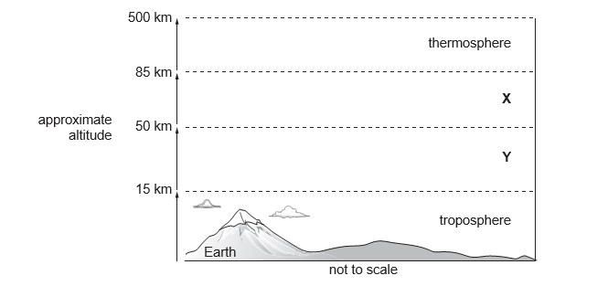

(i) Name the layers of the atmosphere labelled X and Y. (2 marks)
X................................................................
Y ................................................................

(ii) The atmosphere can be polluted by industrial emission. These emissions can cause acid rain.

Explain the formation and impacts of acid rain on the environment.
(6 marks)

b) Examine the implication of urban development on environment (5 marks)
c) “Biodiversity provides us with life sustaining services.” Justify the statement giving examples. (10 marks)
- Using suitable examples, examine the role of the UN Environment in environmental sustainability (7 marks)

SECTION B: CHOOSE TWO QUESTIONS FROM THIS SECTION (40 MARKS)

QUESTION TWO
Environmental Management and Co-ordination (Environmental Impact Assessment/Environmental Audit) Regulations, 2003 has revolutionized environmental management in Kenya in several ways. Explain (20 marks)

QUESTION THREE
Using suitable examples, discuss the causes and effects of the following global environmental concerns
i. Climate change (10 marks)
ii. Ocean acidification (10 marks)

QUESTION FOUR
Elaborate the role of politics in Environmental Management, giving case examples in Kenya
(20 marks)

QUESTION FIVE
As a major sector of the tourism industry, the hotel sector accounts for a significant amount of the overall resource consumption and generates a substantial portion of the waste to the environment.

Critically discuss and analyze the suitable resource management and waste minimization techniques which hotel operators should adopt to mitigate the pressure on the environment. Use relevant examples to illustrate your answer.
(20 marks)

