
UNIVERSITY EXAMINATIONS
EXAMINATION FOR JANUARY-APRIL 2024/2025 FOR BACHELOR OF SCIENCE IN COMPUTER SCIENCE

COURSE: RCS 106 - PROBABILITY AND STATISTICS

DATE: APRIL, 2025 TIME: 2 HOURS

GENERAL INSTRUCTIONS:
Students are NOT permitted to write on the examination paper during exam time.
This is a closed book examination. Text book/Reference books/notes are not permitted.
SPECIAL INSTRUCTIONS:
This examination paper consists Questions in Section A followed by section B.
Answer Question 1 and any Other Two questions.
QUESTIONS in ALL Sections should be answered in answer booklet(s).

PLEASE start the answer to EACH question on a NEW PAGE.

Keep your phone(s) switched off at the front of the examination room.

Keep ALL bags and caps at the front of the examination room and DO NOT refer to ANY unauthorized material before or during the course of the examination.

ALWAYS show your working.

Marks indicated in parenthesis i.e. ( ) will be awarded for clear and logical answers.

Write your REGISTRATION No. clearly on the answer booklet(s).

For the Questions, write the number of the question on the answer booklet(s) in the order you answered them.
- DO NOT use your PHONE as a CALCULATOR.
- YOU are ONLY ALLOWED to leave the exam room 30minutes to the end of the Exam.
- DO NOT write on the QUESTION PAPER. Use the back of your BOOKLET for any calculations or rough work.

SECTION A (COMPULSORY)
QUESTION 1 (30 Marks)
- Define the law of total probability. ( 2 Marks)

- Illustrate the output of the following Python Code when executed. ( 4 Marks)

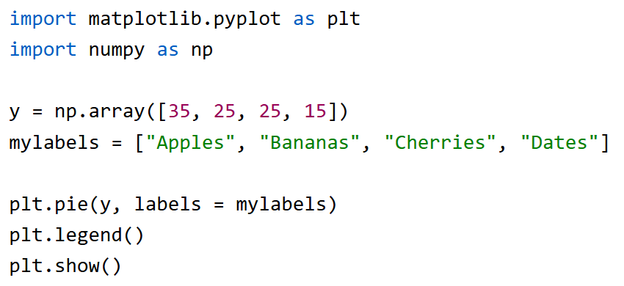

- In a book store, an average of 2 books are per day. What is the probability that exactly 3 books will be sold tomorrow? ( 3 Marks)

- A hawker has a container that has 10 coloured balls. One is green, 5 are red and 4 are blue. What is P(Red, Blue, Green) in the specific order without replacement?
( 3 Marks)

- Enumerate the three main types of probability. Give examples. ( 6 Marks)

- Distinguish between probability and non-probability sampling. Give examples.
( 4 Marks)

- One hundred pastoralists lived arid and semi-arid areas. On their way, 40 pastoralists purchased oranges, 30 purchased mangoes, and 20 purchased oranges and mangoes. If a pastoralist chosen randomly bought an orange, what is the probability he also bought a mango? ( 3 Marks)

- Explain how conditional probability can be used to determine independence.
( 2 Marks)

- Describe the output of the following code when considering combinations and permutations of events occurrences. ( 3 Marks)
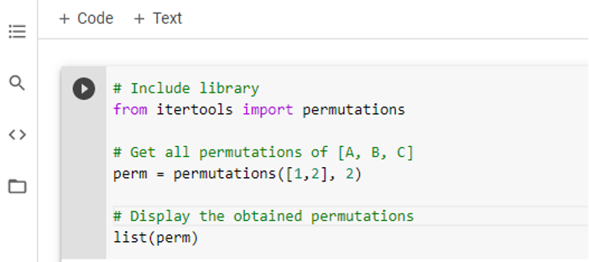

SECTION B (Answer ANY Two Questions)

QUESTION 2 (15 Marks)
- List two ways of describing the elements in a set. Give examples. ( 2 Marks)

- Compare Statistical Independence and Pairwise Independence. ( 2 Marks)

- Explain four main data classification types. ( 4 Marks)

- In a coin flipping experiment, you will win if the output is tail. If it is a fair coin and considering Bernoulli Distribution, what is the probability of success when the coin is flipped once? ( 3 Marks)

- Determine the number of classes using Sturge’s rule, in a set of data where N is the number of observations, calculate the class interval of the salary of 120 employees in a flower farm in which it varies between Ksh. 1500 and Ksh. 75, 500. ( 4 Marks)

QUESTION 3 (15 Marks)
- Compare atomic event with a compound event. ( 2 Marks)

- Describe the output of the following R Code when executed. ( 4 Marks)

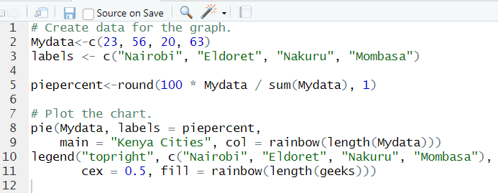

- Define ( 2 Marks)
- Z-Score
- Sampling Error

- Two events Windy (W) and Humid (H) were observed in Kenya. Given that P(W)= 0.6 and P(H)=0.4. If W and H are independent, what is P(W|H)? ( 2 Mark)

- Seven scores were recorded during a basketball match. Calculate their relative frequency. ( 2 Marks)
14 24 18 19 42 16 12

- During Kenyan elections, investigation is carried out to identify independent voters. If your probability of success is 0.1, considering Geometric Distribution, what is the probability that you will meet an independent voter on your third try? ( 2 Marks)

- Mean, mode and median are measures of Central Tendency. State a disadvantage of using median in analysing the performance of an AI agent you have designed.
( 1 Mark)

QUESTION 4 (15 Marks)
- Illustrate mesokurtic, platykurtic and leptokurtic graphs as used in statistics.
( 3 Marks)

- Sketch the output of the following Python Code. ( 3 Marks)
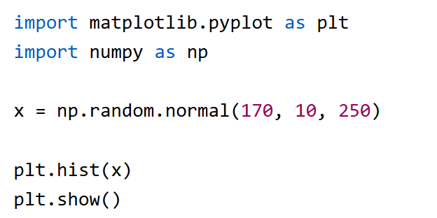

- What is P(A ∩ B) given that P(A)= 0.6 and P(B)=0.2 while A and B are independent?
( 1 Mark)

- Given Mean = 24, Mode =30, Median=26, and Standard Deviation =2.25. Using Pearson’s first or second Coefficient of Skewness, determine if the measure was positively or negatively skewed. ( 3 Marks)

- Determine the standard deviation from the mean of the set of numbers: {45, 32, 25, 23, 28, 53, 62}. ( 3 Marks)

- Using scatter diagrams, illustrate a correlation when r = - 1 ( 2 Marks)

QUESTION 5 (15 Marks)
- A researcher in the School of Computing Sciences observed a set of values that has a mean of 23 and a standard deviation of 2. Find the Z-score of 21, one of the values observed during the experiment. ( 2 Marks)

- Illustrate the output of the code shown below. ( 4 Marks)
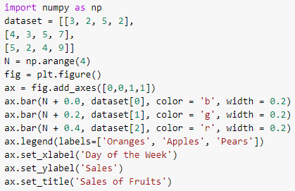

- Define ( 2 Marks)
  - Centroid as used in Data Clustering
  - Class Interval as used in Data Classification

- If C=A ∩ B, given A={4,5,6,8} and B={5,6,7, 9}. What will C be? ( 2 Marks)

- Enumerate two assumptions when using Karl Pearson’s coefficient of correlation.
( 2 Marks)

- Calculate the Interquartile Range of the array: 10 24 63 15 16 17 18 21 22.
( 3 Marks)

