
UNIVERSITY EXAMINATIONS
EXAMINATION FOR SEPTEMBER/DECEMBER 2023/2024 FOR BACHELOR OF SCIENCE IN COMPUTER SCIENCE/BACHELOR OFBUSINESS IN INFORMATION TECHNOLOGY
RCS 102 OBJECT-ORIENTED PROGRAMMING
DATE: NOVEMBER 2023 TIME: 2 HOURS
GENERAL INSTRUCTIONS:
Students are NOT permitted to write on the examination paper during Exam time.
This is a closed book examination. Text book/Reference books/notes are not permitted.
SPECIAL INSTRUCTIONS:
This examination paper consists Questions in Section A followed by section B.
Answer Question 1 and any Other Two questions.
QUESTIONS in ALL Sections should be answered in answer booklet(s).

PLEASE start the answer to EACH question on a NEW PAGE.

Keep your phone(s) switched off at the front of the examination room and NOT on your person.

Keep ALL bags and caps at the front of the examination room and DO NOT refer to ANY unauthorized material before or during the course of the examination.

ALWAYS show your working.

Marks indicated in parenthesis i.e. ( ) will be awarded for clear and logical answers.

Write your REGISTRATION No. clearly on the answer booklet(s).

For the Questions, write the number of the question on the answer booklet(s) in the order you answered them.
- Write your REGISTRATION No. clearly on the answer booklet(s).
- DO NOT use your PHONE as a CALCULATOR.
- YOU are ONLY ALLOWED to leave the exam room 30minutes to the end of the Exam.

SECTION A (Compulsory-30 MARKS)
QUESTION ONE (30 MARKS)
- Explain one similarity and one differences present in a class and Constructor (4marks)
- State whether each of the following is true or false. If false, explain why.
- Methods declared public in a super class also must be private in all sub classes. (1mark)
- Methods declared private are inherited at all. (1mark)
- A constructor is a special method that return a type. (1mark)
- Final is a keyword that can be used with a class to signify that the class should remain as it is without any change. (1mark)
- Extends is a keyword that can be used to demonstrate inheritance between a class and an Interfaces. (1mark)
- The access specifiers used with classes are private only (1mark)
- In Java, memory locations created for the Users interact with at run time can do so without an object. (1mark)
- Study the portion of program below and answer the questions that follow
- package rcs102;
- public class Rcs102{
- String studentname;
- int studentage;
- int studentmarks;

- public Rcs102(String name) {
- System.out.println("Name chosen is :" + name );
- }

- public void setAge( int age ) {
- studentage = age;
- }

- public void setMarks( int marks) {
- studentmarks = marks;
- }

- public void displayInfo( ) {
- System.out.println("The student’s age is :" + studentage );
- System.out.println("The student’s marks is :" + studentmarks );
- }

- public static void main(String [ ]args) {
- Rcs102 student1= new Rcs102( "Tommy" );
- student1.setAge( 24 );
- student1.setMarks(80);
- student1.displayInfo( );
- }

    - Outline the appropriate name to give to our file for the program above to run if we have to use any integrated development environment. (1 mark)
    - Identify the user defined classes and package present in the program. (2marks)
    - Describe the purpose of a constructor in the program. Demonstrate your understanding using the program above by starting the portion of the program that is using it. (5marks)
    - List the instance variables used in the program (3marks)
    - Outline the name of the objects that have been used in the program. (2marks)
    - State the functions that have been used in the program. (4marks)
    - Outline the output of the program once the programmer runs the code. (3marks)
SECTION B (Answer Any TWO questions -30 MARKS)
QUESTION TWO (15 MARKS)
- State whether the following is a class name,Keyword, method name, variable or invalid. (10marks)
    - printf
    - final
    - protected
    - total$marks.
    - program_flow
    - totals.
    - TotalMarks-
    - Class.
    - string

- Assuming that x is 4 show the result of the following Boolean expressions.
(5marks)
        - (true) && (10 > 4)
        - (x > 0) | | (x < 0)
        - (x != 1) = = !(x = = 1)
        - (x != 0) | | (x == 0)
        - !(x > 0) && (x > 0)

QUESTION THREE (15 MARKS)
- Refer to Section A question one part c. Convert the program to become interactive by using the Scanner class. Be creative as possible. (7marks)
- As a developer you have been called upon to help identify the appropriate object that the compiler and interpreter would use in a, b, c and d. Give the reason for your answer. (8marks)
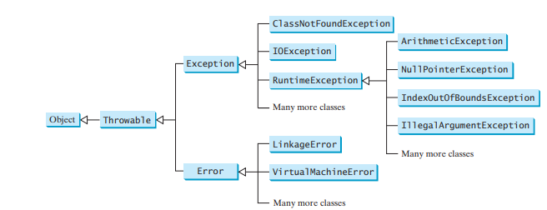

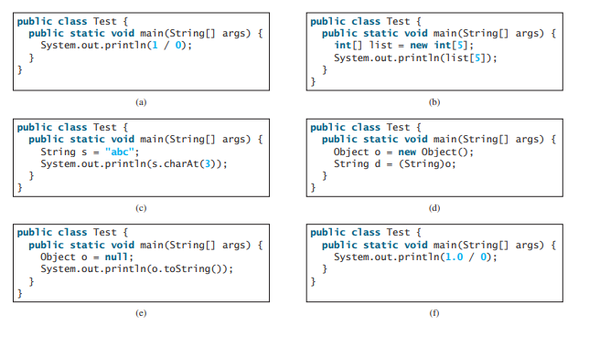
QUESTION FOUR (15 MARKS)
- Study the program below and answer the questions that follow.
public class Loop {
public static void main(String[ ] args) {
for (int i = 1; i <= 5; i++) {
System.out.println("Iteration " + i);
}
}
  - Define the term control variable. (1mark)
  - Name the control variable that has been used in the program. (1mark)
  - Identify the test condition that has been used in the program. (1mark)
  - Explain how the loop works. (2marks)
  - State the output of the program. (2marks)
  - List the five essentials of a counter controlled loop. (5marks)
  - Convert the program to use while loop. (3marks)

QUESTION FIVE (15MARKS)
- Create an interactive program that allows a student to enter marks for 7subjects and calculates the total marks and average marks they have done in a semester.The program displays the name of the student, the total marks scored and the average score. Use an array and any loop of your own choice. (10marks)
- State whether each of the following is true or false. If false, explain why.
    - By convention, method names do not begin with a lowercase first letter, and all subsequent words in the name begin with a capital first letter. (1mark)
    - An import declaration is required when one class in a package uses another in the same package. (1mark)
    - Arguments in parentheses following a method name in a method declaration indicate that the method requires parameters to perform its task. (1mark)
    - Methods overloading is the ability of a method to behave in one forms in the program. (1mark)
    - Variables declared in the body of a particular method are known as local variables and can be used in all methods of the class. (1mark)

