
UNIVERSITY EXAMINATIONS
EXAMINATION FOR SEPTEMBER/DECEMBER 2023/2024 FOR BACHELOR OF SCIENCE IN COMPUTER SCIENCE
COURSE CODE: RCS 210 COURSE TITLE: INTRODUCTION TO EMBEDDED SYSTEMS.

DATE: -- /-- /2023. TIME: 2 HOURS
GENERAL INSTRUCTIONS:
Students are NOT permitted to write on the examination paper during examination time.
This is a closed book examination. Text book/Reference books/notes are not permitted.

SPECIAL INSTRUCTIONS:
This examination paper consists Questions in Section A followed by section B.
Answer Question 1 and any Other Two questions.
QUESTIONS in ALL Sections should be answered in answer booklet(s).

PLEASE start the answer to EACH question on a NEW PAGE.

Keep your phone(s) switched off at the front of the examination room.

Keep ALL bags and caps at the front of the examination room and DO NOT refer to ANY unauthorized material before or during the course of the examination.

ALWAYS show your working.

Marks indicated in parenthesis i.e. ( ) will be awarded for clear and logical answers.

Write your REGISTRATION No. clearly on the answer booklet(s).

For the Questions, write the number of the question on the answer booklet(s) in the order you answered them.
- DO NOT use your PHONE as a CALCULATOR.
- YOU are ONLY ALLOWED to leave the exam room 30minutes to the end of the Exam.
- DO NOT write on the QUESTION PAPER. Use the back of your BOOKLET for any calculations or rough work.

SECTION A (COMPULSORY)

Question (1) - (30Marks)
- Define the following terms/abbreviations as used in the embedded systems. (10 Marks)
  - Sensors.
  - Actuators.
  - Transducers.
  - Microcontroller.
  - Interrupt latency.

- State FIVE technological fields / applications that embedded systems are deployed due to their desirable features. (5 Marks)

- Discuss FOUR characteristics of embedded systems. (4 Marks)

- Describe P.W.M. and state how it is used in embedded systems. (4 Marks)

- State FIVE, hardware related major factors to consider when choosing embedded systems microcontroller. (5 Marks)

- Describe boot loaders, as used in the embedded systems. (2 Marks)

SECTION B (Answer Any Two Questions)

Question (2) - (15 Marks)

- Describe any FIVE components of an embedded system environments and their purpose as well as elaborate on how they operate generally. (5 Marks)

- Explain the purposes of the following in-built components of microcontrollers? (5 Marks)
- I.C.S.P.
- Flash ROM.
- RC Oscillator.
- Real time clock.
- Watch dog timers.

- Discuss how the embedded system are interfaced to the inputs and outputs of real-world systems. (5 Marks)

Question (3) - (15 Marks)

- Define the following technologies as used in embedded system. (4 Marks)
- F.P.G.A.
- A.S.I.C.

- With reference to programmable input and outputs of microcontrollers.
- Describe G.P.I.O. concept. (1 Marks)
- State TWO purposes of DDR register. (2 Marks)
- Compare the G.P.I.O. to primary buses in microprocessors. (2 Marks)

- Briefly describe the following technologies. (6 Marks)
- IoT.
- LoRa.
- ZigBee.

Question (4) - (15 Marks)

- In details compare between USART & UART communication protocols? (4 Marks)

- State FIVE types or categories of embedded systems. (5 Marks)

- Outline FOUR differences between microprocessors and microcontrollers. (4 Marks)

- An embedded system is used in measuring the patient’s temperature, heart beat rate, breathing rate as well as motion in an ICU. With respect to this, answer the following questions.
- Which types of operating system should be use? (1 Marks)
- State any two sensors likely to be used. (1 Marks)

Question (5) - (15 Marks)

- Explain in details how each of the following communication protocols works, to facilitate communicate between microcontrollers, or other connected devices. (6 Marks)

- I₂C.
- SPI.
- USB.

- A technician needs to interface about 10 LCD displays (16 X 2 dot matrix), and a micro-SD card to a system in their project in a console room where workers can monitor and record various parameters of an industry.

- As embedded system designer, which communication protocols would you advice for use in both interfaces? (2 Marks)

- Justify you choices in the question above. (2 Marks)

- As an embedded system designer, you are required to develop an embedded system to incorporate a micro controller and a dot matrix display, as shown in the figure below.

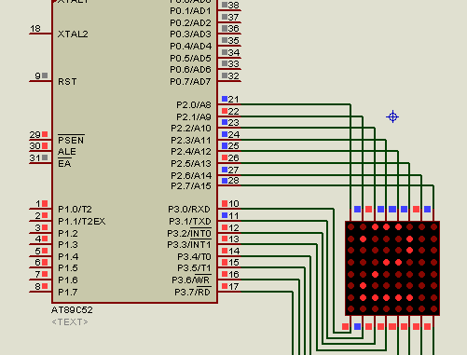

- Briefly describe algorithms / pseudocode you would deploy to display alphanumeric characters on the display. ` (5 Marks)

END

