
UNIVERSITY EXAMINATIONS
EXAMINATION FOR JAN/APRIL 2025/2026 FOR CERTIFICATE IN INFORMATION TECHNOLOGY
RCCS5125: INTRODUCTIO TO DATABASE SQL
DATE : 10TH APRIL 2026 TIME: 2 HOURS
GENERAL INSTRUCTIONS:
Students are NOT permitted to write on the examination question paper during examination time.
This is a closed book examination. Text book/Reference books/notes are not permitted.
SPECIAL INSTRUCTIONS:
This examination paper consists Questions in Section A followed by section B.
Answer Question 1 and any Other Two questions.
QUESTIONS in ALL Sections should be answered in answer booklet(s).

- PLEASE start the answer to EACH question on a NEW PAGE.
- Keep your phone(s) switched off at the front of the examination room.
- Keep ALL bags and caps at the front of the examination room and DO NOT refer to ANY unauthorized material during the course of the examination.
- ALWAYS show your working.
- Marks indicated in parenthesis i.e. ( ) will be awarded for clear and logical answers.
- Write your REGISTRATION No. clearly on the answer booklet(s).
- For the Questions, write the number of the question on the answer booklet’s cover page in the order you answered them.
- DO NOT use your PHONE as a CALCULATOR.
- YOU are ONLY ALLOWED to leave the exam room 1 hour to the end of the Exam.
- DO NOT write on the QUESTION PAPER. Use the back of your BOOKLET for any calculations or rough work.

SECTION A (COMPULSORY)
QUESTION ONE (30 MARKS)
a) Databases are designed to efficiently store, manage, and retrieve data.
- Define the term database. (2 Marks)
- Explain the ACID properties in a Database Management System and their importance. . (8 Marks)
b) The relational data model is widely used in modern databases.
Differentiate between the following pairs:
- Attribute and Tuple (2 Marks)
- Primary Key and Foreign Key (2 Marks)
- Super key and candidate key (2 Marks)
c) Figure 3 shows a database model. Use it to answer the question that follow
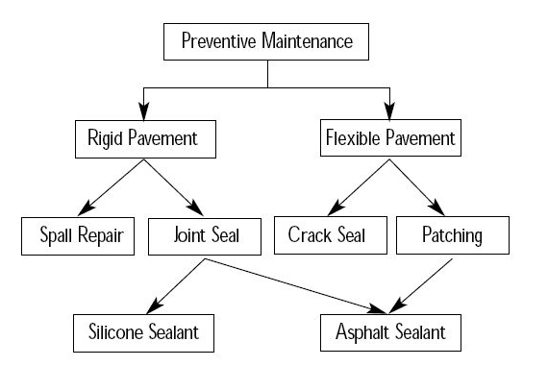
- Identify the type of database model (1 Mark)
- State three advantages of using the model identified in (i). (3 Marks)

SECTION B: ANSWER ANY TWO QUESTIONS (30 MARKS)
QUESTION TWO (15 MARKS)
a) Data modeling is a critical stage in database design.
- Explain the purpose of conceptual data modeling. (3 Marks)
- With the aid of a diagram describe four components of an Entity Relationship (ER) model. (8 Marks)
b) Explain the difference between:
- Strong entity and Weak entity (2 Marks)
- Total participation and Partial participation (2 Marks)

QUESTION THREE: (15 MARKS)
a) Outline TWO characteristics of the first normal form (1NF) (2 Marks)
b) Explain each of the following types of anomalies in Normalization (6 Marks)
- Update
- Deletion
- Insertion
c) Table 1 shows information contained in a database table. Use it to answer the question that follow
Roll_no | Name | subject
101 | John | OS,CN
103 | Jeremy | Java
102 | Jacob | C, C++
Table 1
Normalize the table up to the second normal form (7 Marks)

QUESTION FOUR: (15 MARKS)
a) Explain physical database design. (3 Marks)
b) Explain two concurrency problems that may occur in a multi-user database system.
(4 Marks)
c) Read the passage below and answer the question that follows.
A library wishes to maintain a database to track books and members. Each book is identified by its ISBN, title, and author. Members are identified by a Membership ID, name, and contact details. A member can borrow multiple books, and the library records the borrow date and return date for each book.
Draw an Entity-Relationship Diagram (ERD) to represent this information. (8 Marks)
QUESTION FIVE (15 MARKS)
a) The table below shows a database relation named Staff
StaffID | Name | Age | Department | Salary
1 | John | 30 | Sales | 30000
2 | Mary | 28 | IT | 45000
3 | Peter | 35 | HR | 40000
4 | Sarah | 27 | IT | 42000
5 | David | 32 | Finance | 50000
Write SQL statements to:
- Create the STAFF table, ensuring StaffID is unique. (4 Marks)
- Increase the Salary of all employees in the IT department by 5,000. (4 Marks)
- Delete the record of the employee named Peter. (4 Marks)
- Display the Name and Department of employees aged between 28 and 35, sorted alphabetically by Name. (3 Marks)

