
UNIVERSITY EXAMINATIONS
EXAMINATION FOR MAY/AUGUST 2024/2025 FOR BACHELOR OF SCIENCE IN COMPUTER SCIENCE
COURSE CODE: RCS 210 COURSE TITLE: EMBEDDED SYSTEMS

DATE:04 /07/ 2025. TIME: 2 HOURS
GENERAL INSTRUCTIONS:
Students are NOT permitted to write on the examination paper during examination time.
This is a closed book examination. Text book/Reference books/notes are not permitted.

SPECIAL INSTRUCTIONS:
This examination paper consists Questions in Section A followed by section B.
Answer Question 1 and any Other Two questions.
QUESTIONS in ALL Sections should be answered in answer booklet(s).

PLEASE start the answer to EACH question on a NEW PAGE.

Keep your phone(s) switched off at the front of the examination room.

Keep ALL bags and caps at the front of the examination room and DO NOT refer to ANY unauthorized material before or during the course of the examination.

ALWAYS show your working.

Marks indicated in parenthesis i.e. ( ) will be awarded for clear and logical answers.

Write your REGISTRATION No. clearly on the answer booklet(s).

For the Questions, write the number of the question on the answer booklet(s) in the order you answered them.
- DO NOT use your PHONE as a CALCULATOR.
- YOU are ONLY ALLOWED to leave the exam room 1 hour to the end of the Exam.
- DO NOT write on the QUESTION PAPER. Use the back of your BOOKLET for any calculations or rough work.
- Calculator may be needed.

SECTION A (COMPULSORY)

Question (1) - (30Marks)
- Describe in details, the following terms as used in the embedded systems. (10 Marks)
  - Sensors.
  - Actuators.
  - Transducers.
  - Microcontroller.
  - Embedded System.

- Outline FOUR differences between microprocessors and microcontrollers. (4 Marks)

- An Analog to Digital Converter in microcontrollers, has 12 bits – Outputs lines. With reference to the ADC, answer the questions below;

- Evaluate conversion range for the ADC circuit outputs. (2 Marks)
- Evaluate the resolution for the systems for the ADC circuit outputs. (2 Marks)
- Assuming that the system is operated with a voltage supply of (0 – 5V), with an independent ADC ground, calculate the quantization error. (3 Marks)

- Discuss any FIVE components of an embedded system environment, stating their purpose in the embedded system environments. (5 Marks)

- Compare the I₂C and S.P.I. communication protocols outlining specifications and other major differences.

- Define the following technologies as used in embedded systems. (4 Marks)
- F.P.G.A.
- A.S.I.C.

SECTION B (Answer Any Two Questions)

Question (2) - (15 Marks)

- State FIVE types / categories of embedded systems. (5 Marks)

- Discuss the following concepts, as used in the embedded systems. (4 Marks)
- S.O.C.
- G.P.I.O.

- Outline the difference between USART & UART communication protocols? (4 Marks)

- Define the term boot loader as used in Embedded Systems. (2 Marks)

Question (3) - (15 Marks)

- Most of the microcontrollers’ architecture are based on the RISC architecture rather than the CISC.

- State the major differences between the two architectures. (5 Marks)
- Justify why most embedded systems are RISC architecture based. (1 Marks)

- Explain are the purposes of the following in-built components of microcontrollers? (5 Marks)
- A.D.C.
- P.W.M.
- RC Oscillator.
- Real Time Clock.
- Watch-dog Timers.

- A technician needs to interface about 10 LCD displays (16 X 2 dot matrix), and a micro-SD card to a system in their project in a console room where workers can monitor and record various parameters of an industry. As embedded system designer, which communication protocols, would you recommend for use, in each of the interface?
Justify your choices. (4 Marks)

Question (4) - (15 Marks)
- The schematic diagram below, indicates a keyboard and a seven-segment display system to be used in controlling motor speed parameters. The interface allows the user to press any digit value (0, 1, 2…9), which is displayed, and press button labeled A (accept), then the system implement speed control, by setting the speed proportionally to the keyed value.
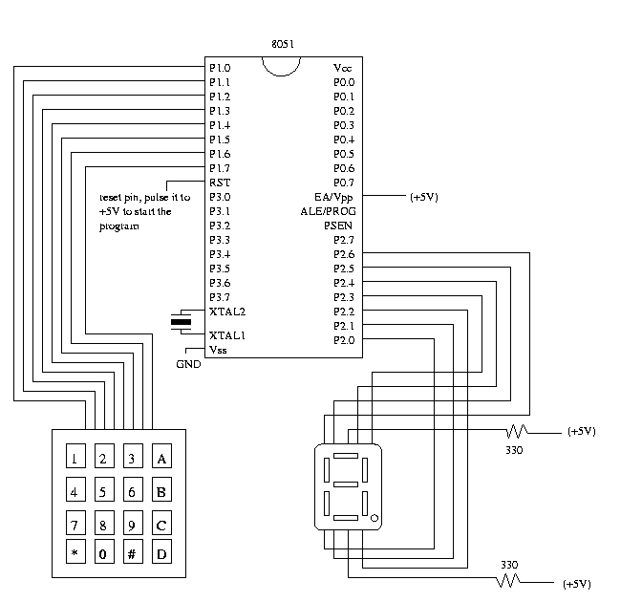
Design simple algorithms/pseudocode to be used to achieve the control. (6 Marks)

- As an embedded system designer, you are required to develop an embedded system to be incorporated to a vehicle’s air bag system, for safety during collision or accidents

- What type of an operating system would you deploy? (1 Marks)
- Which sensors & actuators you utilize to develop the system? (2 Marks)
- Briefly describe algorithms you would deploy. (2 Marks)

- Discuss how the following components are used. (4 Marks)
Serial Monitor.
Serial Plotter.

Question (5) - (15 Marks)

- Microcontrollers can communicate between each other or with other connected devices through either of the following communication protocols.
- C.A.N Bus.
- U.A.R.T.
- U.S.A.R.T.
Explain how each of the above-mentioned protocol works. (9 Marks)

- As an embedded system designer, you are required to develop an embedded system to incorporate a micro controller and a dot matrix display, as shown in the figure below.

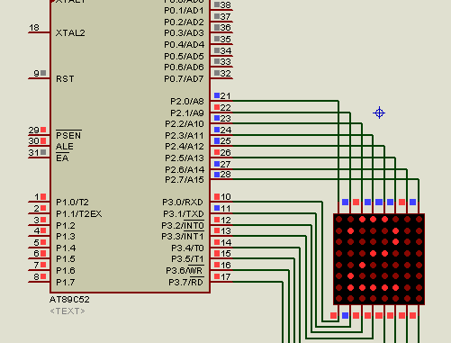

- Briefly describe algorithms / pseudocode you would deploy to display alphanumeric characters on the display. (4 Marks)
- Which hexadecimal values would you use to represent the character '2' shown on the display? (2 Marks)

END

