
UNIVERSITY EXAMINATIONS

EXAMINATION FOR SEPTEMBER/DECEMBER 2025 /2026 FOR DIPLOMA IN COMPUTER SCIENCE

COURSE: RDCS6123– OBJECT ORIENTED PROGRAMMING

DATE: 8th DECEMBER 2025 TIME: 2 HOURS

GENERAL INSTRUCTIONS:
Students are NOT permitted to write on the examination paper during examination time.
This is a closed book examination. Text book/Reference books/notes are not permitted.

SPECIAL INSTRUCTIONS:
This examination paper consists Questions in Section A followed by section B.
Answer Question 1 and any Other Two questions.
QUESTIONS in ALL Sections should be answered in answer booklet(s).

PLEASE start the answer to EACH question on a NEW PAGE.

Keep your phone(s) switched off at the front of the examination room and NOT on your person.

Keep ALL bags and caps at the front of the examination room and DO NOT refer to ANY unauthorized material before or during the course of the examination.

ALWAYS show your working.

Marks indicated in parenthesis i.e. ( ) will be awarded for clear and logical answers.

Write your REGISTRATION No. clearly on the answer booklet(s).

For the Questions, write the number of the question on the answer booklet(s) in the order you answered them.
- DO NOT use your PHONE as a CALCULATOR.
- YOU are ONLY ALLOWED to leave the exam room 30minutes to the end of the Exam.
- DO NOT write on the QUESTION PAPER. Use the back of your BOOKLET for any calculations or rough work.

SECTION A (COMPULSORY)
QUESTION 1 ( 30 Marks)
- Programming languages have both strengths and weaknesses. List three disadvantages of Object-Oriented Programming Languages. (3 Marks)
- Providing examples of each, differentiate between: (8 Marks)
- Classes and Interfaces in Java
- Procedural and Object-oriented programming
- Provide three attributes or features of an object. An object is a computational entity that: (3 Marks)
- If you created two public Java classes Farmer( ) and Animal( ). In addition, you also created a private class Buyer( ) and a derived class Dog() that inherits from class Animal( ). Explain how access specifiers affect the interaction among these classes.
(4 Marks)
- Including all the sections of a Java or C++ code, write a program that calls three other methods from the main method. When called, these methods should display three different statements based on the role of each method. (8 Marks)
- Describe a situation where in Object Oriented Programming exception handling is important. Show how this is achieved. (4 Marks)
SECTION B (Answer ANY Two Questions)
QUESTION 2 (15 Marks)
- Write a Java or C++ program that uses nested if… else to determine if a learner is going to earn grade A, B, C, D or Course Incomplete status based their grades.
(7 Marks)
- Study the diagram and explain any four forms of inheritance. (4 Marks)

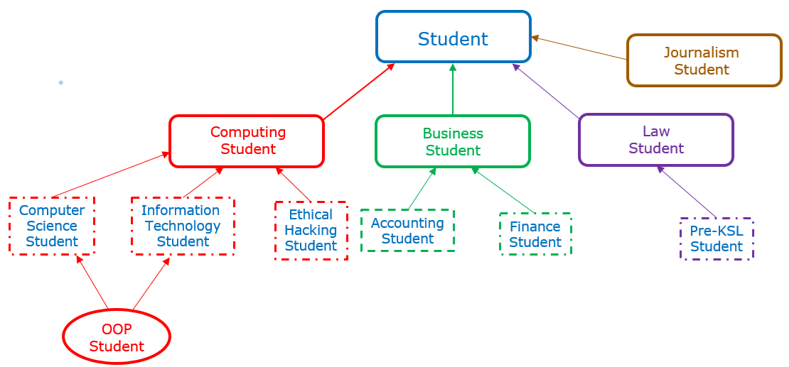

- Differentiate between: ( 4 Marks)
- Text Field and Text Area GUI components
- Static Binding and Dynamic Binding

QUESTION 3 (15 Marks)
- Using an example, illustrate an array of 5 integers. (3 Marks)
- Explain two ways of controlling and exiting loops. (4 Marks)
- Write Java or C++ code for a bank account object that can allow users to achieve the following: (8 Marks)
- Deposit
- Withdraw
QUESTION 4 (15 Marks)
- Define a constructor as used in OOP. (2 Marks)
- Explain the structure of a for loop control structure. Include an example. (6 Marks)
- Demonstrate Polymorphism as used in Object Oriented Programming graphical user interfaces. (4 Marks)
- Compare how public and private access specifies are implemented in C++ and Java. Include examples. (3 Marks)
QUESTION 5 (15 Marks)
- Explain the structure and output of a do while loop control structure. Include an example. (6 Marks)
- Write a C++ programme that prompts the use to provide some information, computes or carries out a logic operation and displays an output that is based on the provided information. (7 Marks)
- Describe the logical operator represented by the following diagram. (2 Marks)
