
UNIVERSITY EXAMINATIONS
EXAMINATION FOR SEPTEMBER/DECEMBER 2023/2024 DIPLOMA IN COMPUTER SCIENCE/DIPLOMA IN INFORMATION TECHNOLOGY/DIPLOMA IN BUSINESS INFORMATION TECHNOLOGY/DIPLOMA IN CYBER SECURITY
RCS 034: MOBILE APPLICATIONS DEVELOPMENT
DATE: 1ST DECEMBER 2023 TIME: 2 HOURS
GENERAL INSTRUCTIONS:
Students are NOT permitted to write on the examination question paper during exam time.
This is a closed book examination. Text book/Reference books/notes are not permitted.
SPECIAL INSTRUCTIONS:
This examination paper consists Questions in Section A followed by section B.
Answer Question 1 and any Other Two questions.
QUESTIONS in ALL Sections should be answered in answer booklet(s).

PLEASE start the answer to EACH question on a NEW PAGE.

Keep your phone(s) switched off at the front of the examination room.

Keep ALL bags and caps at the front of the examination room and DO NOT refer to ANY unauthorized material during the course of the examination.

ALWAYS show your working.

Marks indicated in parenthesis i.e. ( ) will be awarded for clear and logical answers.

Write your REGISTRATION No. clearly on the answer booklet(s).

For the Questions, write the number of the question on the answer booklet cover page in the order you answered them.
- DO NOT use your PHONE as a CALCULATOR.
- YOU are ONLY ALLOWED to leave the exam room 1hour to the end of the Exam.
- DO NOT write on the QUESTION PAPER. Use the back of your BOOKLET for any calculations or rough work.

QUESTION ONE (30Marks)
- Using appropriate attributes, write a snippet code that would display the following toast message” covid-19 is real, keep social distance”. (4 marks)
- With the help of a diagram, describe the activity life cycle of an Android application (6 marks)
- Write a snippet code that would display the following output in an emulator.
(8 marks)
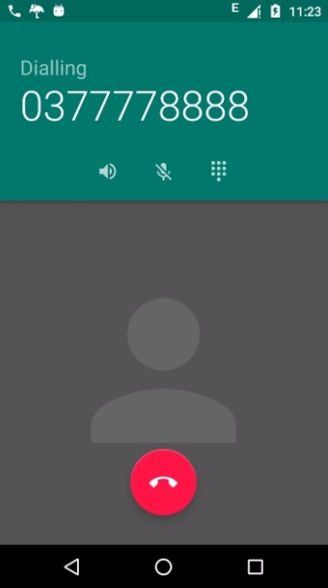
- State any THREE types of notification in android development. (3 marks)
- Discuss any THREE disadvantages of using threads in App development
- Briefly explain any THREE factors or consideration before developing an application.
(3 marks)
QUESTION TWO
a) Explain any TWO key roles of the Android manifest file (2 marks)
b) Mobile phone software development environment pauses unique as challenges as opposed to Computer software development environment, explain any THREE of the challenges (3 marks)
- Write an android snippet code that would convert the following Url “https://e-learning.daystar.ac.ke” to an application (10 marks)

QUESTION THREE
- Describe THREE things we can do as developers to make our apps more accessible to people who cannot use a mobile device the standard way. (6 marks)
- Discuss FOUR core components of an Android app and how they are put together to create a full-featured app. (4 marks)
- Describe what it means for an app to run 'in a sandbox' and how that affects how that app runs on the device. (5 marks)

QUESTION FOUR
- Compare and contrast native mobile app design versus standard desktop app design. (3 marks)
- Assuming you have asked to do an interface for the following scenarios. What kind of the layout would be appropriate? Give a reason for your answer (5 marks)
i) Tour guide application (1 marks)
ii) Food order application
- Briefly explain any TWO types of layouts (2 marks)
- Outline any FOUR types of dialogue boxes (4 marks)

QUESTION FIVE
- Differentiate between:
- Option menus from context menus. (3 marks)
- Wrap content and match parent (2 marks)
.
- Differentiate a content provider from a broadcast receiver. Describe a scenario where you would use each (6 marks)
- Explain how an activity that is destroyed differs from one that is stopped (4 marks)

