
UNIVERSITY EXAMINATIONS
EXAMINATION FOR SEPT/DEC 2021/2022 FOR BACHELOR IN BUSINESS INFORMATION TECHNOLOGY / COMPUTER SCIENCE /
RCS 208: OBJECT ORIENTED ANALYSIS AND DESIGN

DATE: 30TH NOVEMBER 2021 TIME: 2 HOURS
GENERAL INSTRUCTIONS:
Students are NOT permitted to write on the examination paper during reading time.
This is a closed book examination. Text book/Reference books/notes are not permitted.
SPECIAL INSTRUCTIONS:
This examination paper consists Questions in Section A followed by section B.
Answer Question 1 and any Other Two questions.
QUESTIONS in ALL Sections should be answered in answer booklet(s).
- PLEASE start the answer to EACH question on a NEW PAGE.
- Keep your phone(s) switched off at the front of the examination room and NOT on your person.
- Keep ALL bags and caps at the front of the examination room and DO NOT refer to ANY unauthorized material before or during the course of the examination.
- ALWAYS show your working.
- Marks indicated in parenthesis i.e. ( ) will be awarded for clear and logical answers.
- Write your REGISTRATION No. clearly on the answer booklet(s).
- For the Questions, write the number of the question on the answer booklet(s) in the order you answered them.
- DO NOT use your PHONE as a CALCULATOR.
- YOU are ONLY ALLOWED to leave the exam room 30minutes to the end of the Exam.
- DO NOT write on the QUESTION PAPER. Use the back of your BOOKLET for any calculations or rough work.

SECTION A
QUESTION 1 (COMPULSORY, 30 MARKS).
- Object Oriented Programming Case Study
Problem Statement:
Visual Horizon Software Solutions is a small scale training company wants to develop a web application for their employee’s management, initial days their business is limited to few cities with in a state and they maintained their employee’s information in XL Sheets. After few successful years their business is grown and started the company as a Pvt Listed Company now they are in the focus of their business expansion.
In VHSS there are different types of employees like Permanent, Contract, Hourly Based employees working for different designations. The list of designations were Technical Trainer, Soft Skill Trainer, Admin and Human Resources Team (i.e. HR) respectively.
All the employees were working for different departments based on their designation, following are the Departments.1) Training 2) Admin 3) HR
Attempt the following:
- identify and list all classes, data members and member methods (6 marks)
- Draw a class diagram from the content the details in number (i) above. (4 marks)
- Outline the role of analysis and design in software development. (6 marks)
- Draw a use case diagram of riara university e- learning system (online campus). It should have three actors student,lecturer and administrator. Add relevant use cases at least 3 use cases for each actor. ( 8 marks)
- Explain the following as used in OOAD. (6 marks)
  - Aggregation
  - Composition
  - Include
  - Extend
  - Generilization
  - Instansiation

ANSWER ANY TWO QUESTIONS
SECTION B (ANSWER ANY 2 QUESTIONS)
QUESTION TWO (20 marks)
- Outline the purpose of using use cases to describe requirements. (4 marks)
- Draw a state diagram to illustrate the behavior of a child’s bank account, where no Overdraft is allowed. The account is empty to start with. Money can then be deposited, to put the account in credit, and taken out as long as the account does not become overdrawn. The account can only be closed when the balance is Zero. (8 marks)

- Describe the importance of component diagrams. (2 marks)

- Explain the following component diagram in detail. ( 6 marks)

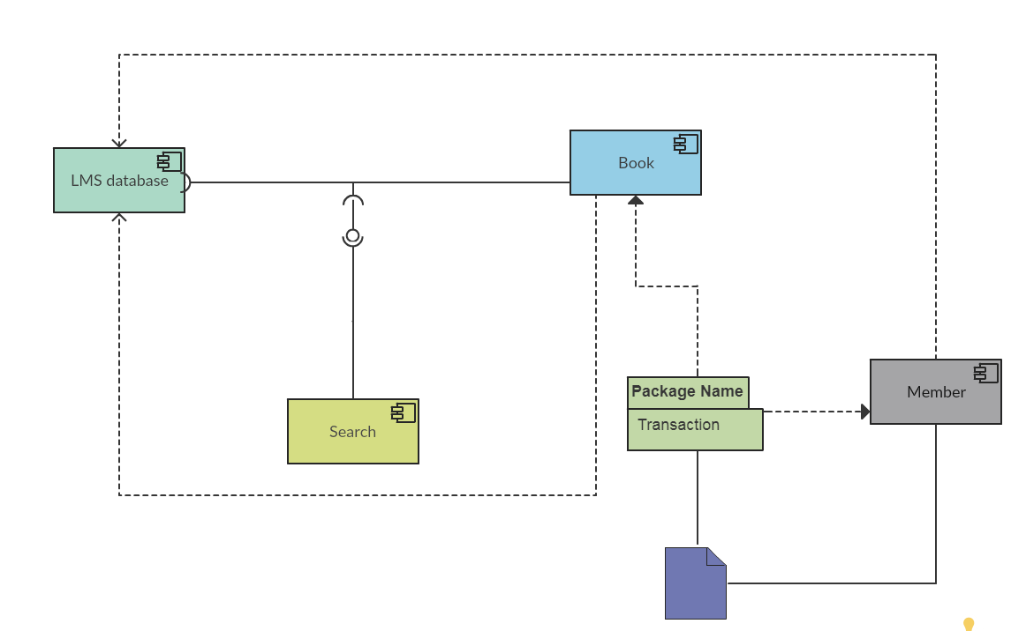

QUESTION THREE (20 MARKS).
- OUTLINE the importance of UML. (4 marks)
- Explain the importance of an interface in OOP. Using any example draw a class diagram showing the implementation of an interface. (6 marks)
- Describe the different views in UML (4 marks)
- Differentiate: (6 marks)
  - Structural diagrams and behavioral diagrams
  - Object modeling and dynamic modelling
  - State diagrams and flow charts

QUESTION FOUR (20 Marks).
- Consider the process of ordering registering for a unit on the Riara University online campus.
  - Draw an activity diagram representing each step of the process, from the moment you access the system to when you view the units on the online campus. Do not represent any exceptions. Include activities that others need to perform.
(12 marks)
  - Explain different types of events within the UML (8 marks)

QUESTION FIVE (20 MARKS)
- The following is a state diagram for the new cash registers being developed by "Quick-E-Mart".
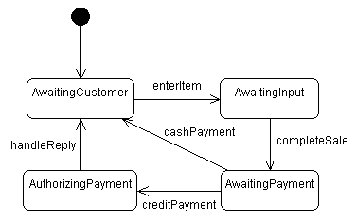
- There is a major problem with this state diagram. What is it? (4 marks)
- How would you fix this problem? (Modify the above diagram or draw a new one.)
(8 marks)
- Explain different types of messages as used in sequence diagrams (8 marks)

