
UNIVERSITY EXAMINATIONS
EXAMINATION FOR JANUARY/APRIL 2024/2025 FOR BACHELOR OF SCIENCE IN COMPUTER SCIENCE

RCS 404: STATISTICAL METHODS

DATE 10TH APRIL 2025 TIME: 2 HOURS

GENERAL INSTRUCTIONS:
Students are NOT permitted to write on the examination question paper during examination time.
This is a closed book examination. Text book/Reference books/notes are not permitted.

SPECIAL INSTRUCTIONS:
This examination paper consists Questions in Section A followed by section B.
Answer Question 1 and any Other Two questions.
QUESTIONS in ALL Sections should be answered in answer booklet(s).

PLEASE start the answer to EACH question on a NEW PAGE.

Keep your phone(s) switched off at the front of the examination room.

Keep ALL bags and caps at the front of the examination room and DO NOT refer to ANY unauthorized material during the course of the examination.

ALWAYS show your working.

Marks indicated in parenthesis i.e. [ ] will be awarded for clear and logical answers.

Write your REGISTRATION No. clearly on the answer booklet(s).

For the Questions, write the number of the question on the answer booklet cover page in the order you answered them.
- DO NOT use your PHONE as a CALCULATOR.
- YOU are ONLY ALLOWED to leave the exam room 1 hour to the end of the Exam.
- DO NOT write on the QUESTION PAPER. Use the back of your BOOKLET for any calculations or rough work.

SECTION A (COMPULSORY)

QUESTION 1 (THIRTY MARKS)

- The number of Instagram messages sent per hour over a mobile network has the following distribution (where X is the number of messages).

$$x$$ | 10 | 11 | 12 | 13 | 14 | 15
$$P(X=x)$$ | 0.08 | 0.15 | 0.30 | 0.20 | 0.20 | 0.07

Determine:
- the mean of the number of messages sent per hour. [1 Mark]
- the standard deviation of the number of messages sent per hour. [2 Marks]
- the probability that between eleven and fourteen messages are sent per hour. [1 Marks]
- the variance of $Y=3X-7$. [1 Mark]

- The manufacturer of solid-state disc (SSD) expect 2 % of their units to fail during the warranty period. A sample of 20 independently selected units are tracked by the company’s research and development department for warranty performance. Determine (to four decimal places),

- the probability distribution of the units that fail during the warranty period. [2 Marks]
- the probability that none fails during the warranty period. [1 Mark]
- the probability that at least two units fail during the warranty period. [2 Mark]
- the mean and variance of the units that fail during the warranty period.
[2 Marks]
- A semiconductor manufacturer produces controllers used in auto-mobile engine applications. The customer requires that the process fall out or fraction of defective are a critical manufacturing step should process exceed 0.05 and the manufacturer demonstrates process capability at this level of quality using $α=0.05$. The semiconductor manufacturer takes a random sample of 200 devices and finds that four of them are defective. Can the manufacturer demonstrate process capability for the customer? [6 Marks]

- State the central limit theorem (CLT) as used in sampling and sampling distribution. [2 Marks]

- A battery manufacturing company claims that the lifespan of batteries produced have a mean of 54 months and a standard deviation of 6 months. your consumer advocacy group tests 50 of them. What is the probability that the mean life time is less than 52 months? [3 Marks]

- consider the following sample of fat content (in percentage) of ten randomly selected hot-dogs;
25.2 21.3 22.8 17.0 29.8 21.0 25.5 16.0 20.9 19.5

Assuming that the Hot-dogs were randomly selected from a normally distributed population, compute a 97 % confidence interval of the population mean fat content (leave your answer in 4 decimal places). [7 Marks]

SECTION B

QUESTION TWO (TWENTY MARKS)

- Differentiate between the terms;
- Sufficiency and consistency as used in theory of estimation. [4 Marks]
- Statistic and parameter as used in statistics. [2 Marks]
- The following data was collected in an experiment on airborne bacteria count (number of calories/ft³) both from $m=8$carpeted Hospital rooms and $n=8$ uncarpeted Hospital rooms.

Carpeted | 11.8 | 8.2 | 7.1 | 13.0 | 10.8 | 10.1 | 14.6 | 14.0
Uncarpeted | 12.1 | 8.3 | 3.8 | 7.2 | 12.0 | 11.7 | 10.1 | 13.2

- Find the mean sample variance for each of the two types of hospital rooms
[10 Marks]
- Test whether the mean number of bacteria count for the carpeted rooms is more than those of uncarpeted rooms at $α=0.05.$ [4 Marks]

QUESTION THREE (TWENTY MARKS)

- The number of requests for assistance received by a towing serves van is a Poisson process with rate of 4 per hour.
- Compute the probability that exactly ten requests are received during a particular 2-hour period. [3 Marks]
- Compute the probability that at least one requests is received during any three-hour period. [3 Marks]
- If the operators of the towing service van take a 30 minutes break for lunch, what is the probability that they will not miss a call requesting for assistance during their lunch break. [2 Marks]

- A company packages a particular product in cans of three different sizes, each using a different production line. Most cans conform to specifications, but a quality control analysis has identified the following reasons for non-conformity.

- Blemish on can
- Crack in can
- Improper pull tab location
- Pull tab missing
- Others

A sample of non-conforming unit is selected from each of the three production lines on the basis of the five categories above and the data summarized in the table below;

 | Blemish | Crack | Location | Missing | others
Production Line 1 | 34 | 65 | 17 | 21 | 13
Production Line 2 | 23 | 52 | 25 | 19 | 6
Production Line 3 | 32 | 28 | 16 | 14 | 10

Does the data suggest that the proportion falling in the various non-conformity categories are not the same for the three lines at 5 % level of significance?
[12 Marks]

QUESTION FOUR (TWENTY MARKS)

- State and discuss the four advantages of sampling over a complete census.
[8 Marks]

- Six samples of each of four types of cereal grain growing in a certain region were analyzed to determine Thiamine content by an Agro-chemical company. The resulting data is as follows

Wheat | 5.2 | 4.5 | 6.0 | 6.1 | 6.6 | 5.8
Barley | 6.5 | 8.0 | 6.1 | 7.5 | 5.9 | 5.6
Maize | 5.8 | 4.7 | 6.4 | 4.9 | 6.0 | 5.2
oats | 8.4 | 6.1 | 7.8 | 7.0 | 5.5 | 7.2

- Find the variance within the samples. [6 Marks]
- Find the variance between the samples. [2 Marks]
- Write the analysis of variance table [2 Marks]
- State the hypothesis to be used in testing the equality of the means
[1 Mark]
- Perform the test at Test the claim at $1\%$ level of significance. [1 Mark]

QUESTION FIVE (TWENTY MARKS)

- (i). The regression equation from an analyst’s diary is given as
$$\hat{Y}=26.8+1.48x$$
While the following information was also extracted

Predictor | Coefficient | Standard Error | t-Value
Constant | 26.753 | 2.373
$$x$$ | 1.4756 | 0.1063

Fill in the missing values. [2 Marks]

(ii) From the diary the analysis of variance table was given as

Source | Degrees of freedom | Sums of Squares | Mean Sum of Squares | F-Ratio
Model | 1
Error |  | 94.8
Total | 14 | 1500

Fill in the missing values in this table. [4 Marks]
(ii). Can you conclude that the model defined a useful linear relationship?
[use $α=0.05$]. [3 Marks]
(iv). What is the estimated variance? [2 Marks]

- Data on the connection between radioactive waste exposure and cancer mortality was published. The data was collected from 9 counties that were located near an Atomic Energy Commission facility in Hanford, Washington. The data give the index of exposure and the cancer mortality rate during 1959-1964 for nine counties affected. Higher index of exposure values represents higher levels of contaminationVariable description; County Name, Exposure Index and Cancer mortality per 100,000 many years. The data was as follows;

County exposure Mortality
1 2.49 147.1
2 2.57 130.1
3 3.41 129.9
4 1.25 113.5
5 1.62 137.5
6 3.83 162.3
7 11.64 207.5
8 6.41 177.9
9 8.34 210.3

Output from fitting the simple linear regression for predicting Mortality from exposure is shown below:

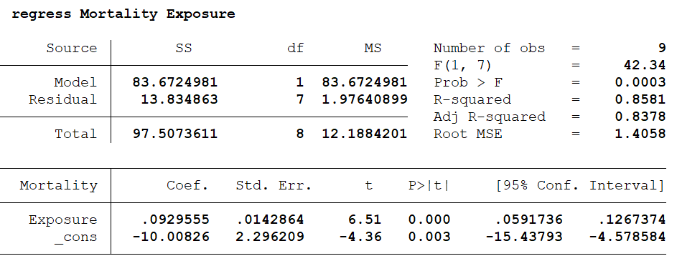

- State the hypothesis for testing the overall model. [1 Mark]
- What is the expected mortality rate for a county with exposure index of 3? [2 Marks]
- Interpret the estimated slope of the fitted model. [2 Marks]
- What is the correlation between mortality and exposure? [2 Mark]
- Is there a significance linear relationship between Mortality and Exposure? Support your comment citing results. [2 Marks]

