
UNIVERSITY EXAMINATIONS
EXAMINATION FOR JANUARY/APRIL 2025/2026 FOR BACHELOR OF SCIENCE IN COMPUTER SCIENCE
RBCS 7426: WEB APPLICATIONS DEVELOPMENT II
DATE: 7TH APRIL 2026 TIME: 2 HOURS
GENERAL INSTRUCTIONS:
Students are NOT permitted to write on the examination question paper during examination time.
This is a closed book examination. Text book/Reference books/notes are not permitted.
SPECIAL INSTRUCTIONS:
This examination paper consists Questions in Section A followed by section B.
Answer Question 1 and any Other Two questions.
QUESTIONS in ALL Sections should be answered in answer booklet(s).
- PLEASE start the answer to EACH question on a NEW PAGE.
- Keep your phone(s) switched off at the front of the examination room.
- Keep ALL bags and caps at the front of the examination room and DO NOT refer to ANY unauthorized material during the examination.
- ALWAYS show your working.
- Marks indicated in parenthesis i.e. () will be awarded for clear and logical answers.
- Write your REGISTRATION No. clearly on the answer booklet(s).
- For the Questions, write the number of the question on the answer booklet’s cover page in the order you answered them.
- DO NOT use your PHONE as a CALCULATOR.
- YOU are ONLY ALLOWED to leave the exam room 1 hour to the end of the Exam.
- DO NOT write on the QUESTION PAPER. Use the back of your BOOKLET for any calculations or rough work.

SECTION A (Compulsory)
Question One (30marks)
- Discuss the different forms of data types below by providing example. (3 Marks)
- String
- Boolean
- Number
- Discuss any FIVE common issues that web development teams’ encounter. (5 Marks)
- Explain the importance of using wireframe diagrams as a web developer. (4 Marks)
- Examine the following JavaScript Code. What is the value of the variable errorMessage (6 Marks)
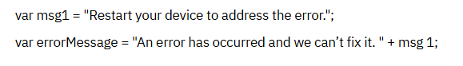
- Discuss the CRUD database function operations, web developers use in Structured Query Language (SQL). (8 Marks)

- Explain the importance of DevSecOps and the DevOps & Shift left approach during the SDLC process. (4 Marks)

SECTION B (Answer any two)
Question Two (15 Marks)
- What can you conclude from the below JavaScript code if you would use to write for your web page. (5 Marks)
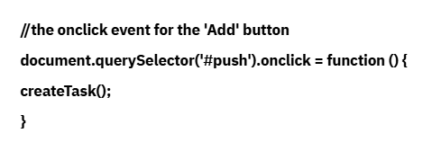
- Assuming you are in charge of the website of your company. You have the structure of the Web Page set up and you have added some content, like the name of the Web Page. You are ready to add CSS styles to the Web Page to make it visually appealing. Provide some of the guidelines that you would recommend for the company’s brand guidelines. (10 Marks)

Question Three (15 Marks)
- Paolo is a creating a social media website. During sign-up, the user’s first name and last name are collected separately using variables firstName and lastName. Paulo now creates a fullName variable to display the name below the profile picture. What is the correct expression to achieve this. (5 Marks)

- Develop an interactive Task List Test for a Web Page highlighting the important areas that a Web developer should consider important parts of a test plan. (10 Marks)

Question Four (15 Marks)
- Distinguish an event listener to an event handler as used in Web Application Development. (4 Marks)

- Discuss the primary ways developers declare JavaScript variables. (6 Marks)

- Explain items that are required to add interactivity to an element on a dynamic Web Page with JavaScript. (5 Marks)

Question Five (15 Marks)
- Discuss the use of the below operators as used in Web Application Development. (4 Marks)
- = (equals)
- = (plus)
- – (minus)
- * (asterisk)

- Discuss any FIVE Web Development Issues, web development teams should consider during web application testing before rollout. (5 Marks)

- Discuss the relationship between Cloud Computing and Web Development when it comes to hosting web applications. (4 Marks)

- Explain the concept of containerization in Web Development. (2 Marks)

